DANIEL 11, PART 2:
THE REPEAT OF DANIEL 11 IDENTIFIES RAPHIA AND PANIUM

INTRODUCTION
In December 2016 a message that Daniel 11 would repeat at the end of the world was unfolded. The principle guiding this study is that history repeats (Ecclesiates 1:9, 3:15 and Isaiah 46:10) in a very specific fashion, which we call line upon line, parable methodology. The diagram below illustrates how Daniel 11:5-20 repeats from 538 A.D. to the second advent. Previous to this study we understood that two waymarks existed between 9/11 and the Sunday Law waymark, calling them Midnight and the Midnight Cry. The main outcome of this study was the further characterisation of these two waymarks, now also named Raphia and Panium respectively. However it was not until our Midnight Mry message of September 2018 that Elder Tess identified the dates of these two, then future waymarks and could more correctly explain their corresponding characteristics. As I understand it, the message of the repeat of Raphia and Panium introduced the reemergence of Russia to eschatology, as previous to this we thought Russia had died from the prophetic stage. It may be that this opened the way for us to more fully accept our Midnight Cry message which initially focussed largely on the role and identity of Russia in future prophecy.

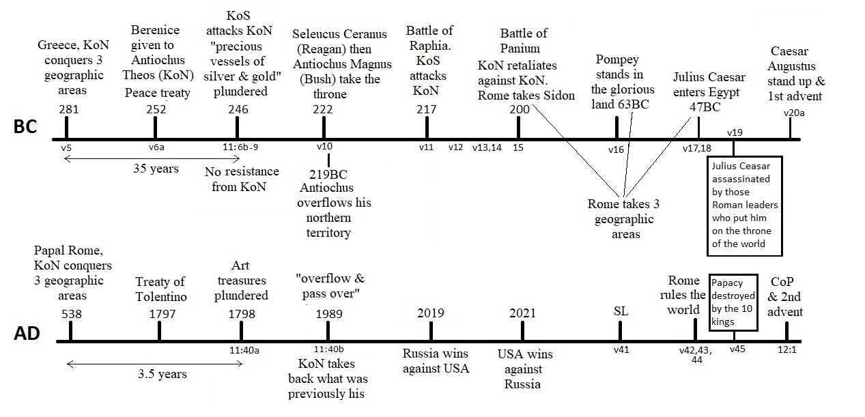

DANIEL 11:5-9 REPEATS FROM 538 TO 1798
Uriah Smith’s “Daniel and the Revelation” offers a reliable and comprehensive narrative on the entire chapter of Daniel 11, so this study will not detail all these events, only those we currently apply to the repeat of history.

Verses one and two of Daniel 11 place us in the history of Medo-Persia, with verses three and four taking us down into the Grecian empire and identifying Alexander the Great. Verse four details his death in 323 B.C. followed by the four generals of Bible prophecy who inherited his kingdom:
- Lysimachus who took the north of the kingdom (Thrace).
- Seleucus the east (Syria and Babylon).
- Ptolemy the south (Egypt and Libya).
- Cassander who took the west (Macedonia).

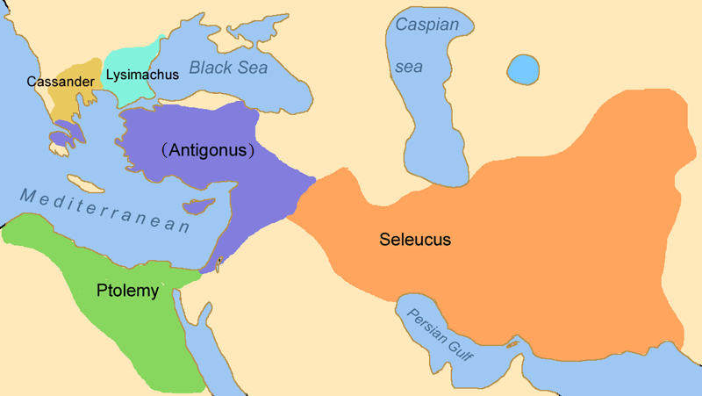

281 B.C Parallels 538 A.D. and the Conquering of Three Geographic Areas
Verse five introduces the phrase, “the king of the south” in reference to Ptolemy I Soter and, “one of his princes”, or one of his generals, Seleucus Nicator. It says Seleucus Nicator, “shall be strong above him, and have dominion” because Seleucus the general took the northern and western territories of Macedonia (now Greece) from Cassander in 286 B.C., and Thrace (now Bulgaria) from Lysimachus in 281 B.C. Thus verse six now ascribes the title, “the king of the north” to Seleucus.

Most important to note is that the king of the north always conquers three geographic areas. Medo-Persia conquers the three ribs of Daniel 7:5, Babylon, Lydia and Egypt (Smith, “Daniel and the Revelation”, 128). Pagan Rome “waxed exceeding great, toward the south, and toward the east, and toward the pleasant land” in Daniel 8:9, which chronologically was Syria in 65 B.C., Palestine in 63 B.C. and then Egypt in 30 B.C. A third witness is how Papal Rome plucked up three geographic areas in Daniel 7:8, “the Heruli, the Ostrogoths, and the Vandals” by 538 A.D. (Ibid. 134). With the above three witnesses we can safely apply this principle to modern Rome, the modern-day king of the north, and see in Daniel 11:40-42 that to rule the world supremely she must conquer the king of the south (Russia), the glorious land (America) and Egypt (the world).

It is noteworthy that Seleucus Nicator helped Ptolemy I Soter in battle so was “his prince”, meaning Seleucus was Ptolemy’s general. Smith however explains this phrase differently, interpreting "one of his princes'' to mean "one of his [Alexander's] princes" (Ibid. 249). However the verse does seem to indicate the prince, or general, belongs to the last person mentioned, which would be Ptolemy and not Alexander. So the king of the south (Ptolemy) first helps the king of the north (Seleucus). Only by Ptolemy’s help does Seleucus rule the north.

252 B.C. Parallels 1797 and the Peace Agreement
Verse six begins by identifying a time period, “in the end of years”, that the following events were to occur in. This is referring to the end of the years of the king of the north, which was thirty-five years later. If you remember in 281 B.C. Seleucus took the third and final territory to become the king of the north, and now, thirty-five years later, in 246 B.C. the king of the north is dead. This finds its parallel in the three and a half prophetic years ending in 1798, since she subdued her third geographic territory in 538 A.D.

Verse six continues to describe the marriage of Berenice to Antiochus Theos (the king of the north) in 252 B.C. Essentially a peace agreement to end the Second Syrian War. Berenice was the daughter of Ptolemy Philadelphus (the king of the south). This peace agreement repeats, finding it’s parallel in the Treaty of Tolentino in 1797 between papacy (the king of the north) and Revolutionary France (the king of the south).

246 B.C. Parallels 1798 and the Deadly Wound
Antiochus Theos was actually already married, so he had to divorce his first wife Laodice in order to marry Berenice. When Berenice’s father died in 246 B.C., Antiochus Theos returned to his first wife Laodice. She was restored to the royal court where, as verse six explains, she then murdered Antiochus Theos, Berenice, her son, and all her servants and attendants.

Verses seven to nine of Daniel 11 all describe one event, the Third Syrian War, also known as the Laodicean War, from 246 B.C. to 241 B.C. “But out of a branch of her roots” simply means someone from Berenice’s family line (see Isaiah 11:1) and refers to Berenice's brother Ptolomy Euergetes.

Ptolomy Euergetes travelled to save Berenice but arrived too late. When he arrived “with an army” he “enter[ed] into the fortress of the king of the north” and not meeting any resistance, took revenge on the new king of the north, Seleucus Callinicus. Ptolomey Euergetes captured Seleucus Callinicus, then exiled him where he died. Thus in 246 B.C. the king of the south delivered a deadly wound to the king of the north, bringing to an end his “great dominion” (verse 5), and all due to a broken treaty, when Antiochus Theos took back Laodice to be his wife again.

In parallel, in 1798 General Berthier marched into the pope’s fortress, the Vatican, also not meeting any resistance, and took captive Pope Pius VI, also for retaliation as well as a broken agreement. Placing the pope in exile where he too later died in 1799.

Verse eight stays in the events of 246 B.C. further detailing how Ptolomy Euergetes conquered the territory of Seleucus Callinicus, plundering all his treasures and then reigned longer than the king of the north’s thirty-five year dominion. In an almost perfect repeat of history, General Berthier plundered the Vatican art treasures in 1798 and took them to the Louvre.

Verse nine then summarises the two previous verses, that the king of the south came into the king of the north’s kingdom with an army, intent on war, and returned with plunder.

DANIEL 11:10-20 REPEATS IN DANIEL 11:40-12:1

219 B.C. Parallels 1989 and the Fall of the Soviet Union
Verse ten begins by introducing the two sons of Seleucus Callinicus, who were Seleucus Ceraunus and Antiochus Magnus the Great. Seleucus Ceraunus, being the king of the north, was first to take the throne. He began to assemble a great army but was assassinated in 223 B.C. by two of his own generals because he was deemed physically and financially weak, as well as pusillanimous. So in 222 B.C. his brother, Antiochus Magnus takes the throne and continues to, “assemble a multitude of great forces”.

This parallels 1989 and how typically at the time of the end we often see two leaders. The army which Rome, the king of the north had assembled by 1989 was America, and the two sons of Seleucus Callinicus are paralleled by Presidents Reagan and Bush, who both oversaw the deadly wound and complete death of the king of the south from 1989-1991.

In 219 B.C. in the Fourth Syrian War, Antiochus Magnus "overflowed" his northern territory, and “passed through” Palestine, taking back the territory he formerly ruled, up to the border of Egypt, “even to his fortress”. This verse parallels Daniel 11:40b when in 1989 the king of the north had assembled an army, the army of Rome, and “shall overflow and pass over” the territories of the king of the south. Although they are translated slightly differently, the Hebrew words for “overflow and pass through” are exactly the same as “overflow and pass over”.

When the Soviet Union collapsed the west only took back the old eastern European territories which the papacy used to own. The king of the north only reclaimed territory up to the border of Russia. This perfectly parallels the fourth Syrian War in 219 B.C. when the king of the north took back Coele-Syria from the king of the south. So verse forty has been prefigured in 219 B.C. Russia is still the king of the south after 1989 just as Egypt was still the king of the south after the Fourth Syrian War ended in 217 B.C. The main difference being that Russia received a deadly wound in 1989 and then fully and completely died in 1991. However, by using parable methodology and comparing and contrasting the king of the south with his counterpart, the king of the north, we can see that Russia’s deadly wound will heal and he will be resurrected. This, like the healing of the king of the north, happens gradually, remembering when a body resurrects, it looks different (1 Corinthians 15:51, John 20:14, 15). So when Russia’s deadly wound is healed she does not resurrect as Soviet Russia with a Communistic union.

217 B.C. and the Battle of Raphia Parallels 2019
Verse eleven details the Battle of Raphia, when the king of the south, Ptolemy Philopater, son of Euergetes, “moved with choler, and shall come forth and fight with him, even with the king of the north” in 217 B.C. After losing his territories to the king of the north in verse ten, the king of the south is now stirred up against the king of the north. The king of the north, Antiochus Magnus, had the “great multitude” or the greater army (see Judges 4:7), as it is throughout the whole of Daniel 11. So America is always the superpower when this repeats at the end of the world. Yet at the Battle of Raphia in Palestine in 217 B.C., the king of the north loses to the king of the south. Under our midnight cry message of September 2018, Elder Tess predicted that Raphia would be repeated in 2019, but would be an information war between Russia and America, as well as the various proxy wars they are fighting around the world, in particular the Syrian civil war.

Still in 217 B.C., verse twelve is an account of Ptolomey Philopater’s self exaltation and subsequent attempt to enter the temple in Jerusalem (Smith, “Daniel and the Revelation” 254 and 3 Maccabees 1). In an entirely different story but with notable similarities, King Uzziah of Judah in 2 Chronicles 26:16-20 also tried to enter the temple in Jerusalem, and it was the fourscore valiant priests with the high priest who tried to stop Uzziah, eighty-one being a number which symbolises this waymark. It is also interesting to note that Pyrrhus desecrates a temple in Sicily between Askulum and Beneventum which represent Raphia and Panium respectively.

200 B.C. and the Battle of Panium Parallels 2021
In verse thirteen, the king of the north, Antiochus Magnus, returns with an even greater army, to retaliate against the king of the south, now Ptolemy Epiphanes in 204 B.C. Then in 200 B.C. at the Battle of Panium, the king of the north defeats the king of the south. This event, Elder Tess has predicted to be repeated toward the end of 2021. It will also parallel 1989 in that it is another deadly wound to Russia, then at the Sunday Law waymark Russia dies forever from the prophetic stage.

Verse fourteen sees the introduction of Rome, “the robbers of thy people”, to the prophetic stage. Rome managed to hold off Antiochus Magnus who had allied with Philip of Macedon to battle with the king of the south at Panium. So Rome is rising into prominence on the world stage, trying to "exalt themselves to establish the vision".

Verse fifteen describes the Battle of Panium, where, with the support of Rome, the king of the north, Antiochus Magnus and Philip of Macedon, defeated the king of the south, the young king of Egypt, Ptolemy Epiphanes in 200 B.C. Thus Antiochus Magnus and Philip take back Palestine, which Ptolomey Epiphanes had previously taken. So neither the young king of Egypt, nor those he chose to defend him, namely the Egyptian general Scopus, could withstand the king of the north.

63 B.C. Parallels the Sunday Law Waymark
Verse sixteen parallels verse forty-one, where we see in both verses, the king of the north enters into the glorious land, representing the Sunday Law waymark. Verse sixteen uses the symbol of a hand to denote power, “which by his hand shall be consumed”, and we see this same symbol in verse forty-two in reference to the mark of the beast law, “but these shall escape out of his hand”.

Antiochus Asiaticus could not stand against Rome and in 65 B.C. Pompey took Syria, and thereby Rome became the king of the north, eventually to stand in the glorious land when Rome took Judea in 63 B.C. When Pompey marched into Jerusalem in 63 B.C. he arrived to find a rivalry between the two Jewish aires to Jerusalem, Aristobulus and Hyrcanus. Pompey tried to resolve it but the underdog, Aristobulus, rebelled and after reneging on an agreement, sought war with Pompey. So Aristobulus brought destruction on his own Jewish people. Pompey invaded Jerusalem and walked into the city as the followers of Hyrcanus opened the city gates granting him access. Pompey battled his way to the temple doors while the Jews retreated into the temple and a three month siege ensued. By the end of the campaign, Pompey had slaughtered twelve thousand Jews and imposed tribute, handing jurisdiction over to Syria. This parallels verse forty-one when the papacy will “cometh against” America and “shall do according to his own will” and pass the mark of the beast law as he “stand[s] in the glorious land”.

47 B.C. Parallels the Papacy Sitting on the Throne of the World
In verse seventeen, we see Rome “set his face to enter” into Egypt, and thus Julius Caesar took Egypt in 47 B.C. Only Egypt was left after Rome took Jerusalem, Syria, and previously Macedonia and Thrace. This parallels verse forty-two, where “the land of Egypt shall not escape”.

44 B.C. Parallels the Fall of Babylon Under the Loud Cry
Verse nineteen prophesies how Julius Caesar then “turns his face” back to Rome in 44 B.C. “but he shall stumble and fall, and not be found” because he was assassinated when he sought kingship overturning the Republic. The same people who voted him to be king delivered him a deadly wound. Caesar died at the height of his reign paralleling Revelation 17:16-17 when those who put the pope, the king of the north, on the throne of the world, “eat her flesh, and burn her with fire”. So verse nineteen parallels verse forty-five when “he shall come to his end, and none shall help him”. In fact we see this principle again with Clovis of France who places the papacy on the throne of the world and Revolutionary France which delivers the deadly wound in 1798.

217 B.C. Parallels the Close of Probation for the World
Then in verse twenty, Caesar Augustus, also known as Octavianus, “stands up… in the glory of the kingdom” paralleling Daniel 12:1 when Michael, the true King of the north, stands up. Notice the kingdom is referred to as a kingdom of glory here because, “Rome reached in [Caesar Augustus’] days the pinnacle of its greatness and power. The "Augustan Age" is an expression everywhere used to denote the golden age of Roman history. Rome never saw a brighter hour.” (Ibid. 266). This glorious kingdom symbolises the glorious kingdom of Christ at the second advent. Verse twenty is literally the first advent of Christ as Augustus’ taxes therein mentioned refer to Luke 2:1, “And it came to pass in those days, that there went out a decree from Caesar Augustus, that all the world should be taxed” which is the event that brought Jesus to Bethlehem (Luke 2:4). So verse twenty is a narrative about the first advent of Christ which parallels Daniel 12:1 and the second advent of Christ.

CONCLUSION
Understanding that history repeats in a line upon line fashion, one can see how the events of Daniel 11:5-20 repeat from 538 A.D. to the second advent. Many of these events are already detailed in Inspiration. Books such as The Great Controversy and Early Writings for example give an explicit narrative of these events, but nowhere in Inspiration are we told that the battles of Raphia and Panium will be repeated at the end of the world. This is hidden treasure, only for the wise, which can only be derived from parable methodology.

