9/11 PART 3:
THE EARLY AND LATTER RAIN, THE JUDGEMENT OF THE LIVING AND THE SEALING OF THE 144000

INTRODUCTION
We have seen how every reform line has five major waymarks. The first three are the first, second and third angel’s messages respectively, followed by the shut door and the second advent. In the line of the 144,000, Sister White already gives you the last three, those being the Sunday Law, Close of Probation (Daniel 12:1) and the Second Advent. So we are left to fabricate the first two waymarks for ourselves, and the purpose of this series is to identify the second waymark. We have already suggested it is 9/11 as it lines up with August 11, 1840 and 27A.D. This paper will incorporate the agricultural model to try and understand the relationship of the early and latter rain with 9/11, and then how the judgement of the living and the sealing of the 144,000 relates to this.

THE EARLY RAIN FOR THE 144000
The early and the latter rain are symbols borrowed from the agricultural model. If you refer back to the diagram of the lines in the first article, it is easy to see how the second waymark for the 144000, 9/11, lines up with the second stage of the agricultural model, the early rain. It cannot be the waymark prior to 9/11 as 1989 is the ploughing. The field has to be ploughed before the seed can be planted and receive the first rain, or early rain (Deuteronomy 11:14). So 1989 is the first waymark which corresponds to the ploughing, not the early rain.

Equally the early rain cannot begin at the third waymark as this is always the Sunday Law, and Sister White clearly says the latter rain, not the early rain, begins at the Sunday Law. So we have no other option but to place the beginning of the early rain for the 144,000 at the second waymark, which thus far we have shown to be 9/11 and the arrival of the second angel’s message.

Then from 9/11 it must be that the wheat and the tares are planted (Matthew 13:25), as “[I]n the East the former rain falls at the sowing time.” (TM 506.1). For a seed to be planted it has to be first buried in the soil, to later arise up out of the ground. This process symbolises baptism which complements our model perfectly as we have already placed the baptism of Christ at this exact waymark. Furthermore, the Red Sea Crossing is the second waymark for the beginning of ancient Israel which also parallels baptism (1 Corinthians 10:1-2). Then as the plant receives the early rain it continues to grow. Rain is a symbol of the messages, doctrines or words of God (GC 341.4; RH, July 20, 1897 par. 6; Deuteronomy 32:2; Isaiah 28:9-12 & 55:10-11). So with each new message the 144.000 are growing toward full maturity. When they accept the message of 9/11 and the third woe they are declared perfect at that stage of growth. Then, one by one, as they accept the messages of the 2520, 126, time setting, Raphia, Panium, the midnight cry and equality, they are found perfect at each stage of growth. This parallels the post-baptismal Christian walk which should be one of perfection (Romans 6:6). As they grow from doctrine to doctrine they are settling into the truth, and intellectually and spiritually being restored to Eden.

THE LATTER RAIN
Ellen White Gives Us The Empowerment, We Must Dig To Discover The Arrival
Firstly let us be very clear, Sister White tells us that the latter rain, judgement of the living and the sealing of the 144,000 all take place at the Sunday Law waymark. Revelation 18:1-3 is the Sunday Law waymark when the second angel’s message is empowered (GC 603.1). Verse four onward is the loud cry under the latter rain. So as we now investigate the message of Revelation 18 please keep in mind that we are equally discussing the latter rain as they are almost synonymous.

The second angel’s message arrived in history in the Millerites time, given as Revelation 14:8, but when it repeats at the end of the world it is given as Revelation 18 (LDE 199). In the last article we saw that the three angels first fly in the midst of heaven signifying their arrival, and when they land on Earth it signifies their empowerment. In the same way, when the second angel arrived in history, the first stage was the arrival in the summer of 1844 (GC 389.2) and the second stage was the empowerment by Samuel Snow’s midnight cry on August 14, 1844. Please keep in mind an important distinction. This is how the second angel’s message arrived for the Millerites line. For the line of the 144,000 the second angel arrives at 9/11 and is empowered at the Sunday Law waymark.

Now one has to juggle an entirely different concept which can become confusing. Ellen White also says the second angel’s message is empowered at the end of the world at the Sunday Law waymark. So please keep in mind two different models, both advocated by Sister White. In one model the second angel’s message is empowered under the midnight cry message of Samuel Snow on August 14, 1844, and in a different model, she says it repeats at the end of the world when it is empowered at the Sunday Law waymark, described in Revelation 18.

Utilising alpha and omega, parable methodology, if the second angel’s message was given to the Millerites in two stages, then that is how it will be given at the end of the world when it is repeated. We compare the similarities of the beginning of modern Israel (the Millerites) with the end of modern Israel (the 144,000), thus at the end of the world, when the second angel’s message is repeated in Revelation 18, it will come in two stages. Essentially, when it is empowered at the end of the world (Revelation 18), it first has to arrive.

This can be confusing because using the Spirit of Prophecy alone, we can also correctly teach that the second angel’s message arrived in history in the summer of 1844 yet using the above alpha and omega, parable methodology we are also claiming it has to arrive (again) before it is repeated or empowered at the end of the world. Let us try to explain further.

The first stage, the arrival, which we have also conceptualised as flying in the midst of heaven, is not mentioned in Revelation 18. The narrative of Revelation 18 starts after the angel is flying, when it has landed on Earth. It can only be discovered using alpha and omega, parable methodology, and we will see how this occurred at 9/11. Again, if we understand the empowerment of the second angel (Revelation 18) being the Sunday Law, then 9/11 is just the arrival of that angel. Perhaps we could call this a precursor to Revelation 18, while the angel is waiting until it can come down to Earth at the Sunday Law.

As we have mentioned, the angel of Revelation 18 gives the loud cry under the latter rain. So we can understand how both the latter rain and the angel of Revelation 18 are synonymous in that they represent the same event which follows this two stage pattern. Thus the latter rain message, synonymous with the message of the angel of Revelation 18, comes in two parts. The arrival or precursor at 9/11 and the empowerment at the Sunday Law waymark.

What can be difficult to grasp is that two different but closely related concepts coincide at 9/11.
1. The early rain falls at the arrival of the second angel’s message for the 144000.
2. There is a precursor to the latter rain, when the angel of Revelation 18 is flying in the midst of heaven.

In fact the arrival of our second angel at 9/11 is exactly the same event as the arrival of, or precursor to the repeat of the second angel’s message prophesied by Sister White and Revelation 18. Our former rain marks the same event as the precursor to the latter rain.

Alpha and Omega, Parable Methodology Shows Two Stages to the Latter Rain
We have alleged that the angel of Revelation 18, and therefore the latter rain, arrives in two stages. When Sister White tells us the latter rain falls at the Sunday Law she does not comment on there being a prior stage to it. This can only be derived from alpha and omega, parable methodology, hence the understanding of 9/11 is hidden treasure which only the wise will understand.

Exactly like the second angel’s message, Ellen White gives us two different applications for rain, both of which come in two parts.

- She says at Pentecost the early rain fell and at the Sunday Law the latter rain will fall (AA 54.2 & 55.1). So she says the rain falls in two parts - early rain and latter rain (5T, 214.2, 8T 21.2, GC, 611.2). We call this application “progression”.
- In reference to John 20:22 she writes, “The act of Christ in breathing upon his disciples the Holy Ghost, and in imparting his peace to them, was as a few drops before the plentiful shower to be given on the day of Pentecost.” (3SP 243.1). Here we see that the outpouring at Pentecost was preceded by a “few drops” on resurrection day - also two parts.

Sister White’s two applications are represented as Model 1 in blue, in the diagram below.
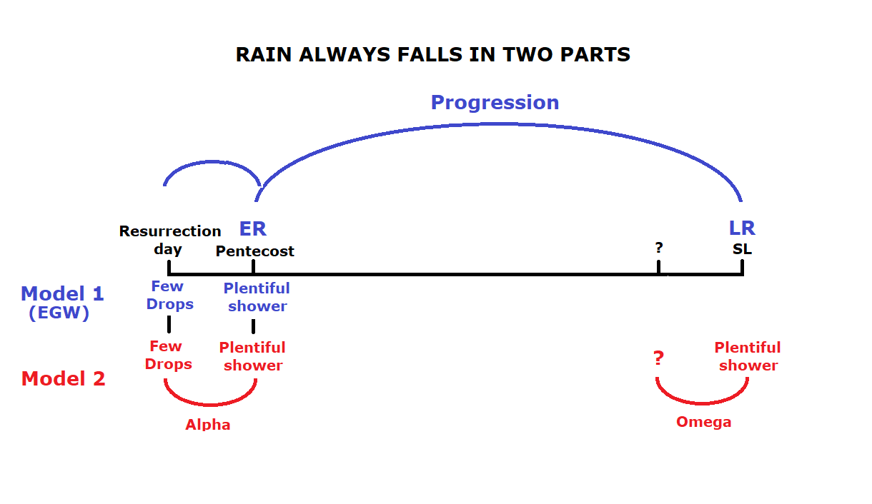

Model 2 above, in red, reveals how alpha and omega, parable methodology, shows the latter rain falls at the end of the world - in two parts. We could equally call this repeat and enlarge, parable methodology. The missing first part is not mentioned in Inspiration. It can only be derived from alpha and omega, parable methodology. Only when we understand history repeats, can we understand that the history of ancient Israel depicted in Model 2 is an ensample, “written for our admonition, upon whom the ends of the world are come” (1Corinthians 10:11). Then we can see the necessity of identifying the precursor to the latter rain at the end of the world.

So Ellen White gives us the model of progression in her writings but parable methodology incorporates her writings into a repeat and enlarge model to discover a hidden waymark we have been calling a precursor. We have already alleged that the waymark illustrated with a question mark above is 9/11. While the loud cry is a warning to the world of the close of probation, 9/11 was a warning to the church, the 144000. The church has to be warned first so they can prepare to then warn the world - first the church then the world.

The Relationship Between Our Second Angel’s Message and the Repeat of the Second Angel’s Message at the End of the World
This precursor to the latter rain of Revelation 18 can only be placed at 9/11. 9/11 is the only waymark before the Sunday Law on the line of the 144,000 apart from 1989, which as the ploughing and the very beginning of the unsealing cannot also be the beginning of the latter rain. Sister White said the latter rain of Revelation 18 is the repeat of the second angel at the end of the world and we have shown how it perfectly complements the arrival of the second angel’s message for the 144,000. It is not a coincidence that the arrival (precursor) to the repeat of the second angel’s message (Revelation 18) is the same waymark as the arrival of the second angel’s message for the 144,000. It is also no coincidence that this precursor to the latter rain is the same waymark as the early rain for the 144000. In other words, the “few drops” of the latter rain is the early rain for the 144,000. We could illustrate it like this.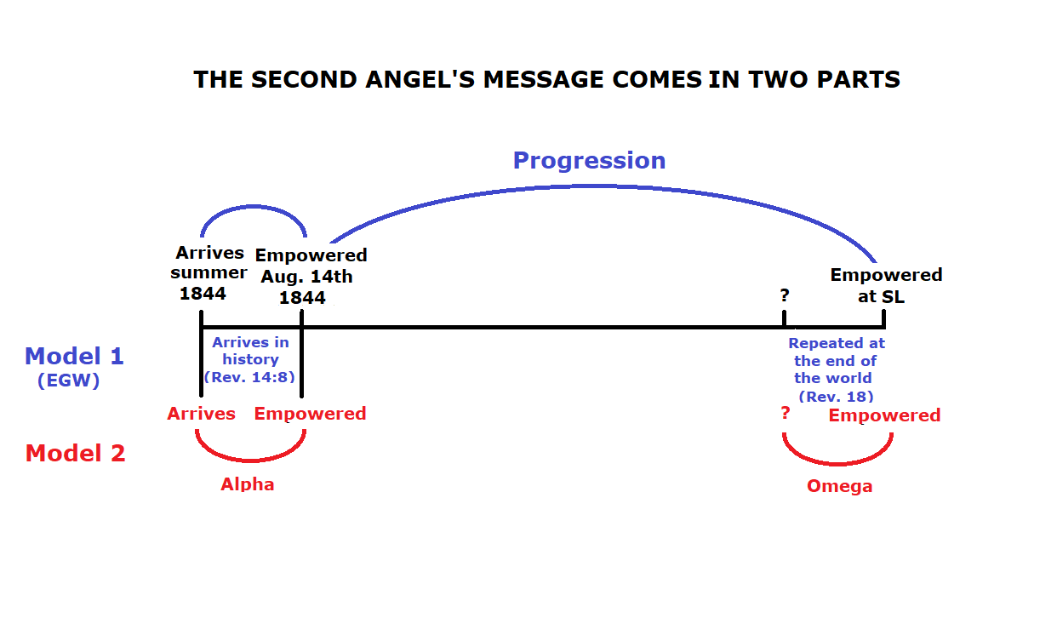

Progression v Repeat and Enlarge
Apart from the second angel’s message and rain, there are two other models in Scripture which follow this same progressive as well as repeat and enlarge pattern, one of which is the parable of the ten virgins. There is a beginning and it travels through time progressively, but it also repeats at the end, and when it repeats it does so in the same fashion as it was given at the beginning. We will not take the time here to investigate the parable of the ten virgins as we will do so in the next article. The other model which repeats at the end of the world in two parts is the process of judgement.

THE JUDGEMENT OF THE LIVING AND THE SEALING OF THE 144000
We have demonstrated how 1844 can be lined up with 9/11 using the arrival of the second angel’s message, but 1844 also saw the arrival of the third angel’s message on October 23rd, with the message of the law in the most holy place. We will look at this further in the next and final article, but for now let us just point out that we can take the prophetic properties from 1844 and parallel them with prophetic events at 9/11.

The first angel’s message from 1798 was particularly, “the hour of his judgement is come”. This judgement is the judgement of the dead beginning October 22, 1844. From the 2300 day prophecy (Daniel 8:13), Miller was supposed to predict that Christ was to move from the Holy to the Most Holy to begin the investigative judgement of the dead. “The announcement, “The hour of His judgment is come,” points to the closing work of Christ's ministration for the salvation of men” (GC 435.2). The error he made was to predict an executive judgement, that being the second advent.

As we can take the prophetic properties from 1844 and parallel them with prophetic events at 9/11, we can place judgement at 9/11 in parallel. If the judgement of the dead was 1844 then it can only be that the judgement of the living was at 9/11. Yet we face the same dilemma as we have in the rest of this article. Ellen White places the judgement of the living firmly at the Sunday Law waymark. However, as the 144,000 we use parable methodology. As we have seen, one type of parable is alpha and omega, and as with rain and the second angel’s message, we can see there has to be a precursor, or a first stage, to these events. Just as the aforementioned come in two parts, so too does the judgement of the living, and as with the others, Ellen White only gives us the second part.

In the model of judgement, we think of Adam, Eve and Abel as being judged first. The investigative judgement beginning in 1844 is when the books of the dead are opened and investigated. Logically then, these books must have first been written. So October 22, 1844 would be the second stage of the judgement of the dead. The first stage would have been to write those books, just as a detective gathers and records evidence during the investigation of a suspect. We could call it, “record keeping”, or “note taking”.

Scriptural evidence for this is that Abel is already declared righteous in the Bible, long before 1844 (Matthew 23:35 & Hebrews 11:4). The reason Jesus knows Abel was found righteous is no doubt because Abel’s record is already in the public domain, that being his prophetic test in the book of Genesis. Please notice that Cain and Abel were given a “great test... by which their eternal destiny will be decided” (2SM, 80.4). It was a prophetic test, in that the sacrifice required was a prophecy of the Messiah, but inextricably linked to that test was a revelation of what was already in their hearts (PP 71.1).

Thus at 9/11 the recording angels begin their work of record keeping, recording the responses to each prophetic test of those that strive to be among the 144000. It cannot be before 9/11 as the symbol of baptism at 9/11 represents being born again. Record keeping cannot occur before one is born, still in the womb. Likewise in the agricultural model the wheat is only planted at 9/11 so it ceases to exist before then. Only when it receives the early rain and springs up can it be investigated as to whether it is a wheat or a tare. We also have seen that from 9/11 God has proven and confirmed His message, movement and methodology, and that He does not waste His efforts. He requires a response from us to accept the ensuing doctrines one by one as they come to light. From 9/11 He can fairly and justly demand of us an affirmative response to the third woe, the 2520, the 126, time setting, the repeat of Raphia and Panium, the midnight cry and equality. Then at the Sunday Law waymark, the judgement of the living moves to its second stage when the records are investigated. As with the other prophetic models, Sister White only comments on this second stage. It is only through alpha and omega, parable methodology that one can uncover the hidden treasure of the precursor, or note taking at 9/11.

The Sealing
So as each of the 144,000 progress through the prophetic doctrines which arrive in their order, they are being progressively sealed as they accept each one. While these are emphatically not moral sins, or moral tests, it is my belief that our moral characters are tried to some extent by these prophetic messages. Pride and prejudice for example can prevent us from accepting the messenger and therefore their message. So while we are being judged by our God-given, prophetic tests, undoubtedly they reveal our moral character too.

Then as we pass each test we are being sealed progressively, doctrine by doctrine as we settle into these truths both intellectually and spiritually (10MR, 252.1). If you remember from the first article, the sealing of the 144,000 is recorded in Revelation 7:1-8 where we also see the four winds restrained, representing the sealing of the 144,000 from the Sunday Law to the close of probation (Daniel 12:1). So at the Sunday Law waymark, the great test for the people of God, the second stage of the investigative judgement begins when the books can be investigated and the sealing angel can identify those who are safe to seal before Daniel 12:1. By the second advent we are expected to be restored to Eden, fit to be taken to Heaven.

The sealing and its required manifestation of righteousness at 9/11, perfectly complements the arrival of the second angel’s message which can be represented by the second step, righteousness, in the sanctuary model, Daniel 12:10, Luke 9:23, John 16:8, Acts 24:25, Revelation 3:18, 14:7 & 17:14, and paralleling baptism (27 A.D.) when we have to manifest righteousness (Romans 6:6). It is simple logic that under the second angel’s message, if one comes out of Babylon then they come out of an antichristian belief system into God’s kingdom, which is akin to exhibiting righteousness.

CONCLUSION
In this article, using line upon line methodology we have attempted to show how 9/11 saw the beginning of the early rain for the 144,000 by comparing it to the agricultural model. Simply, both the early rain and 9/11 are the second waymarks of their respective lines. Furthermore baptism and seed sowing are symbolised here, and the early rain contributes to the growth of the plant just as one is called to walk perfectly before the Lord after baptism.

Again using line upon line methodology, by comparing and contrasting the line of Adventism with the line of the 144,000 we placed the judgement of the living at 9/11. We noted however that this and other such events, Sister White places at the Sunday Law, namely the latter rain message of Revelation 18, and the sealing of the 144,000. However, we saw that using alpha and omega, parable methodology, their precursors can be placed at the former waymark, 9/11. You will not find it explicitly in Scripture, you have to dig for it using alpha and omega, parable methodology. Hence, the waymark 9/11 is hidden treasure, only for the wise at the end of the world.

Sources:
Katherine Harding (15-02-2020) “Review of Vows 21 & 24”: https://www.youtube.com/watch?v=cqULDHbRddQ&feature=youtu.be
Parminder Biant (April 2019) Guadeloupe, “Judgment of the Living 7/9”:
https://www.youtube.com/watch?v=vwktCd1deJM&feature=emb_title

