2018 & THE CONFLICTING ETHOS OF RIGHT & LEFT

TMW VESPERS

MARCH 04, 2022

ELDER TESS LAMBERT
https://www.youtube.com/watch?v=490HRrq9J0U&list=PL6-Mv8H520RncgAlBdn_u3bAlt_kGZZhH&index=4
We went from 1888, looking at the external of 1888, the internal of 1888, and wanting to know what it was like to actually be there, living in 1888, through the history of the Minneapolis conference but also before that history leading up to it, and what it was like in Adventism after that history. Why was there such a mess? So, we’re looking at 1888. We saw how history is complex. It was in the past, and it is in the present day.
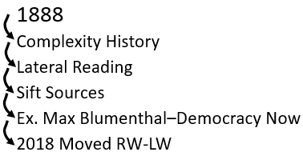
To be able to unravel that history and understand it, we need to know how to laterally read. So, we introduced that as a concept when we began looking at how we research and understand. Then we began to talk about sifting sources.
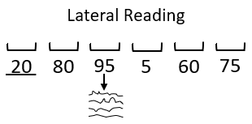
We began to talk about sifting sources that are on the left side of the political spectrum; where we are as a movement. Because, if we are in the left side of the political spectrum, and we agree more, we lean towards the world view of the left-wing, then those are the sources we are going to mostly accept in our research. But even these, we need to sift. So, we began to ask, how do we sift these sources? We took a step back, and we asked, why are we on the left anyways? Let’s go back a little more to 2018, because from 1989 to 2018 we were a right-wing movement. What moved us from the right-wing to the left-wing?
So, why did we decide in the first place that most of the right-wing sources are of little value to us, prophetically? As an end time movement, and why do we accept the world view of the left-wing, of course, heavily sifted? So, we went back to 2018 where the movement made this momentous switch from the right to somewhere in the left spectrum. We said that it was predominantly four kinds of subjects or themes that moved us from the right-wing to the left-wing, all surrounding what was taught in September and October of 2018; September and October caused us to make this massive ideological swing.
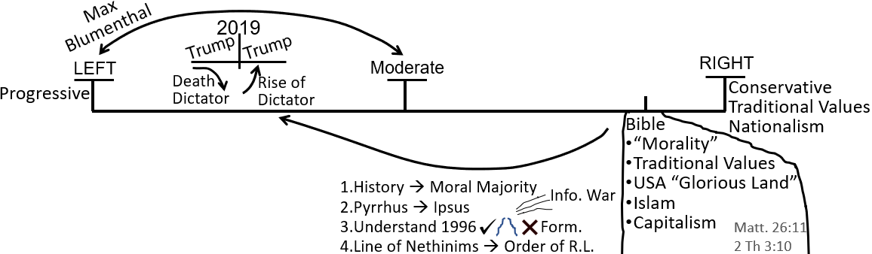
First of all was the understanding the history and connecting it with the moral majority and republicanism. Some people made comments last week that really blew up and was expanded upon. Then it was understanding the history of Pyrrhus as the representative of the king of the south (KoS), what was embedded in Daniel 8:8, particularly the Battle of Ipsus which represented the 2016 election. And now we had a prophetic explanation for that turning point election in American history, in the history of the glorious land, the US and the glorious land being a prophetic subject.
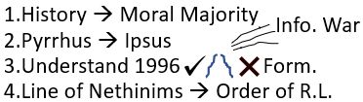
So, we should have a prophetic explanation for such a momentous event in the country that prophecy shines a spot light on. We had that with Ipsus. Then last week we added the third and the fourth; understanding 1996, the formalization of the message internally, but we also then looked externally. We started to say, sure, there was the work of Elder Jeff Pippinger formalized internally in 1996. But when you look at the external, there was also a formalization, formalization though in both the right-wing and the left-wing. The right-wing formalized a political stream of information, which we titled as FOX. The left-wing formalized their political stream of information, which we call CNN. Of course, those are titles of, a lot more that happened in 1996. So, that was number three.
Number four, we discussed the line of the Nethinims. Really, what that point is asking how is God preparing, not just this movement, not just Adventism, but God is preparing the entire world for the Sunday Law (SL). They are already making decisions that will affect how they perceive the Sunday Law event. So, when we look at 2018, and we say 2018, we moved from the right-wing to the left-wing because of the message of the two streams of information, what does the two streams of information even mean? Elder Tess didn’t even teach one subject titled, “Two Streams of Information.” What it was, was key parts of all the messages that kind of coalesced around the Midnight Cry (MC) that all brought us, sometimes from different directions, definitely from different directions, but they all agreed with one another.
Prophecy always agrees with prophecy. And, these different elements of the different parts of the message, whether it was the understanding the King of the South, or understanding the history of 1989 and 1996, and understanding 2016, understanding what is happening with the world, what has to be happening with the world. Understanding all of that has brought us, from all of these different directions at once, to one central point, to one central conclusion. And that conclusion was this movement, to stay a history of success, had to, had to, change its political ideology. People would either follow that and change their political ideology or they would leave the movement, and go back to Adventism and reject everything that God has taught us since 1989.
Elder Tess hopes that we can see that all of these different points combined form what we kind of summarize as the two streams of information. Does that make sense? We have all these different points coming at once, and what we’re going to do through 2019, because people don’t want to change their political ideology, is just labor that over and over and over again which is why these points presented simply in 2018 explode through 2019. Now, we don’t just understand the moral majority, the ten-year history, now we can trace that politicalized Protestantism all the way back to the first great awakening and through 1798; all the way till today. So, from 10 years, it became 240.
Our message just became more and more rock solid, trying to stabilize the people, to try and stabilize the people because it doesn’t matter how clear the truth is, changing our political ideology is painful, and people are not always willing to be guided by methodology and logic and prophecy, not when it starts to conflict with deep, deep, set culture. So, that’s kind of a summary of what we did last week. The combination of the left and the right equals two streams, a kind of a simple name to try and explain what those messages were teaching this movement.
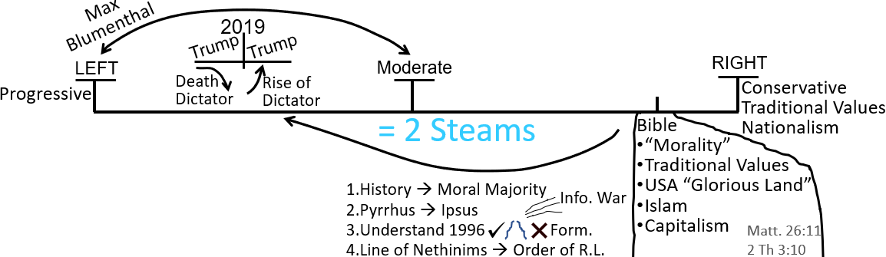
This was the board work that we did after that to explain why that fourth subject that formed the two streams of information that centered on how God has to prepare the world for the Sunday Law. God has to prepare, not just Adventism and people within Adventism, but He has to prepare the entire world for the SUNDAY LAW event. We went here to the board work to illustrate why that’s the case.
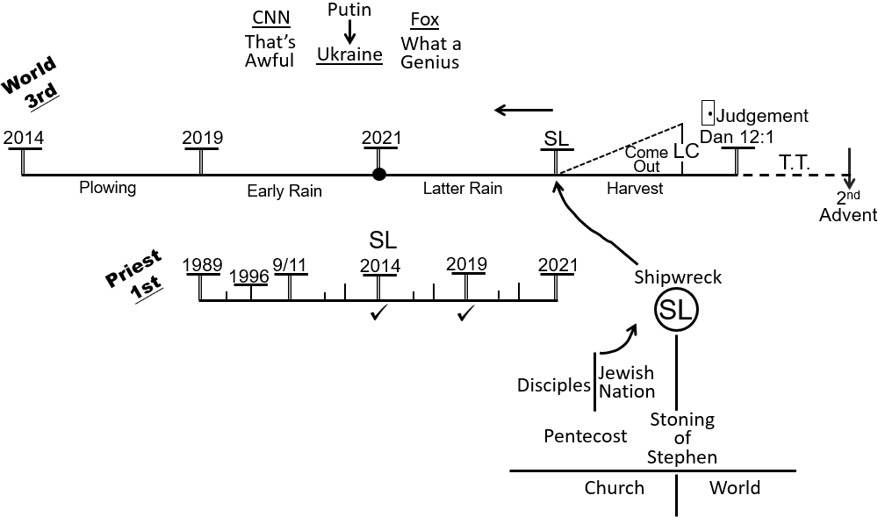
Where we left off after this was, we said, all that’s well and good. That’s where we got to, but the last point that we finished on, we said, what’s the point? Because, what does it even mean to be right-wing, and what does it even mean to be left-wing? Because, if we don’t know what the right-wing stands for and we don’t know what the left-wing stands for, then this ideological change is quite meaningless. We don’t know what it means for us as individuals, for us as a prophetic movement. So, Elder Tess asked people to give in a few words an explanation of what the right-wing stands for and what the left-wing stands for. What is their ethos? We began to do that, but we ran out of time.
So, what Elder Tess wants to do now, she has a list of people who have communicated that are participating. If you haven’t done so, then feel free to raise your hand to talk, but she won’t ask you any questions because she doesn’t want to put you on the spot, if you haven’t chosen to participate. But those who have chosen to participate, she wants to ask them, she has nine people. She is going to go to them one at a time and say, give her, she wants nothing more than two words; one word to tell her what the left-wing stands for and one word to tell her what the right-wing stands for. So, try to get to the point of the ethos for the right-wing and the ethos of the left-wing. Elder Tess believes that just one word for each can summarize both. She doesn’t think that is an oversimplification. She hopes that we can illustrate that.
Moli has his hands up so she will let Moli speak. So, you all have time to think, and I’m going to erase the board. So, everyone has a few moments. Moli, did you have a question?
Moli – No, I’m raising my hand to participate.
Elder Tess – Great. You’re participating. I have ten people. That is a nice round number.
Moli – Do you want me to say anything about the left-wing and the right-wing?
Elder Tess – I might wait just for a moment just so I can get this erased. And then, I’ll call on people because I want to write as you speak to document. Josephine, did you have a thought or question? Please don’t answer about the one word about right-wing and the left-wing yet. But you have a question or thought?
Josephine – No, because I’m participating so I’m raising my hand.
Elder Tess – I didn’t want to erase the board before we started, because it helps us to see, to bring it back, because a week is a long time in 2022. Long enough for an invasion. I’ll just draw up a line of politics. Now, it might get harder for those who go later on. If you see a word up and you just want to repeat it, that’s fine. But I’m just going to draw up left and right. And then we can start documenting one-word answers. So, Moli, one word for the right-wing.
Moli – Moral majority.
Elder Tess – Moral majority? So, is it ok if I put morality? That is kind of the ethos. We’re trying to get to the ethos behind it, and that is the, I guess they’ve put it in their own title for a reason. It’s all about morality. One word for left-wing?
Moli – Progressive.
Elder Tess – That’s a good one. Josephine.
Josephine – Do you want me to use some of the words we used last week, or you want me to say a new word?
Elder Tess – You can repeat anything you like as long as it’s one word.
Josephine – Ok. Republican for the right. Democrat for the left.
Elder Tess – Ok. John, do you want to give a word?
John – Socialism for the left, and conservative for the right.
Elder Tess – Conservatism. A loaded word. That’s a good one. Thank you. Marie.
Marie – Reactionary for the right, and I’m really stumped for the left. I’m just going to say equality.
Elder Tess – Equality. Great. Thank you. Greg.
Greg – Adverse to change. Adverse to bringing new things in. That kind of thing. They like to keep it the way it is. Like Antigonus. They like to keep it the way their ancestors had it.
Elder Tess – So, adverse. It’s kind of like conservative, isn’t it? They’re trying to conserve.
Greg – And, if you’re trying to bring in equality or something, they go, no, no, we don’t want that. We don’t accept that. So, when you’re trying to bring in things from the left, they’re quite adverse to those things from the left. They’re not progressive. They’re adverse to progression. They’re adverse to socialism.
Elder Tess – Yes. We can see that on the Supreme Court. A literal and original reading of the Constitution rather than a progressive reading. So, that’s how you meant by adverse to change. And, willing to change for the left?
Greg – Correct. Willing to try new things.
Elder Tess – Ray.
Ray – Oil on the right, and renewables on the left.
Elder Tess – Is that the ethos of the parties, do you think? Got inside their mindset.
Ray – Oh no. I think I’ve been listening to too much of Rachel Maddow. I guess that sort of fits under conservatism and progression.
Elder Tess – Oil and renewables. Kind of what ties into what Greg said about willing to learn and change and not really willing to try new things.
Ray – The other one I was thinking was capitalism for the right.
Elder Tess – Capitalism. Is it ok if I get rid of oil and put capitalism because it’s kind of related? Lynne.
Lynne – I was thinking nationalist and globalist.
Elder Tess – That’s a good one. So, globalism and nationalism. Catherine.
Catherine – Can we do workers on the left and employers on the right?
Elder Tess – Workers and businesses. We see that through their taxes, don’t we? I think that fits. Rachel. I assumed you were participating.
Rachel – Community on the left and something like self on the right.
Elder Tess – Community and self. How about if we put individual? Is that what you were thinking?
Rachel – Yeah. Just about, yeah, that would be together better. Yeah, communities being as a global and self being nationalistic: me and myself and I.
Elder Tess – So, you’re tying it into that kind of nationalism.
Rachel – Yeah. That’s what it meant I believe. Yeah. Globalism and nationalism are what I had in mind.
Elder Tess – I think that brings us to quite a good point. Brodie.
Brodie – I thought for the right could we say freedom?
Elder Tess – Right-wing, freedom?
Brodie – Does freedom counterbalance equality for the left?
Elder Tess – And equality which we have up here. So, you’re saying freedom for the right and equality for the left.
Brodie – Yeah. That’s contrasting.
Elder Tess – James. You had your hand up.
James – I was thinking of patriarchy for the left contrary to equality since it’s man over woman.
Elder Tess – So, patriarchal over to the right?
James – yeah.
Elder Tess – And the left is?
James – I was thinking equality. I don’t know another word to put for that one, for the left.
Elder Tess – You don’t have to come up with a new one if you feel ones of these is most fitting. That’s fine, and you’ve centered on equality which I would agree with.
Mrs. Bennet – Patriarchal opposite feminism.
Elder Tess – Sorry. Who was that? Feminism, and you’ve chosen the word from the right-wing. This has been the patriarchal. Josephine.
Josephine – May I add in another word. It might not be the right word. Ideological for the right and maybe non-ideological for the left.
Elder Tess – What do you mean by non-ideological? If you could give a little bit of explanation of what you conceptualize that to look like.
Josephine – I think that the left does not have a set of principles, I may be wrong. I mean the right has their set of principles, and they’re out to have that. And you know, the state enforces that, whereas the left maybe does not really have that. They want things right but they’re not out to, they’re not like the right in a sense that they’re… They want their way of thinking. They want their template for everybody else, whereas the left, they’re sort of easy going, you know, if it’s equal, it’s all right. If it’s progressive, we’re happy. I think the right is more …
Elder Tess – So, because they are conservative, they have to have an ideology to conserve, whereas if the left is not trying to conserve anything, you don’t think that they have, they kind of don’t have this ideology that they’re clinging to. Because, I think in one sense we could think that both have an ideology. Both are standing for something. But I can see your point because, if I understand you correctly, what you’re saying is that the left is non-ideological because they are moving, they are changing through history whereas the right is conserving. They are holding on to what you have termed ideology.
Josephine – Yes. That is exactly what I’m trying to say.
Elder Tess – Ok. I just want to look something up. Sandy.
Sandy – I was just thinking for the left, inclusive, and for the right, exclusive. Inclusive or, I guess all ideas or people, and exclusive, you have to fit into their category; into their mold.
Elder Tess – And if you don’t, they cancel you. I think that we are, there’s a lot of truth in what has been in the words that have been given. I didn’t say it this week, but I did say it last week. I think it would be good for a certain part of this discussion if we tried to approach it from an unbiased position as possible. Now, bias is normal and natural and good. We have to have an opinion. We have to have a position that we hold to, and then it becomes virtually impossible to not look through that lens. But I think that this sad face kind of sums it up a lot that we are looking at this side and seeing all that’s wrong with it. We’re answering with a 2022 movement brain, not a 2018 movement brain.
This is good because we’re in 2022. But, if we were to look at both sides and actually want to define the right-wing, how they would see themselves, and define the left-wing, how they would see themselves, I think we would start seeing some of this as more complicated. So, if we talked about the right-wing is patriarchal, I think Margery Taylor Greene would disagree with us. I think that lots of women republicans would kind of disagree with that. I believe that lot of them would disagree with that. The Republican and the Democrat party have become more cemented in the left and the right over the last decades. But it didn’t use to be that stuck. Originally, it was not that fluid.
Brendon messaged in with a thought. He’s unable to speak right now, but Elder Tess wants to put in his thoughts because she thinks that it is one of the couple of thoughts that she wants us to really recognize. Big government on the left. If you’re a left wing, you believe in a big federal government. This is what you expect from the federal government; it’s going to be big. If you’re a right-wing, you’re going to believe in a small federal government. Now, why is that? Why does the right-wing believe in a small government, and the left-wing believe in the big government? That concept, the right believing in the small and the left side believing in big, explains to us, demonstrates what their ethos is. Greg.
Greg – Big government is more inclusive so it’s going to have more members from different areas of communities. The right-side government (Audio cutting out. Difficult to understand).
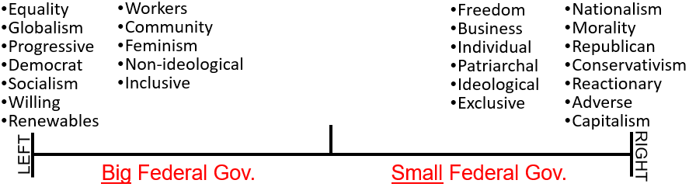
Elder Tess – You cut out a little so I’m going to try to repeat what I think you were saying. Big federal government on the left-wing because they’re trying to be more inclusive. So, bring in more people who are representative of the general population. But what if you had, say, five people on the left, and they’re all white men, and the right side is small and only has three people, but it has a white man, a black woman and a trans-man. It’s smaller, but it’s more inclusive than the left.
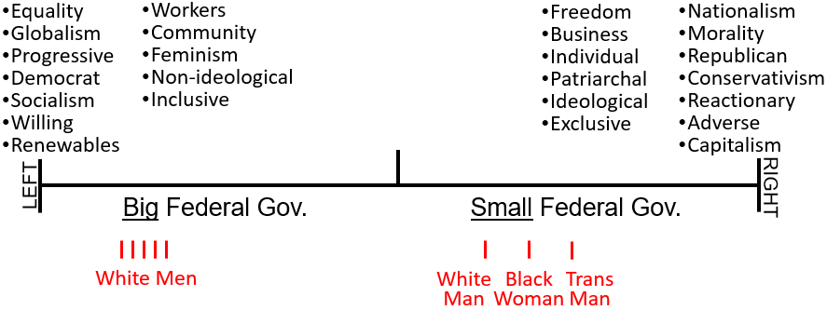
Greg – attempting to respond but cutting out.
Elder Tess – More community representation in the large government. That’s true if you let every member of the community in. I think there’s part of an answer in what you said, but I don’t think it’s getting quite to the point. Raymond.
Raymond – I was just going to say that the right tends towards deregulation of businesses because that was my understanding why they like small government. They don’t like the government interfering with people’s activities, and they sort of approach it from an economic model.
Elder Tess – Stop there and give me one word. They don’t like the government interfering with people’s activities. What would you call that?
Raymond – Freedom?
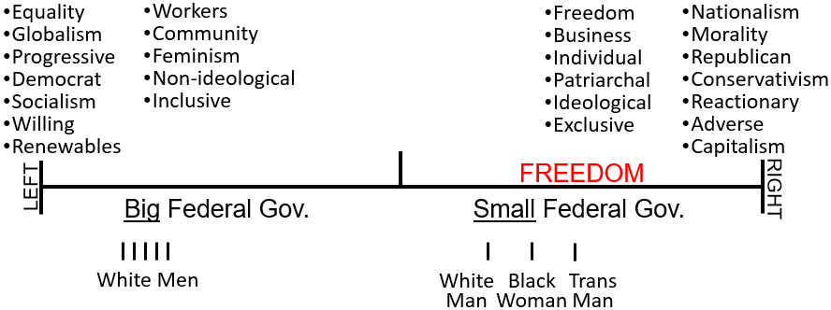
Elder Tess – FREEDOM is the ethos of the right-wing. I would suggest that if you cut out what they don’t agree with, cut out what is impacted by their ideology, if you got to the very, very root of the right-wing, freedom is the ethos. So, sorry to interrupt you, Raymond. Would you finish your thought?
Raymond – Don’t be sorry. I was just going to say that, I was thinking of the sort of the economic mindset they approach it with by deregulating businesses because it allows them to do what corporations do, and they expect wealth to trickle down, which it doesn’t really.
Elder Tess – So, what you are saying is that this small federal government is small because functionally, it has less to do.
Raymond - Yeah. Let’s go with that.
Elder Tess – Then, why is the left-wing big?
Raymond – Because they’re trying to protect the people from unfettered capitalism. Protect the minorities from the people trying to force their own way of life on the others.
Elder Tess – That sounds like you’re describing freedom. So, they’re protecting minorities. You’ve got the point; you hit the nail on the head. They’re protecting people, and that is work. Do you have a word for that?
Raymond – I was thinking restraint?
Elder Tess – What are they restraining?
Raymond – Oppression?
Elder Tess – They are restraining oppression? What do you think their ethos is, then? Someone’s going to write to me at some stage I know and tell me I’m using ethos wrong. That’s all I can think of for now.
Raymond – I keep thinking of ‘freedom to’ on the right, and I keep thinking ‘freedom from’ on the left.
Elder Tess – Freedom from what?
Raymond – I’m thinking this through, and it doesn’t make a lot of sense to me anymore. When I go to articulate it, it sounds just like the right. So, let’s scratch that.
Elder Tess – We can come back to it. Marie.
Marie – I was going to suggest socialism.
Elder Tess – Socialism is opposite of capitalism, and I’m kind of wanting to get to the root. It’s true there’s opposites here. There’s a capitalist leaning perspective and a socialist leaning perspective. But you have people over on the left like Joe Manchin who is a capitalist. Kyrsten Sinema; they’re capitalists. So, we’re dealing with more of a financial system, and I think we can get further into the root of the difference between these two sides. Because we can spend weeks on all that they stand for and all how that tie together. I want us to get to the very, very root so we can make this as simple as possible, because I find politics confusing and hard, and I think other people do as well.
But we can get to the root of the difference between these two sides. If we can do that, we know that the swing that we took in 2018, it wasn’t a swing based on turning us from capitalists to socialist. But it did turn us from prioritizing one thing and learning to prioritize another thing. I wouldn’t say that we were letting go of prioritizing nationalism and learn to prioritize globalism. There are implications to that swing, such as from capitalism to socialism. There are implications. But that wasn’t what the swing was designed to change in us. That’s was not the original point that God was making that He said you idealized this, and you need to change, and you need to now see this as the priority. Moli.
Moli – Equality?
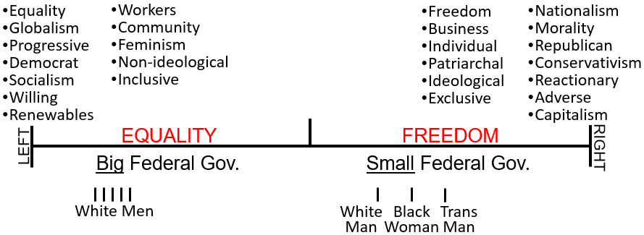
Elder Tess – EQUALITY. That was what I was considering. Freedom is the ethos, if you got to the heart of the right-wing, delved through all the kind of, swam through the exclusiveness, the patriarchal nature, the individualism, the nationalism, their moral stands on somethings, their conservatism, their capitalism, if you swam through all of that and got to that pulsing heart of the right-wing, you would find that labeled freedom. That’s what I want to suggest. And, if you swum through the socialism, the progressivism, the globalism, the community nature, the inclusion, the feminism of the left-wing, because there’s all different leanings of that; some people in the left-wing are certainly not feminist. If you swum through all of that and got to the beating heart of the left-wing, what they prioritize is equality. Sharon. Did I miss your hand?
Sharon – I was just going to say equality, but that’s ok.
Elder Tess – I’m so annoyed at myself for missing you. Is there anything else you want to say about, to make that point?
Sharon – I think, just from what we see is the right-wing offers freedom in exchange for equality, if that makes sense. So, they’re view of freedom, for example the Religious Freedom Act that prioritizes freedom for the majority and not the minority. I don’t know if I’m making sense.
Elder Tess – You are. You’re making sense, but you’re already seeing the problem behind saying that the right is freedom and the left is equality. What I anticipated that people might see, and I think that’s what you’ve highlighted, is freedom for whom? Do you have anything else you wanted to share?
Sharon – Not that I can think of.
Elder Tess – Thank you. Someone has told me the ethos is a Greek word for character, and I am using it correctly. So, we’re getting to the very heart, the character of the two sides. I’m sorry for missed hands. Lynne.
Lynne – I was just going to comment on what you were just saying about freedom for who. And really, they have this concept of the freedom for the individuals themselves. It’s kind of like they are looking out for themselves, their rights and their freedom as opposed to the other side that looks in a sense, more from the concept of equality in a sense of freedom for the society as a whole. So, one side is looking very internally, while the other is looking bit more externally. Obviously, that’s more than just one word.
Elder Tess – I think for a little while, I want to, if I can use a terrible phrase, I want to play devil’s advocate. I want to defend the right because I want us to see how good their arguments are, and where they’re coming from. So, first of all, if we were to define freedom and equality; freedom, I’m pulling up dictionary definitions, freedom is the condition or right of being able or allowed to do, say, think, etc. whatever you want to without being controlled or limited. So, freedom, the condition or right of being able, allowed to do or say or think whatever you want without not being controlled or limited.
Equality is a situation in which men and women, people of different races, religions, etc. are all treated fairly and have the same opportunities. So, I want to give some illustrations. I want to open a business. So, I own a store. This business is going to sell carpentry equipment. It’s going to sell things for building. So, I want to employ people that know how to build. And, there will be some heavy lifting. I have a prejudice. I am a little sexist, so I say that in this store that is my business that I created, in the building that I own, I’m going to employ only men. I say, I own the business, I own the land, and I say that only men are going to work here. I only want men.
And then, the government steps in and says, that’s not fair. We’re going to force you against your will, we’re going force you on the business that you own, and on the land you own to employ women. If we go to the definition of freedom, the conditional right of being able or allowed to do, say, and think whatever you want to without being controlled or limited. Is it a woman’s freedom that she can work at this business? Marie.
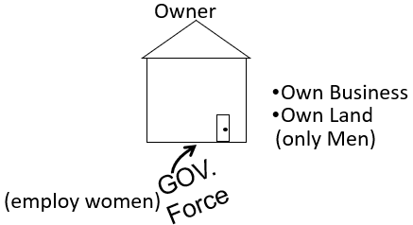
Marie – My internet stopped part way when you were speaking. I’m sorry.
Elder Tess – That’s fine. I’ll repeat myself. What was the last thing you heard?
Marie – You were talking about someone who’s a bit prejudice, and they have their own business, and they only want to employ men.
Elder Tess – And then the government is going to come and force the owner of this business, with the business that he owns, and with the land that he owns, they’re going to force him to employ women. My question was, for the women, is that freedom?
Marie – For the women, is that freedom? It’s equality.
Elder Tess – It’s equality, but it’s not freedom.
Marie – Well, it depends what, who’s using the word freedom. If we’re talking about the right, then, no. That’s not freedom.
Elder Tess – I agree with you. It’s not their land; it’s not their business. I don’t have the freedom to go walk onto NASA and say, I want to be an astronaut. I don’t have the freedom to do that. So, when someone, a man, starts his own business on his own land, for the government to force him to employ women isn’t giving the women freedom. They are giving women equality. Is anyone confused or does anyone disagree? No hands up for confused or disagree. No one has the freedom to walk into my house, and eat my food, do they? Sandy.
Sandy – When you were explaining it, I actually was a bit confused. But, when you can see the difference between equality as you were explaining it there, to see the difference between equality and freedom, I think was quite clear, once you understood that wasn’t freedom. It was actually equality for the woman to have that right. I found that helpful.
Elder Tess – Unless we become really precise, the terms sound kind of the same, kind of interchangeable. We’re fighting for women’s freedoms. But, to a degree, we’re not; we’re fighting for women’s equality. Because in the example of the business owner, who’s freedom is being violated here? It’s not the women. For all the people who want to come just walk into my house and eat my food, whose freedom is violated if they are not allowed to do that? Theirs doesn’t, but if they do then it’s my freedom that gets violated. Josephine.
Josephine – Yes, I was going to comment on, you talk about people coming into your house and eating your food. Yes, your freedom will be violated. Do they have the right to eat your food? What if they’re starving, and there’s food in your household? Stealing is not the right thing but, they could pick up from the floor. They’re dumping something. I’m going biblical. The woman gets what drops off the floor. So, maybe I’m confusing this whole, I mean off the table when Jesus, I’m confusing this whole thing.
Elder Tess – I’m sorry, I can’t quite hear you. I think I’m missing … Are you able to repeat that thought? It’s just a little muffled.
Josephine – They violate your freedom when they come to steal your food, but what if they’re really starving because your food is not divided equally.
Elder Tess – It’s still my food; it’s not theirs.
Josephine – I’m asking, I understand that it is your food. They have no right to steal it.
Elder Tess – If they have no right to it, and for them to take what they have no right to, means that they’re violating someone else’s right. Does that make sense? They don’t have a right to it because it’s mine. And so, for them to take it would be to violate my rights.
Josephine – Yes. Because they’re still doing it.
Elder Tess – Yea. We can make ourselves to feel sorry for them, but if we strip that away it’s still a violation of my rights. It’s a violation of his rights as a business owner, as a land owner, to force him on his business, on his land, to employ women. The women do not have freedom to work at their business. That’s not giving them freedom. He’s giving them equality. Brodie.
Brodie – When we consider the freedom in the right, the freedom is of the individuals isn’t it. So, if we were to compare that to what is happening to the woman on the left, the individual woman doesn’t have the freedom to work at that business. She is still subject to the due process of employment, and she may not get that job, but she will, you know, he may pick another woman, if that makes sense. But she has equality in that she can attend to interview, submit her resume, and be considered amongst the pool of candidates that would have excluded her in the past. So, that gives her equality, but she doesn’t have the freedom to work there, though she might be as skilled as another applicant. Female or male or something else may exclude her. Is that a right way of looking at it?
Elder Tess – I kind of want to get away from the idea that she doesn’t have the freedom because we wouldn’t have the freedom to walk into someone else’s house, let alone, someone else’s business. If this thing belongs to him, therefore it’s his to give out however he wants. So, I agree with most of that. The only thing that I would, I think I would consider is when we say that the women’s freedom is restricted, when they don’t have the access to work some jobs. I’m not talking about government jobs. I’m not talking about corporations. I’m talking like a small business owner. Maybe that’s where I think it gets more confusing or just this owner that owns his own business, who owns his own land. So, if we were going to expand this out like into the health care system, into institutions, that have government involvement, I think it would get a little more complicated. Does that make sense?
Brodie – I think so. I guess I was, maybe I wasn’t clear or I might have missed a point. So, I was saying that she still doesn’t have the right concept of freedom because the right concept of freedom applies to individuals. In my head, I was just trying to differentiate freedom from equality because she’s been given equality but not the right concept of freedom in this instance. But I might just be confused.
Elder Tess – No. I think my brain is slow. I think it’s my brain, not yours. I kind of started to grasp that, but I might need to labor with it a little more. If this was, say, a national park, and the government was to say, only men are allowed on this national park, that would start to be a different… because it’s a public land. If it’s public land, then men and women should be allowed on freely, because it’s owned by the public, and if it’s owned by the public, it’s owned by men and women, and they should have equal freedom. But this business owner is a man. And the land and the business belong to him. So, for him to have to practice equality against his will, takes away from his freedom.
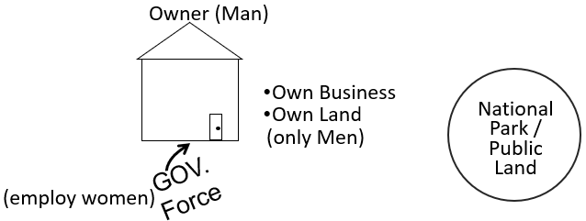
I want to read a quote. I just want to remind us of the definitions. Freedom is the condition or right. It’s your right to be able to, or allowed to do, say, think, whatever you want to without being controlled or limited. So, you have your individuality, your space, your business, your social media platform, and you have the right to do with that business, to do with that platform, to say on that platform whatever you want to. You should not be controlled or limited. That’s the definition of freedom. But my social media platform is mine. Someone else does not have the freedom to come in and write, take over my statuses and put up their own statuses. This thing belongs to me. They don’t have the right to do that. If they did that, they would be violating my freedom.
This is mine. I have freedom in my sphere. This, let’s say, is a government agency, NASA. They have freedom in their sphere. This is a man that owns a business, and he has the freedom to operate, employ, and pay who he wants to, how he wants to, and in what manner he wants to. If you run a business, a government, on the principle of freedom, you only need a small government because they don’t have much to do. They don’t have to look at or monitor all of these businesses, and make sure they’re employing people properly. These businesses belong to the people. It’s their property. So, you don’t need a very big government.
But, if you’re going to be a government that runs on the principle of equality where that is your ethos, you’re going to have to be big if you want to watch what everyone is saying on social media, make sure there’s no hate speech. You have to be big if you’re going to look at how everyone is running their businesses, how everyone is operating, to make sure that they are practicing equality. When you do that though, every time you do that, you are taking away their freedom.
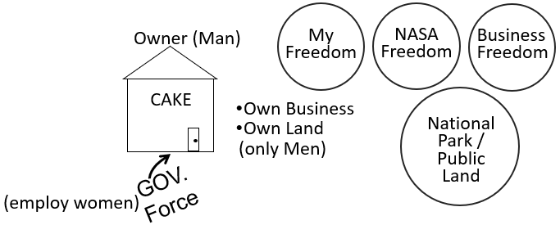
So, let’s say that this is owner owns a cake shop. And he doesn’t want to make a cake, a wedding cake, for an LGBT couple. Right-wing says that it’s his business, he has the freedom, and the right to discriminate with his own property. The left-wing says that he does not have that freedom. We run off the principle of equality, and if he doesn’t behave properly with his own business, we will step in and make him.
I want to read from the American Bar Association from their website because I’m talking about a real case that went before the Supreme Court: Masterpiece Cake Shop versus Colorado Civil Rights Commission. So, we have an owner who says that he will not make and sell a cake to an LGBT couple. That does not violate their freedoms. I hope we can see that distinction. It does take away from their equality though. It’s his business. He can do with it what he wants under the principle of freedom. If you’re right-wing and you are out, because there are LGBT people who are republican, we have to remember that. If we take off our bias there are homosexual men and women who believe that freedom should be the government ethos, and they would take his side because they would say, I don’t like what he does, but it is his business, and it is his right to sell cakes to whoever he wants to sell his cakes to; even if I don’t agree with him.
Do we know this phrase: I will disagree with what you say, but I will defend to the death your right to say it? Have we heard that before? So, there are people who would say, I disagree with you, but I will defend to the death your right to say what I disagree with. There are LGBT people on the right who say, I disagree with this business owner, but I will defend to the death his right to sell his cakes from his business, on his land, to whoever he does or does not want to sell cakes to. So, if we can remove, again playing, I want us to see, strip away the kind of language of bias that we have become familiar to, to get to the root of the disagreement because not everyone in the right-wing is homophobic or believes that gay people shouldn’t have wedding cakes. What they believe is that freedom should be the underlying principle.
This is from the American Bar Association. “No case before the U.S. Supreme Court in October Term 2017 received more attention or raised more important issues than Masterpiece Cakeshop Ltd. v. Colorado Civil Rights Commission.” So, just in the name we should see, first of all, it’s the cake shop versus civil right commission. And the Colorado Civil Rights Commission, if they have civil rights in the name, you know their ethos is equality, not freedom. Their ethos is equality, and they’re looking at him and saying that he does not have the freedom. So, they take him all the way to the Supreme Court. “The underlying issue is profoundly significant: Does a business have a constitutional right to discriminate based on its owner’s beliefs?” This is the sentence that’s the root of the issue. “All antidiscrimination statutes pose a tension between equality and liberty. Any law that prohibits discrimination—whether based on race or sex or religion or sexual orientation or any other grounds—denies the freedom to choose who to serve or to hire.”
So, what the American Bar Association is saying, in the context of this Supreme Court case, is that anytime you have a case like this arise, why it is such a divisive issue, it’s not because one side believes that homosexual should have wedding cakes and one side believes they shouldn’t have cakes. It comes down to the ethos where you either believe that freedom governs or equality governs. They can coexist. People on the left do believe in freedom. People on the right do believe in equality. But, what do you do when the two come head-to-head, because they constantly clash against one another? And, when they come to a point of clash, which one surrenders to the other. Does equality surrender to freedom or does freedom surrender to equality? All anti-discrimination statutes pose a tension, bringing into conflict freedom / liberty, and equality.
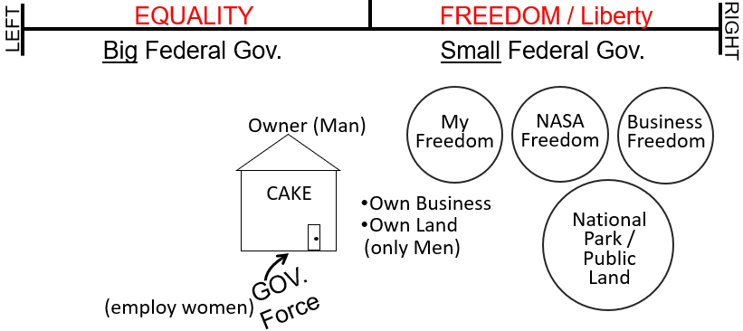
Any law that prohibits discrimination, any type of discrimination, denies freedom. This is the bar association. So, they’re using these terms of equality and freedom very accurately, very precisely. And, they are recognizing this conflict between freedom or liberty, and equality. And, any time these cases come up, the issue is which one surrenders, and if equality, if this business owner is forced to employ or to sell to or to act against his ideology, what he believes in, that violates his freedom. Equality has superseded freedom. Does that make sense? Marie.
Marie – I was just going to say, in answer to your question when they collide, who, you know, which ones correct, and I was just going to say, well, that’s when we have to go back to the constitution. And, what the constitution says about our rights as opposed to, if we do harm to another person.
Elder Tess – I agree with you. I need a moment to gather my thoughts on that. Greg. I missed you above. How’s your connection?
Greg – I’ve taken my headphones off, so I’m just using my computer. Can you hear me alright? I was just going to say when you were talking about the carpenter building a shop with only males, I was going to say that sounds like a marriage cake before you got to it. But, as far as, I think the constitution side of things is dependent on how you read the constitution. Because we know how the right reads, how the left read, how we read, and how we used to read is different. So, you can come to different conclusions depending on your methodology of reading the constitution.
Elder Tess – I agree, and I also suggest on how much you actually care what 18th century, white male slave owners thought. Do we worship and follow their exact words or do we see the point of what America was to be? I would like to suggest that the Glorious Land, one of the reasons that it is glorious is because it’s supposed to have both. We’re not against freedom. You can have sympathy; I have sympathy to the position of the right. It’s the statue of liberty, and not the statue of equality. That is what the US celebrated. From the very beginning, I’m probably getting into next week’s complications.
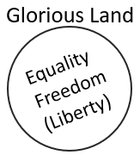
But that was the ethos of what America was celebrating, how badly they often did it. It was the statue of liberty. It was about freedom which is liberty. They were escaping control, authoritarianism, to find freedom in the new world. So, Elder Tess thinks we can see that freedom is not bad. It’s when these two collide. Because there are people on the right who don’t like racism, who don’t like sexism, who wants to see LGBT people married even and to thrive. But they believe that at the core of, at the very center, of the US when these issues invariably collide, that freedom has to win.
You will see people on the right make a kind of argument that, what if the person owning this cake shop is LGBT, and they only want to sell cakes to LGBT people. They will say, well, be consistent. This is the problem they will have with things such as women’s only spaces, women’s only gyms. They will see inconsistency with the left side. So, they will say, give everyone the freedom; just give everyone the freedom, and let society be convinced in their own minds, change in their own time, as we reason and educate them.
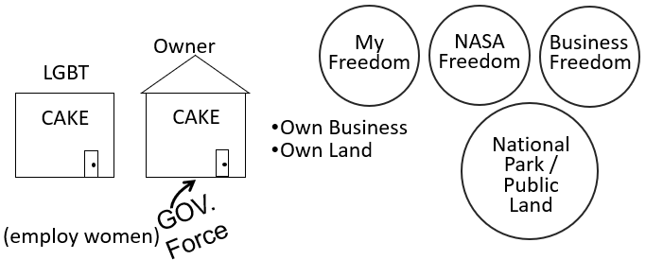
Elder Tess wants us to see, in this light, not the ugliness of freedom, that there’s a point to freedom, that there is, that someone who is LGBT and people did support the owner of this cake shop because however much I disagree with what someone says, I will fight to the death for their right, their freedom, to say it. You don’t have to be anti-LGBT people to believe that he has the right to be prejudiced. The left, however, says that he doesn’t have that freedom. He doesn’t have the right to be prejudiced, and we will have a bigger government because we’re going to push through equality. When we come back next week, we need to consider equality and freedom. If you have thoughts or questions not answered or that come up during the week, which would be good.
Prayer – Amen

