NAVIGATING THE COMPLEX

TMW VESPERS

FEBRUARY 11, 2022

ELDER TESS LAMBERT
https://www.youtube.com/watch?v=jh0jWDL11lA&list=PL6-Mv8H520RncgAlBdn_u3bAlt_kGZZhH
Let’s review how we got to this point. We’re in the process of circling, coming back to the same points over and over. We started with looking at 1888. There was a conflict in 1888, a theological debate. Before we get to that theological debate, let us see the internal division within Adventism. Let’s consider how we look at the whole of the 1888. The whole of the history within Adventism surrounding that controversial time period, surrounding the Minneapolis General Conference. To approach that complicated history, we’ve discussed how complex is the history as compared to the prophetic narrative [Boardwork 2:11] or the clichés that Adventism develops.
Where did we go to understand the reality of what the history looks like as opposed to the prophetic narrative? We went to the trumpets [Boardwork 2:11]. The trumpets looked like the following. You have the first trumpet [Boardwork 3:34], second trumpet, and at what point does the second trumpet sack Rome? The second trumpet, the sack of Rome by the Vandals was 455 AD. The third trumpet was the Huns and Attila the Hun who died in 453. So, if you want to draw what the trumpets look like, it goes first, second, the third happens within the second while the second trumpet is still blowing, and then comes the fourth. So, we can see that the history of the trumpets is much more complicated than the kind of simple prophetic story of Revelation that has one, two, three, and four. The history is stated simply, but when drawn out in its proper historical context, it’s actually, the first, the second, and the third coexisting with the second, and then the fourth which is really only one year.
Boardwork 2:11 Boardwork 3:34
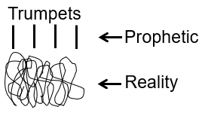
We’re not going into the study of the trumpets but simply laying out the prophetic, simple version as opposed to the reality. Even when we draw it out, it’s still not that simplistic because it’s not just four Germanic tribes that trouble Western Rome. It wasn’t like there were four tribes and that’s all the problems that Western Rome had. So, you had a complicated history of the complex reality, and then you have the very simple prophetic narrative giving God’s people a kind of a structure, just a simple pinpoint to hold onto so they know what is happening in a mess of events.
We went to the history of the trumpets only to show how the 1888 history was complicated. We have these simple Adventist catch phrases that are true. We say things like, Butler and Smith rejected the prophet; they abandoned the foundations. We have these catch phrases but we don’t understand what it looks like to actually walk through that history. This is where they see the simple to see what the Sunday Law (SL) looks like as well as the Loud Cry (LC), Close of Probation (CoP), and the Second Advent. They see these histories as simple. People make comments on her videos stating that everything that Elder Tess teaches is far too complicated; God isn’t going to teach His people or require His people to understand some complicated story of Afghanistan, Russia, and all the events; gender, LGBT. It’s just really going to be simple. It’s just going to be about the Sabbath/Sunday. It’s going to be easy to see.
Another example. The Reformation, simple. You had a noble, brave Martin Luther battling the wicked pope with the devil horns. It’s about John the Baptist; simple, clear, easy message. We’d all pass if we were there; we’d recognize the Son of God; we’d all accept John the Baptist; and recognize those evil Pharisees who refuse to see the prophecy. So, the problem with Adventism is that they just expect to see the events as simple but the reality is that when you actually walk through the history, it is much more complicated. It’s a tangled web of mess. Therefore, the Sunday Law is going to be much more complex even though we have a simplistic prophetic story.
We need to see the complexity of historical events so when we go to the history of 1888, we should be able to appreciate the complexity of the 1888 history. We need to understand the interplay of the different events in the history so that we don’t make the same mistakes of Adventism, the mistakes that the General Conference leadership made.
So, the first point of the discussion was the history of 1888. Second, we moved to a discussion of the complexity of history verses our simple prophetic, parable stories. Third point, we went from the understanding the complexity of history [Boardwork 7:14] to say well, how do you take a tangled history, whether it’s past or present day and understand it. And then, we began to discuss the lateral reading, how we research, especially using external information. Some of the principles would apply to inspiration as well.
Boardwork 7:14
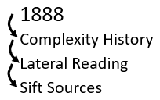
So, we made a point about needing to know the historical context to the complexity rather than just the simple so that we don’t make a mistake with the simple. This knowledge especially applies to today when we’re doing this in the midst of the information war. To do lateral reading, we need to sift our sources. This is where we really sort of diverged from our topic of 1888, which we will at some stage get back to. But this is where you take the lateral reading [Boardwork 9:01] and assuming that none of those are Fox News, these are all good sources, still we might only agree with 20% of this one and 80% of that one, 95%, 5 %, 60%, 75% etc. We don’t necessarily agree with everything that everyone says. Then, Elder Tess might take the 95% and share that on the media broadcast, but she’ll write a little at the beginning so that the people will know what is worth picking up out of that article and hopefully just don’t take the whole of it. It’s important to get to the point to what’s being shared.
Boardwork 9:01
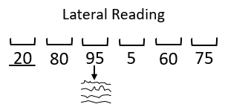
Perhaps, Elder Tess might find a good point in the 20%. For example, she read a really good article lately on foreign policy that spoke about Russia, and she didn’t believe that the 80% of the article was not worth anything but that article made one really one good point that she believed will come into a presentation somewhere, but she didn’t share the article because she didn’t believe that 80% was actually useful. The 20% was a really valid piece of information. So, the sifting of sources, we went from 1888 to understanding the complexity of history including our present-day history where Adventism is making a lot of their most dangerous mistakes. They don’t understand that the history is naturally complex.
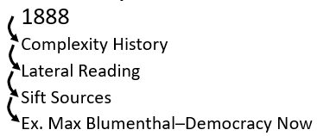
We need to navigate through the past and present events using lateral reading. And even through the lateral reading, we need to know how to sift through the materials which means we need to know how to take information and know what to take and what to leave. From there, we moved to understand the sifting of its sources, and we went to some examples which were left wing examples. Elder Tess started to explain issues with the left wing, and why she would find some sources more problematic. We used Max Blumenthal as an example, but the target of her criticism was subtly, Democracy Now. They say a lot of good things; but picking on them a little bit, she is trying to explain why a source that you would think mostly good, you should still critically sift, especially that branch of the left-wing journalism.
We got to the examples, and some questions were asked. We were discussing how to sift through the sources. By this stage of the Movement, everyone would know that this is, not all, but majority would be left-wing sources. Elder Tess posed a question, how did we, this Movement, become left-wing in the first place. We took a step right back and said, ok, how did we come to be left-wing in the first place. A question was posed in this bottom line [Boardwork 11:45] in the political spectrum with the left wing, moderate or centrist, and the right wing, where was the Movement politically from 1989 to the first three quarters of the 2018? The answer that was given, and everyone agreed, that the Movement was leaning towards the far-right.
Boardwork 11:45
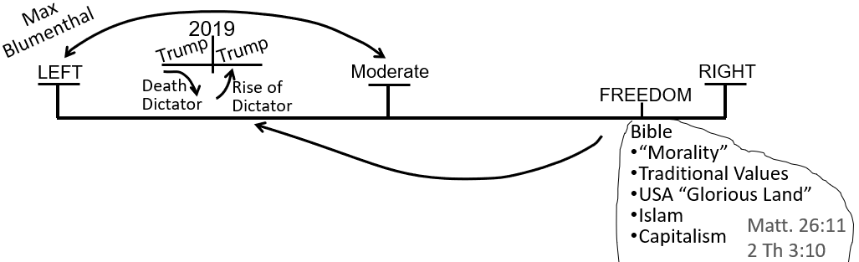
So, another question was posed. Why were we here, leaning towards the far-right? Until 2018? And we gave some reasons as to why this Movement would view the Republican Party and politically conservatism as supporting their biblical and prophetic world view. We discussed their views of morality. We stayed really general [Boardwork 11:45], traditional family values, the US as the glorious land, the prophetic explanation of Islam, and Capitalism as the way of the economy. Then, another question was posed. What moved us from the right-wing to the left-wing? What moved us in late 2018? From the right to the left? None of us were convinced by the news articles. It was a prophetic shift.
We have written down two of the four that Elder Tess wants to review. We have the first one [Boardwork 13:30], the history, but this is prophetic history. This is a reform line, particularly from 1979 to 1989 [Boardwork 13:52]; the history of the Moral Majority.
Boardwork 13:30
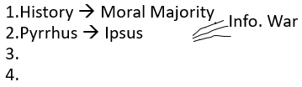
We shift from the right-wing to the left-wing just before 2019 [Boardwork 13:52]. From September of 2018 to November of 2019. One of the first of the four reasons [Boardwork 13:30] that Elder Tess wanted to list for that shift is prophetic history relevant attached to our reform line, particularly the Moral Majority in connecting Republicanism to conservative, Protestant, Evangelicalism, and seeing the union of the church and state.
Boardwork 13:52
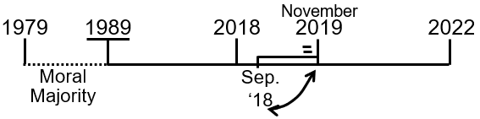
The second point took more of our time [Boardwork 13:30]. Someone mentioned that this was Pyrrhus. The history of the third and the fourth Diadochi War, the prophetic role of Pyrrhus as the King of the South (KoS). We narrowed that down to particularly to the battle of Ipsus. So here, Josephine took us back and made the point last week, swung us back to point two of our journey [Boardwork 15:02] that we’ve been on, and she said that this history is another example of where we have a simple prophetic story [Boardwork 15:11], Dan 8:8 [Boardwork 15:15] that shows the death of Alexander the Great and the rising up of the four generals. It’s another example of how prophecy gives us this beautiful simple picture that Elder Tess is grateful for because her brain can’t hold that much at once.
Boardwork 15:02 Boardwork 15:11
Boardwork 15:15
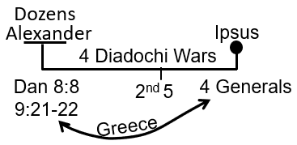
It gives us just what we need to be orientated but the reality is not that simple. The reality is much more complicated. The simple is still true. But it’s the complexity that we need to see if we’re going to navigate present day. So, Josephine took us to Dan 8:8, the time period of the four Diadochi wars, and we revised how these wars showed the complexity that Dan 8:8 makes simple. Then we went to Ipsus and showed how this second point [Boardwork 16:12] of our four moved this Movement from being politically orientated from the right-wing, conservative movement to a left-wing political position. We have shown the complexity of history from the simple models, beginning with the 1888 history to how, in 2018, began to shift from the right-wing to the left-wing [Boardwork 16:50].
Boardwork 16:12
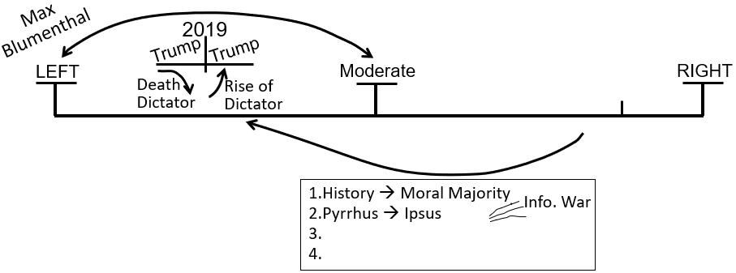
Boardwork 16:50
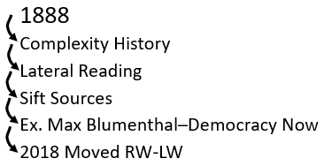
Then, we took a point, we kind of stepped away from that for a second and just made one little side point about Panium. We were still discussing how history is complicated, how the fall of Western Rome was complicated, and our parables help us navigate the complications, it helps to orientate us by giving us the very simple steps.
Elder Tess to Brendon – We took the complexity of history with the simplicity of the parable, and we took that to Panium. Lead us through, as far as you want to, understanding the complexity and the simplicity of the parables, navigating through the complexity of history, and how we took that to Panium.
Brendon – I have no recollection from last week about that particular thing but if I was to comment on it, a lot of things happened over the past six to eight months. And, it has been quite messy. Actually, I’m not sure what I’m supposed to be saying.
Elder Tess – Does anyone else remember that point that was made last week? Does anyone else have anything to contribute on that? Katherine?
Katherine – We spoke about how Panium was beginning of like a cold war period. Also, we compared it with some of the lines of the WWI and WWII. It’s a cold war. And then when we’re looking at WWII, we’re comparing Pyrrhus with Hitler. Hitler died at what would be Panium. The question then is, that means that Putin or Russia died at Panium. How can then Putin do any kind of cold war now. Is that enough for now?
Elder Tess - Yes. That’s accurate. That was what we’re discussing last week. So, we took the complexity. We know that today is complex but where you have brought us to, is the simple story. We have WWI plus WWII equals WWIII [Boardwork 21:50]. We all know that after WWII, once we get to this point in time, Hitler dies. And Hitler, in that prophetic parable that we apply to the present day, Hitler represents Vladimir Putin. So, then we ask, if Putin is alive and becoming more belligerent now, what does our prophetic parable trying to teach us? Does anyone else want to continue on from there with any other thoughts? Brendon, did that bring anything back?
Boardwork 21:50
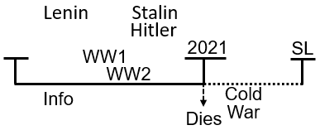
Brendon - It did. As Katherine was saying those things, it brought it back, but I’m still not too sure what the next bit was from memory. I’m sorry.
Elder Tess - It’s fine. This is where we got to the point last week where it started to move really fast, so this is why we need to do this again. Marie?
Marie – I think that you’re saying as Hitler was becoming more belligerent, so now Putin, the KoS, as he is now heading for death, he is also doing the same.
Elder Tess - We have this written as 2021 [Boardwork 21:50], and this is Panium. What date would this be in the WWII, on the lines of the WWI and WWII?
Marie – Would it not be 1945?
Elder Tess – Yes. So, we’re now in 2022 [Boardwork 24:00]. Hitler is dead. He’s not heading for death; he is dead. So, if Vladimir Putin is Hitler, can you see the problem, Marie?

Boardwork 24:00
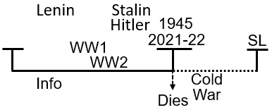
Marie – OK. He’s dead too, but his kingdom is spiraling down between Panium and the Sunday Law. So, he symbolizes death of Hitler now, but there is a progression of his kingdom being destroyed.
Elder Tess – Sure. I think that’s touching on points that we might expand on a little bit more. Josephine, you had your hand up?
Josephine – I was going to make a point about, I’m too ahead of the point that you’re making now. So, I don’t want to say it just yet.
Elder Tess – Do you want me to come back to you? Raise your hand again at the moment when we get to that point. I want to hear your point. Brendon?
Brendon – The dilemma is, you’ve got the death of Hitler or Putin and yet in the external events, Putin appears to be getting stronger.
Elder Tess – Great. You’ve really articulated well our problem. Now, we want a solution.
Brendon - So, at that point, I can’t get to the next point. Sorry, Elder Tess. It’s dropped out of my mind.
Elder Tess – That’s fine. Raymond?
Raymond – Isn’t it like Hitler was symbolizing the KoS? So, we see him die, and the KoS switches to Stalin. No?
Elder Tess – No. Stalin has, they don’t switch through that history. Not in this parable [Boardwork 24:00]. You could put it in there but I don’t think that’s what the parable is trying to teach us. I don’t think that’s where it’s going. Katherine?
Katherine – We talked about 2019, which is on the board [Boardwork 27:37], and we talked about how we have the death of a dictator marked there but from another perspective we could also see the rise of a dictator, and both Trump and so we had to work out how that could make any sense and that makes sense because it marks the changing of his behavior at that point. So, we use the same principle then for 2021, we can see that there’s a change of behavior, possible there at 2021 in a same way.
Boardwork 27:37
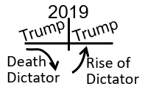
Elder Tess – So, what prophetic parables were we going to here [Boardwork 27:37]? What study is that part of?
Katherine – Revolution? I don’t know if it’s revolution but like Napoleon.
Elder Tess – Yes. It’s the lines of the Revolutions. So, from 2018, we’re teaching that Trump dies in 2019. We’re teaching that he dies, and there’s a new dictatorship. But, all the way through we never taught that that was someone other than Trump. So, what were we teaching about the death and resurrection of one man? To remind us, on the lines of the revolutions, in the lines of the French Revolution, we have two applications, the Russian revolution, the German Revolution, the American Civil War. We see that there is at that way mark, there’s a death and resurrection of a dictator. We know that it is Trump who dies and Trump who resurrects. So, it is symbolizing something. Josephine, have we come to your point?
Josephine – I think that Katherine made it, because I remembered her making that point last week. And I remember the point for this week but, I think she’s made it about Trump dying. But when he rises up, he’s going to be worse than what he was before. So, with the sixth kingdom, I don’t know. In my mind, when the sixth kingdom goes down and it’s going to rise up, the kingdom’s going to be worse.
Elder Tess – So, you’ve expanded the point quite a bit there. This is Trump dying [Boardwork 27:37], and this is Trump resurrecting, and this is the change, a simple story trying to tell us that there’s going to be a change of behavior. So, you brought us to the story of the sixth kingdom and the seventh kingdom. You’re telling us the story of not an entirely new entity. It’s the same entity but what we’re teaching through the end of 2018 through 2019 is that all that this is symbolizing is the changes of behavior, not this simplistic narrative of one dies and one resurrects, one kingdom crumbles which doesn’t really happen in an era of globalization anymore. And then a whole new one rises up. This is not what it’s talking about. It’s talking about the fact that Trump, in the history of his first impeachment was going to radically change in his behavior. He was going to die as one type of dictator because we already knew that he already was one, and he’s going to rise up as a new type of a dictator.
We have spoken before about the stages that it took for Russia to turn into this authoritarian state power that it is now. It didn’t all happen in 1999 when Putin became the prime minister or when he became the president or when he took over from the oligarchs or when he took control over the state media or the internet, or when he changed the Russian constitution. At what point did Russia transform into an authoritarian state? You could argue, none of them. Elder Tess would argue, all of them. What we’re tracing, what these parables are teaching us is these step-by-step changes that are occurring in the stories of the histories of the revolutions, occurring within the US. Moli, you had your hand up.
Moli – I was just, I’m looking at things concerning Hitler. I thought that when Trump was resurrected, he was reflecting the character, it was the transformation of the character of Trump before when he died to Hitler, when he resurrected, become a tyrant.
Elder Tess – You see that he’s still the same person. He hasn’t radically changed, but he is emboldened. He was fascist before but now when that first impeachment takes place, and when he finds that after all that he did, they can’t physically remove him. He still has maintained his power base. The loyalty of his people, the loyalty of the Republican Party especially, he’s that much bolder, and he also now feels like more of a victim. So, he’s angry, and he’s emboldened by that first attempt to remove him from government. So, yes. We’re seeing that worsening. This is what this parable is trying to teach us when we come to the revolutions.
Boardwork 34:04 Boardwork 34:13
So, if we take that from the revolutions, the death and resurrection of fascism [Boardwork 34:04]. We bring that down to this story of Panium [Boardwork 34:13], and we’re still not really going into Panium. We’re going to pull us back from that soon, get us back to this switch from the right-wing to the left-wing. Elder Tess wants to pull us back from this in a moment but we’re just expanding on the thought about how simple our stories are. They have to be to try and help us understand the complexity of what is happening because it reminds us that Adventism believes that the trumpets look like this (straight forward), and not this (a complex mesh of history). Therefore today, they expect present day events to be straight forward when in actuality, it is complicated. The straight forward is the prophetic narrative, but the reality is the intertwining of stories. Not that the prophetic isn’t reality but I hope you can get how Elder Tess is using those terms.
So, Adventism has today real difficulties. They can’t approach Donald Trump, the Republican Party, Russia, global politics, the pandemic. They can’t approach any of this from a prophetic position. They’re trying to take it from a moral position. They’re trying to be unifying rather than divisive. They have all these different divisions within them because they can’t look at present day events prophetically. Does someone want to take what we’ve just said about this history (Trump of 2019) [Boardwork 35:45] and take it back to Putin, 2021 [Boardwork 35:47]? Graham? Would you like to do that for us?
Boardwork 35:45 Boardwork 35:47
Graham – So, 2021 is Panium. What we’ve said in the past in simplistic terms as the overthrow of the KoS, but it’s also a changing of authoritarianism or dictatorship which is the same person. Vladimir Putin, just becoming more aggressive in his actions and particularly, at the moment we see throughout Ukraine. I’m not sure if that’s what you’re after.
Elder Tess – Yes. That is exactly what I’m after. You’re seeing the death and resurrection. We know that the KoS fought an information war from, could we say 2003, from the history of the Iraq war. There has been this conflict which we call an information war between the West and Russia, growing in intensity. When we say that Putin dies in 2021, we’re symbolizing him with Hitler. We also know that beginning at Panium, a cold war begins between Putin and the West. Therefore, he can’t be dead. We know he’s not dead because he is waging a cold war now and that’s what our prophetic narrative laid out for us, that there would be a cold war from Panium to the Sunday Law.
So, this death symbolizes, just like it did with Trump, it’s symbolizing a change of behavior. A change of behavior that is moving from the context of an information war to that which is more accurately symbolized as a cold war. We said that that would happen in the late months of 2021. Now there is overlap. It’s complicated. There’s a lot of overlap between saying something is an information war and saying that something is a cold war. Especially in the way that war is fought now, there is lot of information war in a cold war and quite a lot of cold war in an information war. But we hope that if we look externally at what is happening right now, this is the largest troop mobilization since the end of the cold war that’s been happening since the late 2021 on the Ukrainian border. There is a change of behavior.
So, a complicated present-day history taking us up to the Sunday Law; simple prophetic parable to help us step through that history and know where we are at. Josephine?
Josephine – I just want to ask a question. So, we’re looking at Ukraine and Russia, and we’re looking at NATO and America and the British, sending troops, lining up there. But we know, is it correct for me to say, that we know that it’s going to be a cold war and not a hot war? Or, am I sort of assuming?
Elder Tess - The original points that were made about the information war, I’ll just explain the context a little. Raphia and Panium were already being taught in the Movement by the end of 2018. And, partly because of the complexity of the present-day history after the invention of the atomic weapons wasn’t really being understood prophetically or with prophetic glasses. The people within the Movement were expecting Raphia and Panium to look like Russian tanks embarking, disembarking on Florida’s beaches and Russians pouring on with semi-automatics and machine guns, and bombs flying into Moscow. They’re expecting a hot war between the two super-powers. Russia and the US, direct hot war.
So, when Elder Tess started teaching that it would not look that way; that this was a war centered on information, disinformation, and manipulation of information, that didn’t discount war entirely. We know that we had Iraq, Afghanistan, and Syria, just to name a few. So, she is not suggesting that there won’t be military conflict in Ukraine or in other countries, that it won’t get very volatile between Russia and the West. What the whole context of us fighting against hot war was that hot war at that point in time in 2018 in the Movement meant essentially Russian tanks on US soil. Does that make sense?
Josephine – Yes. Thank you very much. That’s really clear in my mind.
Elder Tess – There can be proxy wars within a cold war. It can look quite heated at times. But with both globalization and the invention of nuclear weapons, the point of teaching on information war was first of all, 1989 was the invention of the World Wide Web (WWW). Disinformation has been weaponized to an extent never seen before in the earth’s history. And that is the most dangerous form of warfare today, and it’s also the form of warfare that we find internally and in the context of the Great Controversy. It centers on information streams. Remember that this is 2018, we’re teaching two streams of information for the first time, and one of our evidences of that is the external way the war is fought now: Two streams externally, two streams internally. This, however, does not mean that there is not an armed conflict. We’ve seen that in Iraq, for example.
So, Putin, he is facing difficulty in 2021. If we know what happened with Navalny. Putin is very threatened especially internally in 2021. And with his imprisonment of Navalny, we know the protests of 2021 was so full. Elder Tess thinks we can easily forget what took place in 2021, but what is particularly marked is a change of behavior. It’s not like information war ended in a cold war. Information war extends all the way through the end of earth’s history. It is trying to show us in this complicated mess of external events that we need to expect to see a change of behavior, and we saw that. Is everyone ok with this if we leave that there? If we leave 2021, and we move on?
Elder Tess stopped here and made a point about the Sunday Law. We might just revise [review] that quickly. Does anyone want to revise [review] that for us, to take the complication of history, take what we did here, and we went to a Bible verse, and from the Bible verse, we made a point about the Sunday Law. James. Do you remember that?
James – Was this last week’s study?
Elder Tess – Yes. But I know that it moved quickly at the end so if you don’t want to or if it doesn’t recall easily, that’s fine. If you can think of any… Oh, you weren’t on last week. Sorry.
Elder Tess – Is there anyone else? Katherine.
Katherine – We looked at Dan 11:40.
Elder Tess – Can you read for us the relevant parts?
Katherine – It had to do with the many being overthrown. Do you want me to read the verse? I can bring it up. Dan 11:40-41. “At the time of the end, the king of the south shall push at him and the king of the north shall come up against him like a whirl wind, chariots, and horsemen, and with many ships, and he shall enter into the countries and shall overflow and pass over. He shall also enter the glorious land and many countries shall be overthrown. But these shall escape out of his hand, even Edom, Moab and the chief of the children of Ammon.
Yeah, the many; the many being overthrown [Boardwork 47:00]. We’re talking about the Sunday Law, and we know that many will be overthrown of people that are in God’s kingdom which means in this Movement because to escape, to be taken out of God’s hand means you have to be taken out of this Movement. This is my understanding, and so many will be overthrown means that people will be lost at that point, and the question was posed if we predicted something really dramatic, visible like, something you could clearly see, and it happened like balls of fire out of the sky or something like that. If that was predicted and that actually occurred at the Sunday Law, who would leave the Movement because you would see that fulfillment, and so you wouldn’t even leave the Movement if you had some grudge with the leadership or some issues with something that had to do with the message or something to do with equality or issues of gender or whatever. If it was that sort of easy to see, you wouldn’t leave. So, how can people be overthrown? It implies that it must not be so visible as that. Otherwise, they wouldn’t leave.
Boardwork 47:00
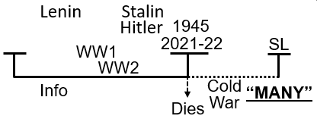
Elder Tess – That’s spot on. Is there anything else you wanted to add?
Katherine – No.
Elder Tess – Brendon. You raised your hand. Were you going to say something? Were you going to, kind of say what Katherine said that reflects what your thoughts were?
Brendon – Yes.
Elder Tess – Can you repeat that in your own words? Explain in your own words on the Sunday Law.
Brendon – So, if many are overthrown at the Sunday Law, therefore, most people in the Movement do not understand what it looks like. It must be so messy, and if was such a clear-cut event like fire balls hitting an American city, like what Elder Jeff predicted, many wouldn’t be overthrown. So, we know that prophecy can’t look like fire balls falling out of the sky. So, exactly what you’re going through now is exactly what prophecy looks like. It is very complicated. It’s what you’re saying and I guess, since many people are going to be overthrown, it’s not going to be easily seen.
Elder Tess – Both of you hit the nail on the head. That is a good revision [review] of what we said. Dan 11:41. Many inside the Movement are overthrown there at the Sunday Law. There are hands up, and I want to hear them. Josephine.
Josephine – If the people in the Movement that are overthrown, what about the many in the Adventism as a whole? Because they don’t understand this complicated history. Would they be overthrown?
Elder Tess – It’s complicated because we teach that Adventism is shipwrecked at the Sunday Law, don’t we? But I think taking those other parables aside, what we take from 41, kind of in the context of the verse, is that to be overthrown you have to be standing. And in the context of Acts 27, Adventism is standing till the Sunday Law. Again, it gives us a simple story of Adventism that other parables help break down for us. With Dan 11:41, we teach that that many is members of the Movement because it has to be people who are [standing], you can’t overthrow someone who’s already overthrown, and it would be like sending people back to Babylon who never left. Does that make sense?
Josephine – Yes. That makes a lot of sense because as I don’t know, I’ve been studying Acts because I’m delivering it, the last part of it. So, I wanted to make sense of that, and how it compares to many here in Dan 11:41. And like you said, I understand it very well now.
Elder Tess – That was a good question, but I think that sometimes, so we don’t become tangled, we need to divide up our parables, and Acts 27 is, I love that parable so much, but it can entangle with some of the others. For example, are we within the conference structure all the way to the Sunday Law? It teaches us couple of points very well, but in a very narrow, specific fashion. To not become tangled, we need to divide, and kind of keep the two separate. Graham, you had your hand up.
Graham – I didn’t hear Brendon or Katherine cover it but I just want to bring out the point of fear. So, fear is something that is missing when you have the comparison between the complicated play of human events that we see now leading up to the Sunday Law and that the Sunday Law, compared to the fireballs or something coming out of the sky. So, when you got that fear that keeps you in the Movement. In the other one, the fear is gone. So, where do you lie now?
Elder Tess – I kind of see fear in both but different types of fear.
Graham – I guess so. The way I was viewing it is the prophesy neatly laid out in the structure gives you this fear of God, and for me I almost see this fear being removed when we see the events, we see taking place around us today and understanding that we’re growing with the complicated play of human events. Not that there’s not fear there but it doesn’t seem to be something that stops you making a decision whether you stay or go in the Movement.
Elder Tess – So, we have security in understanding. Is that what you’re describing?
Graham – Yes, I think when you have a more holistic understanding of events that are taking place around us, it sheds that fear, but in the fear some sort of event taking place that is visible and predicted, that fear is there that keeps you within the Movement. It seems to be a dividing piece.
Elder Tess – It’s very emotional, isn’t it, in a way when you’re just looking for such an event? So, I agree with you. I think I need to think about that some more. I think, not discounting that, I think that some people though can also find a comfort in thinking that it’s just going to be simple. And then, it’s a comfort that we don’t really need to understand everything. We don’t need to worry too much because we will just see it, and when we see it, we’ll just do the right thing. If it’s just Sabbath and Sunday, I’ll just see it in congress, and then I’ll keep Sabbath anyway, and then my salvation will be secured. I think shaking people from that can also cause a different type of fear as well. It can be securing to feel like God has shut every door, every kind of way out of salvation and not given us any room to hang doubt upon. That would comfort me. But I know that God hasn’t, and there are hooks for my doubt. But I think we’re describing two quite different types of fear. It is good to bring fear into the discussion.
Just to add on a couple of thoughts with what was shared. I see we have this picture of WWI [Boardwork 57:05], WWII or kind of overlapping. Again, it’s a little bit complicated. But we see this conflict between Putin and the West through all of this time, particularly from the George Bush era. George Bush Jr. through to 2021. And then, we’re going to see end of 2021, this radical transformation where Putin, and really, it kind of came as a bit of shock to many because Biden was soft. He was soft on Putin because he was going after Xi and China. But then, all of a sudden, there’s this escalation, and they are calling it the new cold war. And it’s the greatest troop mobilization for sure since that time period.

Boardwork 57:05
Then, we come to the Sunday Law of Dan 11:41, and again, Elder Tess just wanted us to see the past, in the past we see our parables teach this (simple) [Boardwork 58:13] and reality is this, (complicated); but the parables, they are what anchor us. We’re anchored by understanding these first four trumpets. Otherwise, how would we know how Western Rome fell? It would just give us a headache, and then we wouldn’t be sure. It helps to explain Western Rome fell looked like this. Greece fell kind of look like this. The US is falling. Russia’s falling, and then we have parables to illustrate that. But, the reality of walking through that history does not look exactly like the simple. You can see it enough to be anchored. We can see enough that the end of 2021 to be anchored. That’s the whole point of it. But what we don’t have is no room to hang our doubts. What we don’t have is just a simple story to explain a simple history, because history and present day is never simple.
Boardwork 58:13
So, when we come to the Sunday Law, many are going to be overthrown. So, if Elder Tess stood up tomorrow and say, “Balls of fire are going to fall on Nashville, on Feb. 02, 2026, and that will be the day of the Sunday Law. What Elder Tess is saying is a simple prophecy, and it’s going to look simple. But, that’s not how it works. And then, when we get to that date, Feb. 02, and balls of fire fell on Nashville, I wouldn’t leave, you wouldn’t leave. She doubts that anyone would leave because your faith is anchored on the external event; your faith is anchored on seeing simple prophecy, simple parables that explain simple history. But this is where people get tangled if their faith is hooked on seeing simplicity; clarity and simplicity. It’s clear, but you have to see the complicated play of human events.
If we describe how a Laodicean mindset would view the Sunday Law, discounting what we should be learning, have learned, and have been learning by now, what do we think happens at the Sunday Law? We think Putin dies, because isn’t this like a deadly wound and a death? Putin dies; simple, right? Russia dies; simple, right? US turns fascist; church and state union. Simple, right? And then what do you think begins? Many of us would probably say, “No. We know that isn’t the truth but what we might envision is world peace. Conflict, fall of the KoS, US a dictatorship. And then, what do you think happens after the Sunday Law? It’s just world peace, essentially, because the US is running everything. We should consider that it doesn’t look like that at Panium, and it doesn’t look like that at the Sunday Law.
Do we really think that Xi in China, who has called Putin his very best friend in the whole wide world, his best friend, is just going to let Russia dissolve and let Putin be humiliated by the US? Do you think that the North Korea is going to let that happen? North Korea is seeing conflict and is now testing and demonstrating its weapons arsenal in a way it hasn’t done in years. Iran is acting belligerent, and if it chooses to go ahead, it can have a nuclear warhead in approximately three to four weeks. They have been in this stage for a while. They could head for it, and they could have one in three to four weeks. Israel has essentially said that if US doesn’t stop Iran, and we think that they’re going for it, we’ll go to war with Iran without you, now that we have nuclear powers. We have regional conflict with massive weapons.
If we think that the Sunday Law and some type of the fall of the US is going to bring about a type of world peace at the Sunday Law, Elder Tess suggests that we’re in for more trouble than we can imagine. If we think that the progressives in the US is just going to see the rise of fascism and not fight back, we have a little bit more trouble ahead of us, more than we can necessarily imagine. But we know that God gives us parables and prophetic light for the dispensation that we’re in. We needed to understand 2001 to 2021. That’s [part of] the Early Rain (ER) of the 144K. So, from 2001 to 2021, that was the time period that we were walking in, so that is the time period God had to give us prophetic light to understand. Now, we’re walking from 2021 to the Sunday Law. The point is, we’re walking in a new dispensation.
As we walk from 2021 to the Sunday Law, we have more to understand, and when we get closer to the Sunday Law, we don’t necessarily have complete clarity on what the history after the Sunday Law looks like. We’re not changing what we have taught in the past, but seeing that as we get closer and our vision clears, these waymarks are complex. And we’re not heading towards global peace. This brings us up to what we’ve discussed in last week’s class. From 2001 to the Sunday Law is the ER for the 144K. We’re tangled there, but we’ve still had these changes in dispensation, and we still aren’t into the Sunday Law itself to see exactly what that looks like. We’ll have that clarity when we need it. Does anyone have a comment or a question? Does that make sense? Marie?
Marie – I just want to clarify; is this still a death at Panium for Putin, leading up to the Sunday Law? You sort of spoke about China not allowing him to be defeated. I know that you’re trying to make a point, but I just wondered from a simplistic prophetic picture, is this still the case?
Elder Tess – Yes. I’m not trying to change what we’ve taught in the past. What I’m trying to do is to have us discuss and consider what these things look like. I found a quote that I really liked. This is a completely different topic. It’s dealing with 2014, Gamergate. There was an article written in 2016 about Donald Trump and the 2016 election. In 2014, Gamergate, the events relating to the alt-right, were not taken very seriously. By the end of 2016, what they’re saying, what they’re seeing is that they can now trace what led to Donald Trump. Now you could take from 2009 and the Tea Party. You could take it through few different waymarks. But, this article in 2016 referencing Trump’s election it says, “Everything we’re seeing now had its precedent two years ago.” Now, two years ago, in 2014, people can’t see that those events are going to lead them to Trump’s fascism, Ipsus, and the fall of the US.
But, once we get on a little further in history you can look back and say, Oh yea. That’s how US fell. So, when we get into the future history, Elder Tess thinks that we should be already be able to look back and see that what Putin did at the end of 2021, first of all, it was quite unhinged. Secondly, it’s not something that he can come out of successfully, not saying what it would exactly look like. It will be a failure, but it’s not something that you can just come out of successfully. His steps have been political suicide. It has been very unhinged. When we trace the decisions that have been made, the conflict with the West, Elder Tess believes that we will be able to trace his fall. Especially, what he had done at the end of 2021. What does that fall look like, and what do we call a complete fall, in this time period, in this context with globalization and the backing that he has.
Just to take what we have already discussed to this story of Panium is talking about the deadly wound and death is really simple. What that actually looks like is complicated. 2014 is a really good example. We see that at the Sunday Law, the US is fascist. We look back at 2014 with the benefit of hindsight now and we say, yea, that was a real key point, a turning point when the US started to fall into fascism. We can already see by the end of 2016 that everything that they were seeing under Trump had its precedent in 2014. Sometimes, it takes time to understand the complications and the steps of how that became a political fall. Does that make sense, Marie?
Marie – Yes it does. Thank you. I just picture Putin hanging on tooth and nail because we know, we have the lines. It just seems like he’s hanging on tooth and nails because he knows that he’s dead or dying. The reason why I picture it that way is because we have the lines to show us.
Elder Tess – Yes. I wasn’t really meaning for us to go right into Panium in these classes. We’ll do that in the future in camp-meetings and in different meetings. I do think that we can see, my only point that I wanted to address is that in a kind of a simplistic fashion was the change of behavior [Boardwork 1:10:30] showed us the fall into fascism of the glorious land, a waymark in that fall. That was all in the lines of the revolutions. But when we take it down here [Boardwork 1:10:40], we see a change of behavior in Putin that will have a political impact. We need to see the complications, especially when we see that this is not Russia vs. the U.S. on its own. Simply, yes. Complicated story, no. This is the West v. Russia, China, North Korea, Syria, Iran, Venezuela, etc. This is one of the complications.

Boardwork 1:10:30 Boardwork 1:10:40
We need to expect to see the Sunday Law and the history through that as complicated. Just like the fall of the Western Rome; just like the fall of Greece; just like our parables are teaching us. We need to be careful not to get lost in the complexity. The simple is still accurate. We’re given the simplistic narrative because God knows full well that if we only have the complexity [Boardwork 1:11:34], we’ll be lost. We won’t know how to orientate ourselves. We’ll have no idea where we are. So, we need to hang on to the simple. We need to hang on to the lines and the parables. Without them, Adventism has no idea where we’re at in the world history.
Boardwork 58:13
They are valuable. They are not to be diminished. But we do need to see that it is complicated or we won’t believe that these parables are accurate. We made our points about the Sunday Law, and if it was any less complicated, Elder Tess doesn’t think that people would simply leave the Movement over doctrinal disagreements. If they could hang on to a ‘fireballs over Nashville’ anchor for their faith, they would. They won’t have that. They didn’t have that in 2014. They didn’t have that in 2019. They didn’t have that in 2021. And, they won’t have that for the Sunday Law. We have to be anchored in the parable and the message.
Prayer – Amen.

