THE COMPLEX AND DANIEL 11:41

TMW VESPERS

FEBRUARY 18, 2022

ELDER TESS LAMBERT
https://www.youtube.com/watch?v=pz8IJr9FMH4&list=PL6-Mv8H520RncgAlBdn_u3bAlt_kGZZhH&index=21
Does anyone have any comments on what we covered last week? Josephine?
Josephine – The list on my right hand [Boardwork 1:07] which is your left hand near the right, Bible, morality, traditional values, USA Glorious land, Islam, Capitalism, that list there, right at the bottom, is that what we believe or what the right believe, or we believe together with them? Who believes that?
Boardwork 1:07
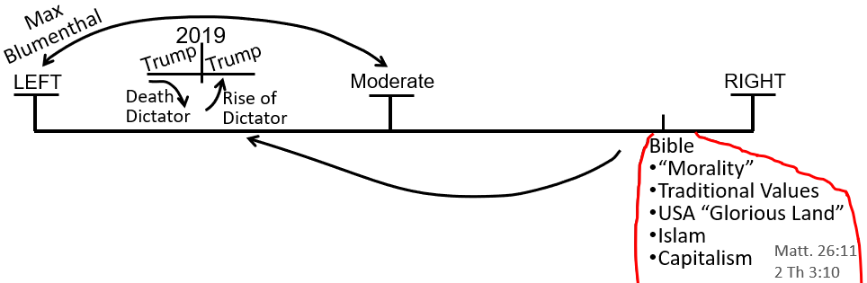
Elder Tess – When we think of Protestantism today, we know that they are split. They were split over slavery in Millerite history; and they’re split today, but the part of Protestantism that is vying for political power is the right wing. They are on the right of the political spectrum, and this is what we have behind us is the political spectrum. So, it’s the right-wing Protestants that are trying to push their religious views, their biblical perspective through the state. So, a liberal Protestant might believe in gay marriage, but that isn’t really a Bible-centered view that they have. They just might think that people can do what they want now.
They might believe that their morality should be separate from state law. So, they might believe in separation of church and state; separation of their own church and state. So, a liberal Protestant might view it that way but it’s the conservative branch of the Protestantism that is trying to impact politics today, which we saw under Donald Trump. So then, we asked, well what is it that a Protestant would look at in the Bible to say, our right-wing view, our republican conservative political views are supported by what we read in the Bible? Elder Tess would suggest that Adventism and this movement fit in with Protestantism.
Protestantism, Adventism, and this Movement (as it was part of Adventism), all were leaning towards the right-wing of the political spectrum. And Protestantism, but also Adventism, and this Movement, up until late 2018, they all believed that their biblical views supported their political leanings. So, what biblical views supported a right-wing political leaning? And then, as a group we listed them. Views of morality, general term; we were very general, covered a lot of things like traditional values of the family, of the home, husband head of the household, etc.
USA, the glorious land, is a biblically supported view that the right wing would have that Adventism has and this movement has; the views of Islam that Adventism, this movement, especially this movement has seemed to be supported by the biblical narrative. And a republican like Ted Cruz would say that his capitalist beliefs are supported by the Bible, and we gave two verses for that. So, this isn’t what we believe certainly not now. I don’t believe that the Bible supports the capitalist system. I don’t think it’s easy to pull one simple monetary system out of the Scripture and put that on to today. The book of Ruth is a classic example. But, this is what the right-wing Christian conservative would believe. Does that make sense, Josephine?
Josephine – Yeah. Thank you very much. That was very clear.
Elder Tess – I’m glad. If it becomes less clear, ask again. We can go more into it. But that’s really where we started. We saw that we were here [Boardwork 6:05], right leaning, up until Sept 2018. We would have learned that at 2018, we had a problem. We looked a lot like Protestantism, don’t we? And, we’re getting awfully close to the SUNDAY LAW, and we started to see 1989, World Wide Web (WWW), information war, and two streams of information. Because you asked a question last week on something related to information war. And this is all tied to that. We saw that information war. We saw the two streams.
Boardwork 6:05
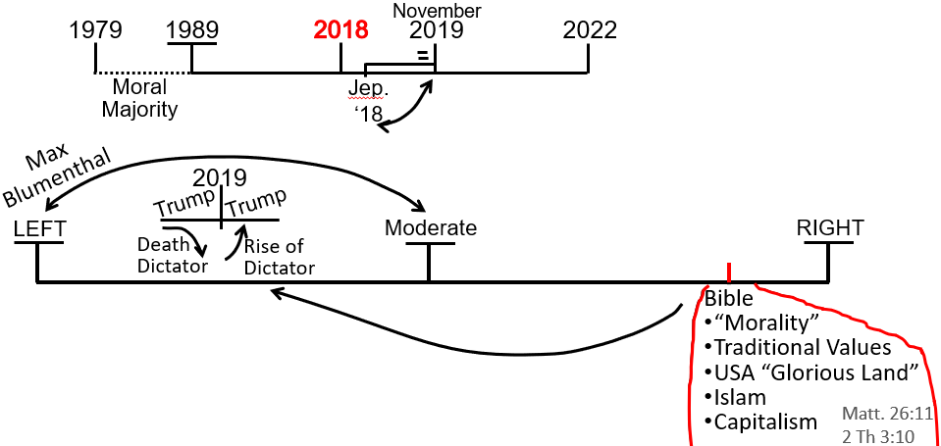
We saw that Adventism was in the same stream as the conservative Protestantism which is really in the same stream as Catholicism, mainstream conservative Catholicism. This movement needed to be able to finally divide between what is biblically supported and what we’ve imbibed from the wine of Babylon, from 126 years of drinking in Protestantism which puts you here, on the right-wing. So, we got divorced from this Protestant kind of stream and we ended up in the left-wing, and we’re seeing how we did that. If anyone else has a thought or question that they thought last week that they wanted to speak about, and we always run out of time?
Rachel - On that line that you’ve got, left, right, and the moderate, we know where we were close to that right. But, on the left side where would you place us now on that left side?
Elder Tess – That’s a loaded question, Rachel. I don’t think that we can really trace that until we start unpacking the left-wing, and I think that there is where we’re heading. We’re heading into that discussion of unpacking this left side [Boardwork 8:22]. We stepped back and asked, why were we on the right, and what moved us from the right to the left? But our original question was, how do we divide up the left side? So, we’re heading there. Is that vague enough for the moment?
Boardwork 8:22
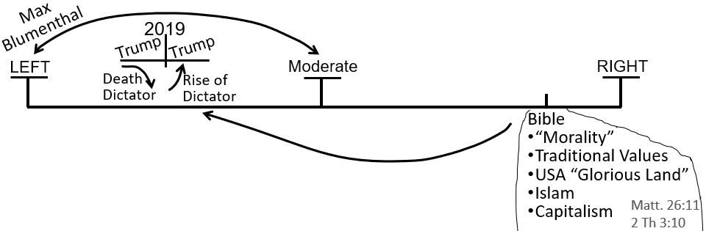
Rachel – That’s very clear. Thank you for answering that.
Elder Tess – I disagree. I don’t think that was clear at all, but it’s a promise that we will head there. I just want to repeat the thoughts about the complex and the simple if no one else has anything they wanted to say. I’ve been trying to think of a simpler way to say that; to describe that. And, I really don’t mean to discredit the simple. The simple is beautiful. The problem we have with the simple is if, let’s say that you have something fine such as three strands of wire, just little intertwined wires. If you just have these three little wires, they are so easy to be bent out of shape. It is easy to take it and warp it. This is the problem with the simple. There is nothing inherently wrong with the simple model. The problem arises when we have a simple model, and that becomes very easy to manipulate and be bent out of shape. Does that make sense?
Elder Tess wanted to give a few more example. The word that she was looking for is to distort. The problem with our simple model is that it’s so easy to distort them. If they were kept in their proper frame, they’re perfect. But it can be bent and distorted. So, question. You go to the Gospels. We argue that this is the problem that ancient Israel had in their own history. So, we should automatically think that if that was the problem that ancient Israel had in their omega history, that’s the problem that modern Israel should have in their omega. The problem was that ancient Israel had a simple concept of the Messiah that was coming, and what he would do, what he was all about, what he would look like and act like. They had a simple concept, and they got that from the Inspiration.
So, it was perfect. The problem was, because they saw the simple, they bent that out of shape, and they distorted it. So, what was the simple? If I was to say, locate the simple that they had in the New Testament, where would you find it? We’ve done this in a presentation, but I’ve only done it once. So, if you don’t recollect, that’s fine. But, if you were to go to the Gospels, where does John the Baptist get his simple model from? Where would you find it? Marie.
Marie – I don’t remember what you have said. So, it’s a guess. But I’m guessing Revelation?
Elder Tess – I was heading more towards what John the Baptist had that would’ve distorted his view. I would go back to the Gospels. Does that make sense? Revelation comes after. We have a distorted view; like you saw the trumpets. We get this simple lay out of prophecy. But if we were to take just John the Baptist as one man, first angel doing his work; what perfect, simple prophecy was John the Baptist given?
Marie – I’m sorry. I just didn’t think about that. I’m guessing then Daniel 9 or Isiah.
Elder Tess – I think you’re right but I was looking for one in the Gospels to narrow it down, because otherwise, you might find a few. If you’re not sure, that’s fine. Josephine. You had your hand up?
Josephine – I was thinking, wasn’t his father a priest who worked in the temple, and wouldn’t he have had the same ideas as the priests, the leadership?
Elder Tess – Yes. So, John the Baptist gets his views from his father, and where does his father get his views from?
Josephine – His father gets his views from all the priests that inherit the ideas of all the leadership.
Elder Tess – Yes. Not the answer I was looking for but still correct. Where else did his father get his views from? What did his father have?
Josephine – The prophecy of the coming of the Messiah, the King?
Elder Tess – Yes. And, where would you find that?
Josephine – You mean in the Old Testament or in the New Testament?
Elder Tess – In the New Testament. You said that his father had a prophecy.
Josephine – Didn’t the angel come and said to Mary to give birth to a…
Elder Tess – So, there is the visit of the angel. If you go to Luke 1, it gives a story of the birth of the John the Baptist, all that leads up to that. His father is punished in a way for his unbelief. Then, you come down to verse 67. Luke 1:67. Zechariah’s prophecy. Katherine. Is that where you were heading?
Katherine – Yes. That was where I was heading.
Elder Tess – Tell me your favorite verses that the father of John the Baptist would have taught his son. What are the most problematic verses that you would consider there? Verse 67 says, “And his father, Zechariah was filled with the Holy Spirit and prophesied.” So, this isn’t just his father feeling emotional and deciding to have a speech. This is the work of the Holy Spirit. It’s described as a prophecy. So, through that prophecy, what verses do you want to pick up on, Katherine?
Katherine – Verse 71 is pretty good. “That we should be saved from our enemies and from the hand of all that hate us.” And verse 74, “That he would grant unto us that we’ve been delivered out of the hand of our enemies that we might serve him without fear.” There’s 76. “John would be a prophet and go before the face of the Lord, and prepare his ways.” Verse 79 speaks about guiding their feet into the way of peace. Those are the ones I’ve noticed anyway.
Elder Tess – So, 79, “our feet,” who do you think the “our” is? Whose feet?
Katherine – Israel’s feet, sounds like to me. Verse 79. “Give light to them who sit in darkness and initiate it to guide our feet into way of peace.” I just thought that they might see that as the nation of Israel having peace from the Romans.
Elder Tess – So, you get to 70 A.D. and be pretty confused, wouldn’t you?
Katherine – Yeah. For sure.
Elder Tess – So, those are the verses that I think I would’ve picked as well. Especially verse 70, that he spake by the mouth of His prophets, that God spake through prophets from the beginning of the world. Verse 71, that we Israel should be saved from our enemies and from the hand of all that hate us.
So, there’s a Messiah coming. He’s going to lead Israel into peace because He’s going to save them from their enemies the Romans and from all that hate them; to perform the covenant, the oath that He swore onto the father of Israel, Abraham, their blood lineage. It’s clear, isn’t it? It’s so simple. It’s so simple and beautiful and clear. Lynne, I see you smiling and nodding.
Lynne – Yeah. I was only going to say something similar, along the lines of that they had a Redeemer. They were promised a Redeemer to deliver them, and that was their focus. So, they all were expecting a political leader, a king really. Something like an Apis Bull character to come and save them.
Elder Tess – Exactly, and it’s so clear that’s what they were to receive. For me, if I was there, I feel like that was really simple. And then Jesus comes along and says, yes, but who are your enemies? And what does ‘being saved’ look like? And all of a sudden what Zechariah was told and then what John the Baptist was told, and then what the John the Baptist taught, and what all of Israel thought, looked so simple; but all of a sudden, it looks very complicated; very messy. You have the story of the New Testament and the end of ancient Israel, because the complication of the history completely swept them away. So, this is the problem with Adventism today. It’s so simple; just look out for that Sabbath/Sunday issue, right? Just look out for God saving His people through the history of the unifying of the socialist dictatorship, apparently uniting church and State; taking away your rights. Simple.
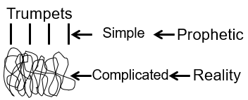
The problem with the simple like the prophecy that Zechariah had is you take something simple like, I’ll destroy your enemies, I’ll save your country, and I’ll bring you into a time period of peace. Sounds simple but it’s so easy to bend out of shape, and that’s what they did because they couldn’t see what peace looked like, who are your enemies in reality; what does ‘being saved’ from your enemies look like. Maybe you are your own worst enemy. Maybe, that’s why He’s there to save you from. All of that looks like it’s breaking the simple, and in reality, they distorted it.
So, Elder Tess thinks that is the most frightening example for Adventism today about the issue between the simple prophecy and the more complicated reality. Then we could go into the trumpets. We could go into the Protestant reformation. Now, this is an important one to get. Ellen White is clear: good v. evil; Luther and Calvin v. pope. Is that accurate to say, good v. evil; Luther and Calvin v. the pope? Rachel, do you think that’s accurate? That’s what Ellen White teaches. I’ll describe how I see it, and then see if you agree with me. Perhaps if I describe how I see it and then I’ll ask if you agree with me or if not, that’s fine.
Elder Tess thinks that’s accurate. She thinks that to say that Luther and Calvin against the pope is good v. evil. That is what we said when we said, right-wing, evil, and left-wing, good. We said, good v. evil. She believes that that is accurate. But the problem is, it’s simple; and when it’s simple, it’s easy to bend out of shape. When we bend that model out of shape, we’re not able to get to today and see the problem with Calvinism. To trace through Calvin to the US, to its church and state as it existed in 1798, through to today. So, Elder Tess says that it’s simple but distorted. She thinks, perhaps, it’s the distortion that you’re walking against because you see the distortion, and you think that’s all wrong. Does that make sense, Rachel?
Rachel – Yeah. You explained that really well. Because I was sort of looking at that, yeah, they’re both good, but there is that, as soon as you point it out to the right and to the left, it made sense. I agree.
Elder Tess – So, we’re on the same page. A few years ago, we would have said, of course, Luther v. the pope, good v. evil, and that would be the simple, and it’s true. The problem we have with that now, however, is now we know all about Luther. We especially know all about Calvin, and we don’t want to call him good anymore. The simple, however, is still true. It’s just that it gets distorted when you don’t understand the complexity and all the bad that Calvin was. Does anyone disagree with that? How I’ve described that. Brendon, you had your hand up.
Brendon – Yeah. You explained what I was thinking, so, thank you. But you said it better than I would have.
Elder Tess – So, you agree. We’re all on the same page? I want to keep to this simple, that it’s accurate. It is the same as we had beginning of 2020 in Portugal. We had spent months showing the north v. the south in the American Civil War. So, clearly, north v. south, good v. evil. And then, we had a good look at Abraham Lincoln, and it got more complicated. All of a sudden, we might not want to say, good v. evil. But north v. south is still good v. evil. This is why we have a problem with the simple. It’s not because the simple is wrong, but because the simple lacks detail, it’s easy to pull out of shape and distort. Rachel.
Rachel – I was just trying to think of a different word then distorted; and in my mind, I was trying to wrestle with that word, trying to make more sense of it. I’m still thinking about it, but isn’t it a compare and contrast that we can say that there’s differences that at that time when we look at it, they’re comparing and contrasting, but then when you add more information, you can see different comparing and contrasting. I’m not too sure. I’m trying to find a different word than distort.
Elder Tess – I think that when we bend it out of shape, if you think of another way you want to describe it, please raise your hand again because I’d like to hear it. If we bend it out of shape, it puts us in a place where when we need to look at something further along in our journey, we’re in a dangerous place. And, this is where we’re heading without going too far, when we discuss left-wing and right-wing; because when we say good v. evil, what is that? Very, very simple. So, you know if it’s very, very simple, what’s the problem? We’re in a whole lot of danger. This is what the movement has been fighting about since late 2019. This is the bedrock behind every shaking, every problem, and every fight that we have had in this movement since late 2019. It’s over good v. evil, and I’m saying that people have distorted that.
We need to see the complication. She would go so far as saying that about every single fight we’ve had since, over whole of the last dispensation, because the good v. evil, left v. right, was only fit for purpose up until November, 2019. After that, that was not that simple, and the simple explanation was no longer fit for purpose. What she wants to ensure is that we don’t start saying that we are backtracking. When we say pope v. Luther and Calvin, when we say that it’s more complicated than that, are we in any way rehabilitating the image of the pope? Are we making him look any better? Brendon, I see you shaking your head, no. No, we are not rehabilitating the pope.
So, when we discuss the problems with the left, we are not backtracking. We are not saying that we were wrong about the right wing-today. Brendon, your hand was up.
Brendon – So, is this, understanding what you’re saying now, does this have its origin in, when we’re going through all these things, for us to accept these things it had to be laid out in a simple fashion. And so, then I remember you and Elder Parminder would use phrases like, you almost got to keep two things in your mind simultaneously. So, you, it’s almost like they were separated. The example is the one you gave with the civil war. You’ve got to keep, you’ve got to know that the south is bad, but simultaneously, you’ve also got to know that the north is bad. So, you’re holding these two things. And now, I think that it’s like you’re giving us the next step in understanding that, because back then, we had to hold two thoughts at the same time. And now, you are sort of saying… Is that where it sort of started? Originally, and we had to keep these two things in mind. Not in tension but in, I don’t want to muddy the waters.
Elder Tess – I think I get [what you’re saying]. Brazil, early 2019, we were teaching Acts 27, and I still don’t know how to put it into words, but I felt like our lines needed to be three dimensional.
Brendon – Yeah. That’s right.
Elder Tess – We’re doing the best we can with a two-dimensional concept. Is that kind of what you’re [getting at]?
Brendon – Yes. And we consistently through the lines had to, it’s almost like we had to keep with the story of that one, but also understanding that another story gave us a different perspective which carried on. So, initially it’s like what you said, that the south is bad, the north is good. But then, you get a magnifying glass and you take closer look and now, all of a sudden, the north is evil as well. And, depending where you’re stepping, depending on how close you are to what you’re looking at is depending on… Yeah, what you said is correct.
Elder Tess – I know the concept that you’re struggling with because it’s the same one I struggle with. And I don’t know how to describe it. It’s really fine to go there. I think it was described early 2019. The best way I could think about it was to say they feel like they should be three dimensional. We have good v. evil, but then step back and you start to see like, it’s just like this web structure. It’s more complicated. But again, bringing north and south into it when we went in and saw the problems with, say, Abraham Lincoln, we were not in any way making the south look better. There is no backtracking there. We haven’t made a mistake. But we still need to be able to divide this left-wing up. Katherine.
Boardwork 34:27
Katherine – I was just thinking sort of the way I was visualizing, just like when you zoom in something. So, like when they do color printing on things, sometimes they’ll make something purple, looks purple, and it’s designed to look purple in the picture, but if you zoom in on it really closely, you’ll see it’s made up of like red and blue dots. So, when you zoom in, it’s actually not purple. But, when you zoom out, it actually is purple. It’s designed to be purple. So, maybe like it’s in the details when you zoom in but doesn’t necessarily make the original thing wrong. Just like the abolitionist, we would have said that they were good. But when you zoom in on it, you can see that amongst them, if you really look at their motives, a lot of them were not actually motivated by good things. They were still pretty racist. So, it’s still true to think that the abolitionists were good, but when you zoom in, you can sort of see a bit more detail.
Elder Tess – I like the point about the colors. The best way I could try and picture and describe it in Brazil was like those glass slides, where you have the glass slides layered on top of each other, and the glass slide at the bottom will have certain amount of detail, but then as you layer each glass slide has a bit more detail. What you start to have inside that cube is this three-dimensional shape take place. It’s this layering and you could pull each one out and look at it. You can pull out and look and understand the problem with Abraham Lincoln. You can pull one out and zoom right out and just see like you said the color purple; good v. evil. You start to go in, it’s seeing that complication.
Not wanting to make it too messy; if we could just kind of keep it that the simple is true. It’s beautiful and perfect, but we will warp it. We will have this glorified view of Calvin which will affect us today, if we don’t see that good v. evil fight in the Protestant reformation was a little bit messier. It protects us. Josephine.
Josephine – I was going to say, going backward is, we’re only going back to study history in more detail. We’re not going backwards because we got it wrong. We’ve got the simple pegs. What we’re going to do is, it’s like our anchor, and we’re just going back to magnify, so that we can understand where we are today. It’s not because we were wrong. It’s not because we, the movement, has regressed. The movement has not regressed. It’s progressing in a much faster pace, going through details, making sense of our whereabouts today. Navigating in a very dangerous sea so to speak, where there’s reefs and strong winds. We need to be able to know when to hoist the sail or know when to turn towards the wind or when to stay out of the way. That is my simplistic explanation or contribution.
Elder Tess – I agree with you. I don’t think we’re going backwards. We’re not rehabilitating Donald Trump or the right-wing at all. We’re not undoing what we’ve taught about the Republican Party; republicans evil, democrats good. What I think we’ve meant to see, certainly since January of 2020 (because I’ve been teaching that this is complicated since January of 2020), is that it’s more complicated in the left-wing. And, what we really need to be careful about now is dividing it up accurately. And we’ve come to that discussion because you, Brendon, asked how we sift sources, and 95% of our sources are left wing. So, the reason that we’re sifting and only taking 20%, 80%, 5%, is because it’s complicated. It’s just not good v. evil. If it was just good v. evil, we wouldn’t need to sift sources here [from the left]. We could just take 100% of, I mean they all fight, but you could much easily take in sources from the left-wing. So, that’s how we’ve gotten to this discussion. Thank you, Josephine. Marie.
Marie – I was just thinking of all you see is all there is v. all you see is not all there is, going back to Elder Parminder’s studies. I was also thinking that it’s almost like compare and contrast in itself. You’ve got just the basic, and then you can compare and contrast it with itself, but you get a much bigger picture. I don’t know if that makes sense.
Elder Tess – I think it makes sense. Sometimes I need to think about things a little bit more, but I think it does make sense. I like the point about what you see is not all that there is.
Marie – the other thing I was thinking too is it’s almost like a fractal. When you zoom in, you see a lot more.
Elder Tess – Yes. When you go in closer to something, you see more detail; and as we advance towards the Sunday Law, we have to see in more details. Naturally, what we were to see in the Sunday Law in September of 2019 is too limited compared to what we are meant to see now. So, I wanted to just consider one more point before we head back into the left wing. Ray. Question. We turn to Dan 11:41. Ray, would you read Dan 11:41?
Ray – “He shall enter also into the glorious land and many countries shall be overthrown but these shall escape out of his hand, even Edom, Moab, and the chief of the children of Ammon.”
Elder Tess – So, Raymond. When, first of all, you agree that the many are members of this movement?
Ray – Yes.
Elder Tess – When are the many overthrown?
Ray – When he enters into the glorious land?
Elder Tess – If we take it to reform line, where would you put that? If I drew the line of the 144K.
Ray – Is it the Sunday Law?
Elder Tess – So, you want to put the “many” at the Sunday Law?
Ray – I’m not very confident about it, but, sure.
Elder Tess – If it was super simple, maybe we wouldn’t be doing this. Does everyone agree with Raymond? Do you want to put it somewhere else? Josephine, you’re happy with it being at the Sunday Law?
Josephine – I’m agreeing with you, with Raymond; but then I think that many in the movement have fallen a little bit at a time. We’re not in Sunday Law yet, and yet we had some fall out. But this is obviously, if you’re already standing as you said. So, come Sunday Law, something will happen that many of us that are in this group, may not be in the group.
Elder Tess – So, we look towards the Sunday Law, and we see there a great shaking where many in the movement will be overthrown. Does anyone see that differently? Katherine.
Katherine – I was trying to look it up quickly, but I can’t remember who she’s speaking of when Ellen White is talking about people putting down their banners and others taking them up. And I couldn’t remember if that was in the context of like Levites taking up the ones that have been put down, or whether that’s to do with after the Sunday Law, and the Gentiles doing that. But that would make a difference to where you would place it. It seemed like if that was the Levites who were picking up the banners that people put down, then that would be during the harvest of the Levites, would actually be before Sunday Law. But I can’t remember the context of that. Do you know the quote that I’m talking about?
Elder Tess – I couldn’t locate it immediately but I know it, yes.
Katherine – Yes. So, that’s just why I’m not sure. I’m considering at this point on where to put it.
Elder Tess – Sure. So, you are seeing those… We know that after the Sunday Law, there’s the Loud Cry (LC). So, there’s a picking up here in the Latter Rain. But you also know that there are two waymarks in here during the Early Rain, and this is also a harvest of the Levites during that time and just before the Sunday Law. So, you’re seeing it as wider than just the Sunday Law event.
Katherine – I’m not saying I know anything, but I put a question mark on it, that’s all.
Elder Tess – Sure. Lynne. My chat didn’t scroll down, and so I missed you.
Lynne – I was only going to add to that discussion about the complexities and the simple, and I was thinking it reminded me of layers. I know we are going back a bit. As you saw a layer, that layer was true, and then when you peel that layer off there was lot more complexity underneath each layer. So, it doesn’t discredit the first layer. It just lacks more detail, and that’s how I was thinking of it. I can remember we used to say, you know, when asked a question, is it good v. evil? And then you’d say, well it depends. It depends on the story that you’re telling, and it depends on the complexity of the story. It depends on which layer you’re at.
Elder Tess – If you’re going to compare the north to the south, then obviously, north is good. If you’re going to compare the north to what they should have been, then they don’t look very good at all. So, I agree. It does depend on what you’re comparing it to. Josephine.
Josephine – This may not be useful at all. But I was just thinking, if we went back to the history of the Millerites, would that give us a good idea of when they started to fall? Like June, 1842, something like that? Before it came to 1844.
Elder Tess – We’re dealing with the Sunday Law. So, we would be dealing with 1850. You’re bringing us back to 1844 which is relevant to where I want to go. Instead of going to the Millerite history, I want to go to our own history that connects with 1844, if that makes sense. Ray. When was FFA overthrown? We know that they weren’t here last year in 2021.
Ray – At the German camp-meeting in 2019?
Elder Tess – We’re discussing now the line of the priest if we’re going to go into that detail. I’m not trying to connect to the Sunday Law in anyway. They are separate shakings that are prophetically illustrated. We know the shut door was November 9, 2019. So, where on this line of the Priest do you want to put the overthrow? It has to be a waymark. I’m going to try and force it into a waymark and then we can continue. So, give me a waymark, Ray.
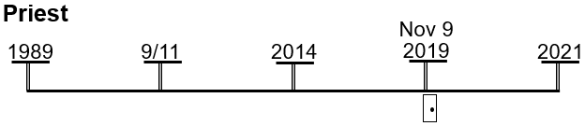
Ray – I’ll go with November 9, 2019, CoP.
Elder Tess – What have we taught about the repeating pattern before?
Ray – Boston, Concord, and Exeter?
Elder Tess – What happens at Boston?
Ray – The message is given, and then there’s a swelling.
Elder Tess – So, a message begins, and then it starts to swell.
Ray – There is an increase of knowledge.
Elder Tess – Concord?
Ray – Yeah.
Elder Tess – What do we say about the increase of knowledge?
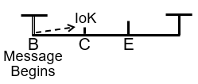
Ray – Do you mean like how people come into unity, like people come into concord?
Elder Tess – Yes, but if we were to go back to this reform line of the Priest, and we start tracing the increases of knowledge we start saying, line upon line, 2520, Acts 27. We see that this, line upon line is going to develop into Daniel 11:40-45; 2520 is going to develop into time setting; Acts 27 develops into two streams of information. What do we say about the increase of knowledge?
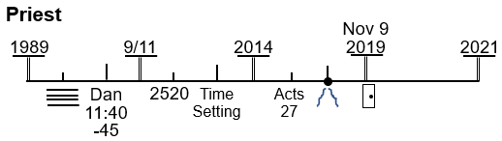
Ray – They build on the last message before?
Elder Tess – Yes. Brendon has his hands up so if you’re not sure and he has an answer, I might come back to you if that’s ok? Brendon. What do we say about the increase of knowledge?
Brendon – I had my hand up for something else so I’m not sure about that one. The message is unsealed at Boston but…
Elder Tess – What did you have your hand up for?
Brendon – I was just referring to when you look at the many, which is accurate. If you go to the overthrow of the many, it would be at the Loud Cry because that’s what’s happened every other time. The formalization is where the shaking happens, and that’s where everyone gets overthrown.
Elder Tess – Josephine. What do we say about Concord or all the increases of knowledge? What do we say about them?
Josephine – Well, I might not have the right answer, but I’m going to say something anyway. When there is an increase of knowledge, we should take note. We should make a choice, and sometimes, some people choose not to move forward, while others choose to accept and move forward. Those who don’t move forward, they eventually fall backward.
Elder Tess – So, you have to imbibe that increase of knowledge? Not resist it? You have to not fight that increase of knowledge. You have to move with it; you have to walk with it.
Josephine – Yes. That is what I’m trying to say. You walk with it. If you fight it, then you’ll just fall. You don’t move forward if you don’t accept the increase of knowledge.
Elder Tess – Yes. I agree. Rachel. What do we say about Concord?
Rachel – Is it because it doesn’t require you to change? It doesn’t …
Elder Tess – Say that simply. If it doesn’t require you to change …
Rachel – It doesn’t challenge you.
Elder Tess – It doesn’t challenge you?
Rachel – It doesn’t make you uncomfortable. I’m not sure now.
Elder Tess – No, you’ve got it. I think I just wanted to say it’s easy. But you’ve said it. You’ve just described it in more detail. Am I okay to simplify and just say it’s easy?
Rachel – Yes, please.
Elder Tess – I think lines are easy; 2520 shook Adventism but it was easy; Acts 27 was easy. Is that what you were going to say, Brendon?
Brendon – Yes. It doesn’t challenge you.
Elder Tess – It doesn’t challenge you. It’s easy. And then, what happens? It goes from easy …
Brendon – It goes to life shattering.
Elder Tess – Life shattering. We are keeping with the details and that’s ok.
Brendon – It goes to hard
Elder Tess – It goes to hard. Knowing that we’re in the time of the end, last generation, time setting, and two streams of information that’s going to tear us away from our political ideology. It goes from easy to hard. Raymond, and then, we’re tested on it. There is a test. This is just a shut door. What’s this test on, at the shut door? What are you being tested on?
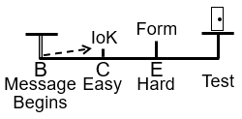
Raymond – The message that began back at Boston, and everything that it has grown into.
Elder Tess – But it’s easy at Concord. If I asked you what 2 + 2 equals, am I really testing you?
Raymond – No.
Elder Tess – If I asked you the square root of eight figures, am I testing you?
Raymond – You would be really mean seeing that I’m really not good at math.
Elder Tess – I have a bad habit of loving the things that I’m bad at so I sympathize. I’m suggesting that there isn’t much of a test at Boston. If you’re tested over at the shut door, you’re tested on what’s hard. You’re tested on the formalization. You start with a concept, you build on the concept, but it’s at the formalization that you have the completed work. You have a concept; you have the build through the 2520; and then, you have the time setting. What were they tested on in 2014?
Raymond – It was the Sunday Law for the priests.
Elder Tess - What’s the test for the dispensation from 9-11 to 2014?
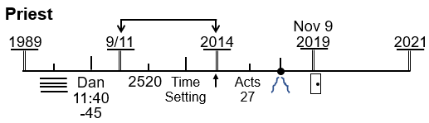
Raymond – Time setting.
Elder Tess – What are they tested on?
Raymond – Time.
Elder Tess – When does the test start?
Raymond – Through 2012 to 2014.
Elder Tess – When did Elder Jeff fail the test?
Raymond – 2012?
Elder Tess – Do you agree with that? I’m saying the test for the dispensation between 9-11 and 2014. Not future. When was Elder Jeff confronted with the test?
Raymond – I can’t remember.
Elder Tess – You said 2012. I agree with that. My point is that it’s not in 2014. When was FFA overthrown in the dispensation between 2014 and 2019? November of 2019?
Raymond – No. 2018.
Elder Tess – So, if we got into the words of overthrown, I think we could start arguing about when something is actually overthrown. Technically, the door is not shut. I’m not kind of wanting to go into those, into the dividing up the words. My point is, when does the test begin? What are they tested on? It’s here at the formalization. Do we all agree that it’s here? It’s the formalization. You have your papers. The test starts. So, we know the story of Gethsemane. We know that this, 2019, is the cross. We know how we apply the story of Judas. We understand the shaking that occurred there, but it’s all about the formalization. This is the history of the test. It’s all about the formalization. This is when you have the hard message that’s going to decide where you stand. So, coming back to the Sunday Law, Marie, when are the “many” overthrown?
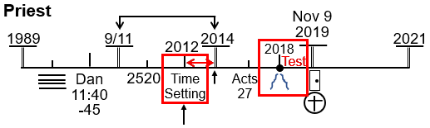
Marie – The final overthrowing, is that the Sunday Law?
Elder Tess – You describe it any way you want to. So, you’re saying that the Sunday Law is the final. So, you’re saying it’s the end?
Marie – Going on your explanation of the formalization, it would be the beginning of that overthrowing. And, at the Sunday Law, it would be the final end of it.
Elder Tess – You say there’s an end; you say there’s a beginning. Now you’re starting to talk about a period of time.
Marie – Yes.
Elder Tess – And you want to take that back to the formalization. Does anyone disagree? Josephine, your hand is up.
Josephine – Are you asking me in relation to what you’re saying right now? Are you asking me why my hands up?
Elder Tess – What did you want to say?
Josephine – I was just going to say, it’s rather a question than contributing to what Marie is trying to say, but I agree with Marie. But I wanted to ask a question before that. Maybe I ask it later?
Elder Tess – you can ask it now.
Josephine – So, these two tests that you have on this line, one is 2012, the other is 2018, and there are two tests there. Am I understanding it right?
Elder Tess – We divide our lines into five fingers, the five fingers of the reform line with four spaces in between, and in each space, a message is given. Between 1989 to 9-11, we had to understand Daniel 11:40-45 in the context of reform lines it built. Between 9-11 and 2014, we had to understand time setting in the context of 2520 that it had built. Between 2014 and 2019, the test of two streams of information, everything that was going to teach us about republicans and democrats and Trump and Clinton which was built upon Acts 27. Yes, we’re tested at each point in time, but this test at the Sunday Law is described in Dan 11:41. It is given particular notoriety. It is the Sunday Law test. Yes, there are these sequential tests but all these tests, all that these are doing (and between 2019 and 2021 was LGBT), is preparing us for the Sunday Law test because we are the priests. We needed the training to prepare us so that we can go to work. So, all of these tests are preparation for this, Sunday Law, big test. Does that answer your question?
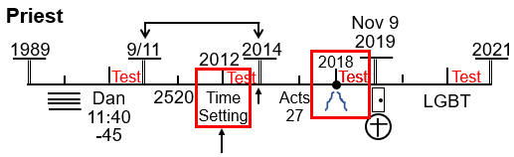
Josephine – I got it. That was perfect. That’s where I was …
Elder Tess – So, you wouldn’t take a five-year-old and sit him down to test him on calculus. He’s got to go through all these other tests or you know, the final exam we have when we finish school. We have grades; we have a build-up. I think that’s the kindest way to learn, not the hard at the beginning. So, all these are build-up, and we’re coming to the Sunday Law. Raymond. You put it here at the Sunday Law. Do you want to change anything about this history?
Raymond – Yeah. Can I shift it back to the formalization?
Elder Tess – So, you want to put back here just before the Sunday Law?
Raymond – Yes, please.
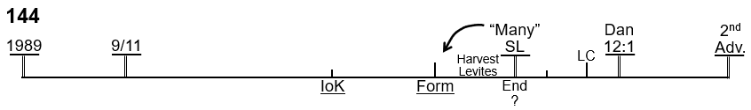
Elder Tess – Of course. And, what’s the formalization?
Raymond – Gender?
Elder Tess – You can do here [2019, the increase of knowledge] first and then here [2021, the formalization.]
Raymond – I’m not sure, sorry.
Elder Tess – That’s fine. I might come back to you. Does someone want to put these two in for us? Lynne? I see your hand up.
Lynne – My hand was up for something else. I’m not sure I can answer it very well. Please repeat the question.
Elder Tess – We’re on the line of the 144K. We’re in the history of the Early Rain (ER). Dan 11:41 says that the ER ends at the Sunday Law where the Latter Rain (LR) begins. It tells us that at the Sunday Law, many of God’s people will be overthrown. We’re in the ER dispensation, and I’m asking what years and days coincide with the increase of knowledge and the formalization.
Lynne – Ok. It would have to be 2019 and then 2021.
Elder Tess – 2019 and 2021. What are you associating with 2019?
Lynne – It would be increase of knowledge about equality in the movement, and …
Elder Tess – You want to give a word to that? What would we say for gender equality?
Lynne – Are you talking feminism as such? Or women’s rights?
Elder Tess – I would put feminism here at 2019, increase of knowledge. And what for here?
Lynne – That’s the same, isn’t it, except it was obviously more complicated because we had LGBTQ, and it was also basically, the formalization was about…
Elder Tess – LGBT is the formalization on the Priest before 2021.
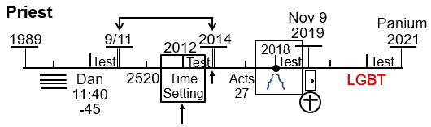
Lynne – Are you talking 2021 or 2019?
Elder Tess – 2021
Lynne – 2021, there was a formalization of the message. 2021 was Panium.
Elder Tess – Yes. What was taught in October of 2021?
Lynne – Radical feminism.
Elder Tess – Radical feminism. Can you see how it builds? I know that not all of us were there at the German international camp-meeting, but wow, was there lot of unity and happiness on equality in 2019. It’s easy. Was that ok, Lynne?
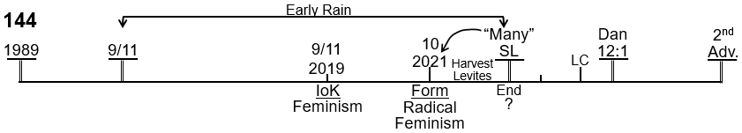
Lynne – Yes. That was good. That was fine, thank you.
Elder Tess – Brendon, your hand was up.
Brendon – No. Lynne answered. I would have said the same thing. I have nothing more to add.
Elder Tess – We read Dan 11:41, and we look into the future, and we say in the future there’s going to be this disagreement in the movement, don’t know exactly about what, but there’s going to be this great shaking. It’s hard to imagine; many people will leave. I would like to refine that a little. We’re out of time, so I’ll just summarize. It’s at the formalization that things get heated. The disagreements start surrounding the message of the formalization. Now, back here, two streams of information, I wasn’t a teacher in the movement here. I wasn’t teaching prior to September of 2018. So, it comes all at once; two streams of information comes, and comes as a bit of a shock wave. It splits the movement into two groups. Those two groups continue to run somewhat together, but clearly divided until we get closer towards 2019, and then one group formally splits. 2021 is a little bit different. Raymond. When did I start teaching radical feminism? I’m picking on you because I know that you’ve gone back and watched some of those.
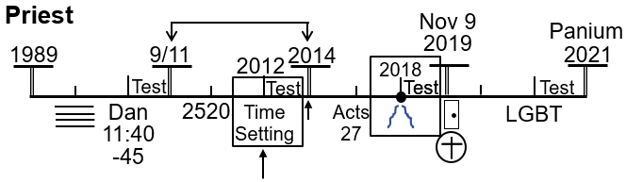
Raymond – Was that Uganda, 2020?
Elder Tess – Uganda, January of 2020. We had just entered into that dispensation, and in Uganda, I was laying out the problem with the left, the problems with Michael Moore, the problems with AOC, the problems with Ilhan Omar, problems with Burney Sanders, and the problem with the left-wing. Radical feminism was particularly being taught from January of 2020. So, if we’re going to talk about how radical feminism has impacted the movement, right back from January of 2020, that formalization has been impacting the movement. Every split, every shaking, and every fight that we had in the movement since November 09 of 2019, other than what continued with FFA and their followers, has been about radical feminism, has been about how you sift the left-wing which is what we began discussing.
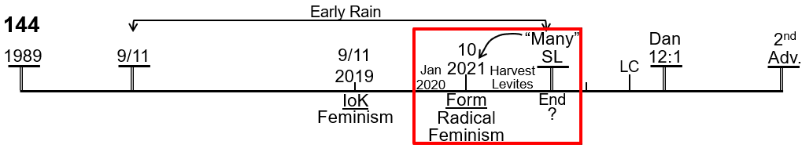
We started by explaining the simple; good v. evil. Perfectly fine for 2014 to November of 2019. It’s perfect for that dispensation. From November 09 of 2019, it was no longer safe to just say good v. evil. It doesn’t mean that it was wrong, but if it stays simple, left-wing good, right-wing evil, if it stays simple, we would be in trouble. If it stays simple, we all stay with the safe comfortable increase of knowledge message of feminism. But we entered into a new dispensation, and from January of 2020, we began pushing towards radical feminism. And, this is where the shakings developed in the US, in Brazil (still on-going), in Zimbabwe, in South Sudan, and within the French ministry. Every issue since then has surrounded this issue of radical feminism which is the formalization. So, Brendon, who are the many?
Brendon – Many are the ones who are fighting against radical feminism.
Elder Tess – From when?
Brendon – From 2020.
Elder Tess – From January of 2020. So, when we see what this movement has been through, we know the split with FFA, we know those problems, but when we entered into a new dispensation, and people say, yay, we get to go to the Levites, and then twice in last month I taught, first time, I was trying to teach 2014. So, we can see the significance of this center event of the reform line of the priests. But I also wanted us to see the danger of the Laodicean condition because while it’s tempting to just want to talk to Adventism, to all those nice people that we want to get and understand, I wanted to talk, not to random trouble makers. What I’m concerned about is the “many.” The many people consist of all the people that have left from January 2020 and that are still perhaps inside the movement in their minds but have been opposing what we teach on feminism, some of them right back to the German international camp-meeting. Certainly, opposing radical feminism today.
So, this is how important it is to sift the left, because what the many have left over is radical feminism. But how you get to understand radical feminism is by looking at the left and identifying all the problems with it. When you see all the problems with it, and you see an article you think, I like 5% of this but 95% of this is all of the problems. All the things that Elder Tess disagrees with. And, you start sifting. Does that make sense?
The “many” are not some far-off group. We didn’t go through from 2014 and start thinking that somewhere in the months of October and November and December of 2019, there was going to be a new issue, and a new group was going to start fighting. That is not what we see. It surrounds the formalization. And, I’m sure that we’ll continue to have knowledge increase.
It never stops. There will continue to be disagreements, and people will continue to fight. But it surrounds right back from the beginning of 2020. All of that is surrounding the subject of radical feminism. And, it’s radical feminism that is what the many trip over. That’s how important it is for us to look at the simple model, good v. evil and left-wing v. right-wing. We need to understand that simple model is extremely dangerous if we don’t step back and decipher it correctly.
Prayer – Amen.

