FROM RIGHT WING TO LEFT WING

TMW VESPERS

FEBRUARY 25, 2022

ELDER TESS LAMBERT
https://www.youtube.com/watch?v=HlrQk6NksaI&list=PL6-Mv8H520RncgAlBdn_u3bAlt_kGZZhH&index=3
Elder Tess – Last week, we covered the complexity of history. I tried to illustrate that a little more, as far as emphasize how important and beautiful the simple is, and that we’re not saying that there’s something wrong with it, but it can be manipulated and warped. We made that point by especially going back to the end of ancient Israel which is the only biblical history we have to show us what success looks like. It was this simple prophecy given by the Holy Spirit given to the father of John the Baptist that sets him up for failure, because it looks so simple and just so clear. So, it’s really a lesson for Adventism today.
We went into a few different thoughts after that. We did touch on Daniel 11:41, but Elder Tess thinks that’s a whole new field, and perhaps a little bit more problematic than an oversimplification can make it; so, she doesn’t want to go back to that. She doesn’t want to go back to Daniel 11:41. Outside of where we headed towards the end of last week’s vespers, does anyone have any thoughts or questions through the week that have arisen, that you either thought of last week but didn’t get to ask or that have come up through the week related to what we’ve been covering, but just not that later digression? I just want to give anyone an opportunity.
So, this movement was, you could argue, right-wing, and it swung to the left-wing. In the history of 2018, 2019, and what caused that? What brought us from the right-wing to the left-wing? Natakarima. I’m sorry if I don’t pronounce your name accurately; I will take correction, and want to learn. You had your hand raised. All I want to do is to take us back to where we left off and continue. So, I would rather hear from you.
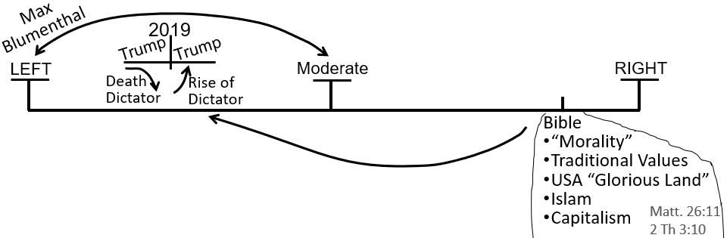
Natakarima – I just want to understand a brief view of the left and the right, and where we are in between these two. I want to understand our position as a movement at the present time.
Elder Tess – So, where are we today? You weren’t with us for the early studies of these, those weren’t recorded; I’m sorry. This is [Boardwork 5:35] about where we were as a movement from 1989 to 2018. And then, in 2018 and 2019, because of the Midnight Cry (MC) and the messages associated with that, we moved from the right-wing to the left-wing political spectrum. I haven’t really gone further to define exactly where we are, because I don’t think it’s really that simple to say we’re here or there on the left-wing because I’m not sure if we really know what that means, the difference between here and there. But we’re going to go into the discussion of the left-wing, breaking it down the various left-wing perspectives and some of the problems with the left-wing.
Boardwork 5:35
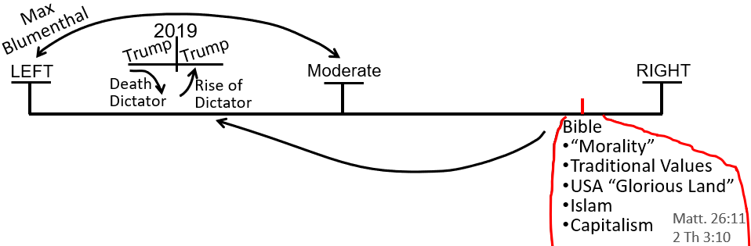
So, we are here today on the spectrum of the left-wing because of the prophetic messages that we understood in 2018 and 2019. And, we’re listing the key prophetic messages that moved us from the right-wing to the left-wing. Perhaps there’s more, perhaps it’s an incorrect list or too simplistic list, but there was about four prophetic points of doctrine that caused us to make this switch. We have listed two, and coming back to this topic now, I want us to list the other two.
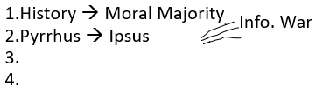
The first two are understanding the history of our reform line of 1989, what led up to 1989. If you have been joining prayer meeting, I believe that Raymond Stanton has been explaining this history of the moral majority, explaining how our understanding of the moral majority caused this right-wing to left-wing swing. There’s also, I believe that Graeme will also cover in some presentations, the studies of Pyrrhus and Ipsus, the Greek history that’s kind of hidden in Daniel 8:8; that also helped us to understand the 2016 election and lot about politics today.
We’re listing the four points that moved us from the right-wing to the left-wing; four points that were kind of embedded in the 2018 messages. So, to directly answer your question as a movement, we’re in the left-wing spectrum. Exactly where, I think gets a little bit more complicated. But we are going to discuss more of the left-wing. Does that answer your question?
Natakarima – Yes. As we move on, I’ll probably get a clearer picture. It does make sense. It takes time to process.
Elder Tess – It does, which is why that was taught in 2018, and we’re discussing it in 2022. So, you’re not alone there. But, if you have questions or thoughts along the way, please speak again. So, we covered the first two: history and the moral majority, and Pyrrhus and Ipsus. Has anyone had thoughts on the other two? Josephine.
Josephine – My hand was raised for the question you originally asked. I haven’t thought about those two yet. Give me some minutes and I will.
Elder Tess – You can ask your original question if it’s still …
Josephine – No. I was going to answer, but I think you’ve done a fine job. I’m happy to sit back and listen.
Elder Tess – So, these other the two, they weren’t all taught immediately in 2018. I think one of them, I might have taught in December of 2018, partly because of this resistance. People were resisting what had been taught in Arkansas. Any thoughts on number three and number four? Lynne?
Lynne – I’m taking a risk. Was it Acts 27? Where you started to see the corporate lines, the structure lines, as oppose to the … I’m not sure of the word to use, but you had the church and the state line; the SDA and the state line.
Elder Tess – I’m not sure if in Acts 27 you would get the justification for the left-wing. I’m trying to remember the earlier part of the line of Acts 27 as it shows the ship going off course, and it doesn’t really go into the subject of racism so much. It doesn’t go into what was the political issue for the Millerites. I don’t think that would quite bring you there.
Lynne – The other thing that I would think of would be when we started to look at the early presidents and understanding Abraham Lincoln and that he wasn’t necessarily the big positive character that we thought. And then I think we started to look at the influence of the republican, democrats, and the right and the left. That’s my thoughts, so obviously, I’ll be keen to hear the right answers.
Elder Tess – Sure. I think most of that came later, like in 2020 because if we talk about Abraham Lincoln, we’re starting to criticize the left-wing where we’d swung to. That would take us back to the left. If we can please not answer in the chat. Moli, you’re heading somewhere I like. Are you able to unmute? What were your thoughts?
Moli – Yeah. I was thinking of the two streams of information. When you created the study of Acts 27.
Elder Tess – I would suggest that two streams of information ties into both of these, both the third and the fourth. If you were to look at our reform line, we’ll do the priests. What key waymark would you associate with two streams of information? Any thoughts, Moli? Do you have a key waymark, where you would say, that’s where I see two streams?
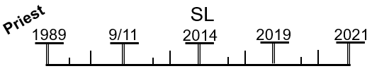
Moli – 2014 and 2019.
Elder Tess – Yes, but I would suggest before then. Because you’re seeing the two streams really conflict there, but 2014 is the Sunday Law. I suggest that you need to see the two streams before you get to the Sunday Law.
Moli – 2012.
Elder Tess – Why 2012?
Moli – Because Elder Jeff was starting to oppose, I mean go against the message with the time setting.
Elder Tess – I can see you’re going to the internal which is fine. If you were to consider the external though. If you were to consider externally, two sides of information; two streams of external information.
Moli – 9-11
Elder Tess – Why 9-11?
Moli – The conflicts of Islam when they come onto the scene.
Elder Tess – We do see a split there.
Moli – CNN.
Elder Tess – When was CNN created? If we go to an inception point. What is the antithesis of CNN? What is the opposite? CNN and?
Moli – FOX, isn’t it?
Elder Tess – Yes. Exactly. When was FOX created?
Moli – 1989?
Elder Tess – Not quite. A bit after. It was created in 1996. So, you brought us to two streams of information. You brought CNN, and I said if you’re going to talk about CNN, think of its opposite because there’s two streams, two sides; CNN and FOX. And when are those information streams created? They were created in 1996, along with host of others. So, if we’re going to talk about information streams, two sides in an information war in a social culture war, then we find their inception point in 1996. And, I can get why you can see facets of that at every waymark after. There is catalyst in 1989, of course. But, these two powerful sides formalized in 1996. And, we know that 1996 was the first, really the prototype of the formalization in this message because that was when the Time of the End magazine was created. Is that Ok, Moli?
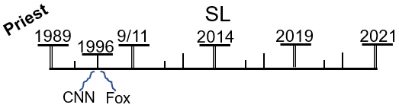
Moli – Yes, it is clear now.
Elder Tess – So, the first of these other two, I want to put down was the understanding of 1996. Because our concept of that prior to 2018 was, yes, it’s the formalization. Our focus is on the internal. We have the Time of the End magazine. We have Daniel 11:40-45, and reform lines all getting formalized. What we needed to see in the time period of the Midnight Cry (MC) was what was also getting formalized were these two influential, powerful external streams of information. They are going to take opposing sides in a culture war. And the Sunday Law, past and future, all center on this culture war.
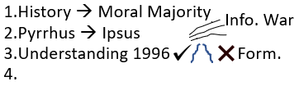
That is why understanding 1996 and two streams was an integral part of this right-wing to left-wing swing. Because if we got the problems with the Republican Party through the moral majority and if we got that Clinton should have rightfully won the 2016 election from the battle of Ipsus, then you know which side in 1996 was the good stream, and you know which side in 1996 is the bad stream. Because Fox news was the mouth piece for Donald Trump, and Donald Trump is Demetrius in the battle of Ipsus, and Donald Trump is supported by Jerry Falwell, the son of the original creator of the moral majority.
So, 1996, understanding the external formalization of two streams is going to connect with Ipsus, which is going to connect with understanding the moral majority, to show us why, not just Donald Trump needs to be understood as a wrong stream of information but news sources that are his conservative mouth piece are very much dangerous as well. So, Elder Tess hopes that we can see how these points connect; 1996, the formalization, Time of the End magazine; but also, whenever you have the true message formalized, you’re also going to have opposition.
There were quite a few hands up. Was everyone just wanting to suggest where we were heading? Were your questions answered? So, I won’t go back to anyone who had their hands up. If the last few minutes haven’t answered your point, then please raise your hand again. Or, if you have a thought. Brendon.
Brendon – I can see the logic with what Moli was saying and how you brought that about. I had another thought, which was what convinced me also to move [to the left]. I just remembered looking at the studies of “In God We Trust,” and “Under God,” and tracing that right from the civil war, and the north using, “In God We Trust,” and putting on coins and tracing that all the way through right up to the “Project Blitz.” What we see now and from that you can see who were the good and who were the bad guys. And so, that also made me shift. I’m just going off what helped me move, but that might be similar to the moral majority.
Elder Tess – What I think might have happened is that we understood the moral majority, and then it blew up. Does that kind of make sense? We understood 1979 to 1989, and then it was connecting all of that to Billy Graeme, to 1888 to 1863 to 1798. It’s following this point, the history of the moral majority, has rapidly expanded. So, I think that’s accurate. With this list here, if we brought it into 2019 and later points, I think it would grow. I guess I restricted it a little to 2018 itself, because 2019 it did expand. Our position has only grown stronger, I think. I agree. Does anyone have any more thoughts to say on point three? Josephine.
Josephine – I don’t know if I have any thoughts on point three. But I just wanted to clarify, if possible, the connection of Demetrius to Trump. I sort of know that very well but I’m having a, just for now, I can’t make the connection. I know that Trump is dictatorial, but Demetrius has that connection.
Elder Tess – Graeme, do you feel comfortable answering Josephine’s question? If you want to answer her. I understand that Graeme has been working on Ipsus.
Josephine – I know the Ipsus battle, but I’m just having a bit of difficulty. I know that he was defeated during the battle of Ipsus when his horse is charged. I don’t know where I’m going wrong.
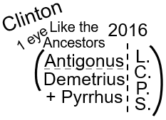
Graeme – I can try, but in two minutes it’d be hard to justify it. So, Antigonus and his son, Demetrius, fought against the allies of Lysimachus, Seleucus, and Cassander. Antigonus and Demetrius on the same side fighting the same three allies that were joined together. Demetrius was supported by Pyrrhus. Pyrrhus was the king of the south at that time. When we make an application of it, we look at Antigonus, his name means, like the ancestor, and we align Antigonus with Hillary Clinton, and we align Demetrius with Donald Trump. Donald Trump is assisted by the king of the south at that point.
Josephine – I got it.
Elder Tess – Is that ok, Josephine? Are you done, Graeme?
Josephine – Yes, I understand. For a minute there, my mind was blurred; but I do know that, what he’s explained; and he’d done a really good job. That came really clear to me. I got it. Thank you.
Elder Tess – Thank you, Graeme. I think Graeme’s going to be leading us through Ipsus at the prayer meeting. There will be a deeper delving into that history and application; but if that’s satisfactory for now, then he broke down the application.
Josephine – Yes. That was very good. I don’t know why I forgot it because I’ve been studying that, and for a moment there, it was blurred in my mind. Thank you very much, Graeme.
Elder Tess – I know the feeling well. So, we have the history of the moral majority. Seeing evangelical Protestantism unite with a particular political party. We see how by 2016, partly due to that uniting but also just what has happened within the republican party itself, you see the election of Donald Trump; and we know how to understand that election, partly because of our understanding of Daniel 8:8, and how that verse blew up. Then we understood that there are these two sides with information streams, news sources, which need to be carefully sifted. Also connected to the formalization of this message in the same year, at the same waymark, 1996; CNN and FOX. That can also be expanded quite a lot; 1996 was a heavy year for information.
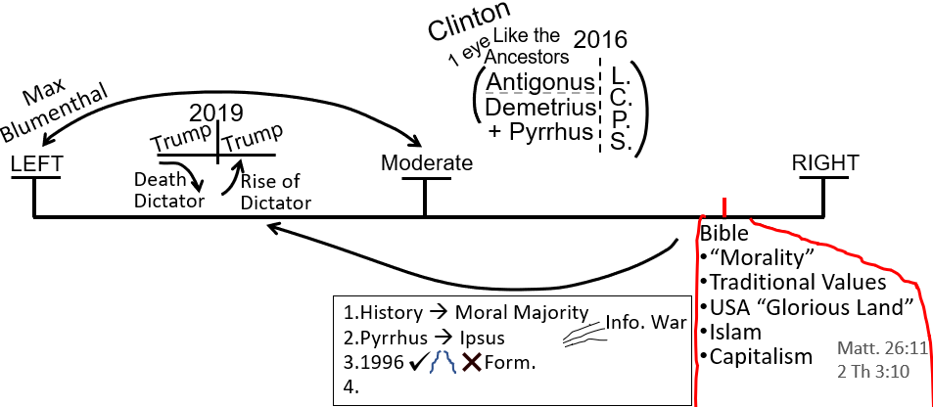
If everyone is fine with point three, we’ll move on to point four. Elder Tess thinks that this is the point that might have been not taught in September of 2018 but December. Still connected to the two streams of information. It’s really this third point but connected to the fourth, it makes it so much stronger. Any thoughts? Hint. Does what happened in 1996 only effect the priests? CNN. FOX. Is it only the first group that is affected by these external information streams? Greg.
Greg – Nothing really comes to mind.
Elder Tess – Is it only you and I that are affected by the different perspective of CNN and FOX?
Greg – No. everyone.
Elder Tess – Everyone. So, what do you want to call them?
Greg – Levites and Nethinims.
Elder Tess – So, the Levites and the Nethinims are affected by 1996, two streams of information. How does that make it a much stronger point? If we just say 1996, two streams, that affects you and me; but if we say that it affects the Nethinims, how does that make it a much stronger point about this rightward, leftward swing? How important it is to get our politics right. Ray.
Ray – Is it because, if we understand that God is using those streams to teach other people, we can see, sort of like by consequence, what they’re learning must be the same as what we’re learning?
Elder Tess – Let’s just take one of them. The bottom line, that’s the first group. Let’s talk about the world, the top line. The line of the Nethinims. Where is the Sunday Law for the Nethinims? When is their harvest? When do we say to come out? Harvest. Come out. Otherwise called the Loud Cry (LC). So, their Sunday Law is before their Harvest, and Daniel 12:1 is after their Harvest. So that is the line of the Nethinims. Raymond, state your point again.
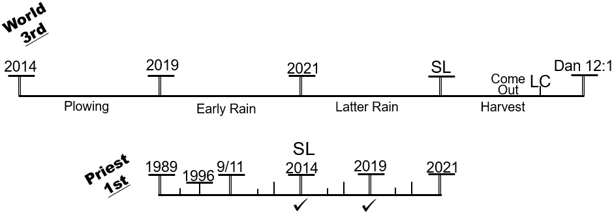
Raymond – I’m not sure if I got it right, but if we can see God teaching them even though they are not as developed in their understanding as we are, we should still be able to see what they’re learning. It has to be the same as what we’ve learned, and what we’re learning.
Elder Tess – So, they’re learning, but you and I aren’t teaching them.
Raymond – Yeah. God’s teaching them completely independently of us.
Elder Tess – When do we start teaching them?
Raymond – Right at the bit where it says come out? No, wait. Is it 2021? Oh no, that’s the Levites.
Elder Tess – At the Sunday Law?
Raymond – Yeah.
Elder Tess – I would agree with that. If we were teaching them before, we wouldn’t wait till the Loud Cry to say come out, would we? This is when we find the stone striking the statue, and there are people who have to come out of Babylon. If we were teaching them in 2021, we would be giving the cry before the Sunday Law, and we would be saying come out of what? We can only say come out; Babylon has fallen once we see that fall. So, if this is their harvest, then we have their plowing between 2014 to 2019, Early Rain (ER) between 2019 to 2021, and Latter Rain (LR) between 2021 and the Sunday Law. And you said, Ray, that we’re not doing that. We’re not plowing them; we’re not giving them their ER; we’re not giving them their LR. If we’re not, then who is?
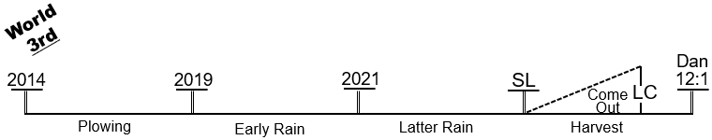
Raymond – I would say God through external events.
Elder Tess – God through external events. So, we have an external event. We have Putin who is going to invade Ukraine. So, Putin attacks Ukraine. And we have CNN say, that’s awful, and we have FOX say, what a genius. Who wouldn’t want to expand their empire? So, you have CNN and FOX. You have one singular external event, but you have two different perspectives of it. And what you’re saying is that the Nethinims, the World, this is how their being taught, either from one stream or another stream. Either in a positive sense or a negative sense. Is that all right? Do you want to expand on that thought at all or disagree with me?
Raymond – I think the only thing that I would add to this is that when this was explained I understood that, like why we don’t do public evangelism. Let the penny drop for me, our position on public evangelism when this was taught. Before that, I didn’t get it.
Elder Tess – Yes, and it’s really good that prior to 2019 we didn’t do any public evangelism either. That would have been a mess. So, we call them out after the Sunday Law. Prior to the Sunday Law, it’s all about Adventism. This is what waymark? For ancient Israel? Josephine. What is the Sunday Law for Ancient Israel?
Josephine – That’s not 1844?
Elder Tess – Ancient Israel, not modern.
Josephine – Is that 70 AD?
Elder Tess – The Sunday Law of our time period. No.
Josephine – That would be before that?
Elder Tess – Yes. Think about the stages of the work. This is when we’re saying that we’re not allowed to …
Josephine – Is that the Pentecost?
Elder Tess – Who do the disciples go to at Pentecost?
Josephine – They went to the Jews.
Elder Tess – To the Jews. So, you have the disciples. Then the disciples go back to the Jews. Who aren’t they allowed to go to?
Josephine – Not to the Gentiles yet.
Elder Tess – They are not allowed to go to the Gentiles yet. So, first of all, God is going to teach the disciples, and then they are allowed to go back to the Jewish nation, give the Jews a second chance. All of that has to happen before God will allow them to go to the Gentiles. Does that make sense? We come to the Sunday Law, Daniel 11:41, where would you put that for ancient Israel?
Josephine – They were going to the harvest, is that for harvesting the Jews?
Elder Tess - If we harvest the Jews after the Sunday Law, who do we start harvesting after Daniel 12:1?
Josephine - The Nethinims?
Elder Tess – After their probation closes? This is Daniel 12:1. The time of trouble before the Second Advent. Do we not call the people out of Babylon until the time of trouble?
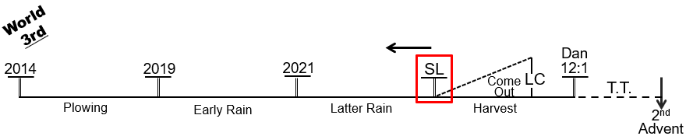
Josephine – No, we call them before, isn’t it?
Elder Tess – Where before?
Josephine – At the LC?
Elder Tess – The LC. Who are we calling at the LC? You have three choices.
Josephine – The Jews have been called. Not the Jews, the Levites have been called.
Elder Tess – So, from the Sunday Law to Daniel 12:1, this is the calling of the Levites?
Josephine – It’s the Sunday Law. We call the Levites?
Elder Tess – Then you would say that this is Pentecost, at the Sunday Law. Then it’s after Daniel 12:1 that we go to the Gentiles?
Josephine – To join us and the Levites?
Elder Tess – What’s Daniel 12:1?
Josephine – Standing up.
Elder Tess – I know it’s not fitting the parable exactly, but if Daniel 12:1 is October 22, what happens there?
Josephine – October 22 is, do you mean the real thing that happens on October 22nd, Christ goes to the Most Holy?
Elder Tess – What we associate with October 22 is a door being shut. Judgement. You have a shut door, judgment, a time of trouble such as never was. No one can join in this time period after the door gets shut.
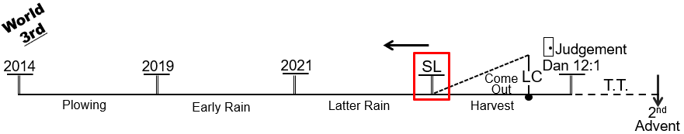
Josephine – So, that means it has to be before the door is shut. It has to be before.
Elder Tess – It has to be before. Does that make sense? In the old model where Jesus was coming back in 1888 history, we’re fleeing to the mountains. You can’t, unless you’re shouting while you’re running, you can’t call people out of Babylon if you’re physically fleeing. The time of trouble is in that model what would have fitted 150 years ago. This is survival. We’re not going to work. This is hiding. So, if we’re hiding in the time of trouble, we have to be going to work before then. We have to do all our work before then. Is that ok?
Josephine – Yes, that’s really clear. Sometimes you know those things but when I hear your voice, it seemed to, sometimes just flush them out. I think it’s nerves, maybe.
Elder Tess – This is why interaction is so much of a better way to learn than just be told something. It’s a much better way, to dialogue. Don’t ever think that time or exercise is wasted. Best for all of us. So, our work is done at the shut door, and it happened for the disciples that for the end of ancient Israel, it happened in three stages: first the disciples; then there was Pentecost; at Pentecost, they went back to the Jewish nation; they still weren’t allowed to go to the Gentiles until here. When were they allowed to go to the Gentiles?
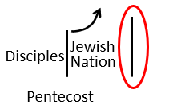
Josephine – After the Jews when the Jews joined them. Then they could take the message when the way was opened up.
Elder Tess – Yes. This was a time period, a time period of them doing that work. We usually associate an event with this waymark, when the door shuts for the Jewish nation as an institution which I know that you’re looking at Acts 27; it’s essentially shipwreck for the Jewish nation. So, you know that we would be calling that Sunday Law because that’s shipwreck. And they go from talking to the church to talking to the world. We associate an event with that Sunday Law waymark. Do you have any thoughts on this? If you don’t, that’s fine. You got the structure and the concept.
Josephine – Maybe somebody else might come up with a thought.
Elder Tess – Sure. And, I’ll come back to you and see if it starts to gel. So, I’ll come back to you in a short space, if that’s ok. Rachel.
Rachel – Is it the stoning of Steven?
Elder Tess – The stoning of Steven. I heard you, Josephine.
Josephine – Yes. 34 AD. Sure.
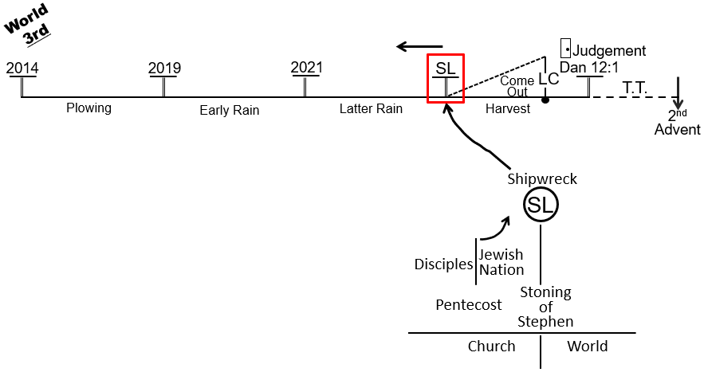
Elder Tess – That’s what I get when I’m trying to do the line of the Nethinims without seeing all four at once. We get tangled. So, is that ok?
Josephine – Yeah. That’s great.
Elder Tess – And you can see the parallel that’s with the Sunday Law.
Josephine – Yes. Yes. That’s right. I do know that very well. I just, you know, foraging in my mind.
Elder Tess – The importance is that once we see it, it all connects. The reason I went through this is because it still sounds extreme to say that we aren’t doing public evangelism. It sounds like this extreme foreign concept. And I wanted to step through it just to remind ourselves, although it might still sound extreme, it’s the same model that God used at the end of ancient Israel in the history of the first advent. Jesus didn’t come and go straight to the Gentiles or encouraged that at all. They were shut off from doing that work until he had an opportunity to draw out a movement from his church and create a new church. This is the same thing that is happening in the history of the end of modern Israel: first the church, then the world.
So, if we aren’t allowed to go to the world until the Sunday Law, like the disciples weren’t allowed to go to the Gentiles until the stoning of Steven, and this is their harvest, going back to the agricultural model, then they have to be Plowed, Early Rain, Latter Rain, all before they get Harvested. And, Ray, it was you who brought us to this reform line.
Josephine - Could I ask you a question just in relation to that, please?
Elder Tess – Sure.
Josephine – I have been asked this week, so why is your movement, no, it’s not my movement, why is your movement hiding all this information that you have? Why aren’t you publicly sharing, and I was telling them about this Christ to the disciples, the disciples to the Jewish nation. And then, I said that we aren’t hiding anything. It’s in the internet. That’s how I find them, how I found the movement, by just searching the internet. Is this making sense? Why are we hiding that was the question, and my answer was basically what you’re teaching tonight: the Christ to the disciples; the disciples to the Jewish nation, and then later on to the Gentiles. But the question was why is your movement hiding if you have all this information, why are you hiding it? I said, we aren’t. We have it in the internet. It’s there. Where are you getting your information from? Did your leaders have affirmation? Is God giving it to you? The information that you got?
Josephine still speaking - I had the same question in my mind when I first came across the information. Where’d the information all this knowledge that I never learned before, now I’m getting the opportunity to learn it, and it didn’t take me long to realize that it’s the truth, and when I realized that it is the truth, I didn’t care to ask the question. I just knew that God has to be giving the leaders the information for the group. So, I never verbalized that question in my mind because I was happy, content, and satisfied to keep learning. But now, I’m being asked the same question that I never verbalized. I’ve been asked again, and while you’re on that, I just wanted to mention, why is your people hiding. Is my explanation for that kind of satisfactory for now? It has to follow that pattern?
Elder Tess – I find it interesting that the same people asking those questions would be the same people that say God never changes. So, God preferred male leadership 2000, 4000 years ago, and they would stick their stake in the ground, and say that God never changes. And yet, they should go to the end of ancient Israel, and see what God did. And, they should consider whether or not they would ask the disciples, go ask Luke, and go ask Peter. Why are you hiding this from the Gentiles in 32 AD? In 33 AD? I don’t think our message is hidden. I would agree with your response. There are people in this movement who came straight from the world; not from Adventism. And, they were not rejected. We didn’t turn them away. We welcomed them. They went through the baptismal studies. Some have been baptized. It’s not that we are deliberately hiding. But there are complexities just as there were for the end of ancient Israel.
So, the first part from 1989 to 2019, the priests, the movement doesn’t have a proper grasp of the truth for themselves. The movement needed to know what message it needed to bring. That would be like having the disciples go and teach the Romans when they still thought that the Roman nation was about to be overthrown. If they were to go to a Roman centurion and say, don’t you know that we have a king, and he’s going to destroy your empire? They would’ve made some problems for themselves later on. So, to go out to the world in 2016, 2017, and not clearly understand what was happening politically, both domestically in the US and externally with their foreign policy, would not have helped many people. The message had to be straight for us. 2019 to 2021 is the time of trouble for the priests. It’s a time period when there are a lot of complexities, lots of problems. If I could say it that simply.
As the 144K goes, they’re still preparing their message to give the Loud Cry, and that has been happening through the history of 2019 to 2021 as well. So, I (Elder Tess) think your answers are correct. It’s a matter if they want to say, if God never changes, that is the methodology that they would want to approach the Scriptures with, then they should read the entirety of the New Testament, and be consistent. She doesn’t think the disciples would’ve said that they were necessarily hiding but there was a work that had to be done decently and in order. Especially as a work as serious as this one.
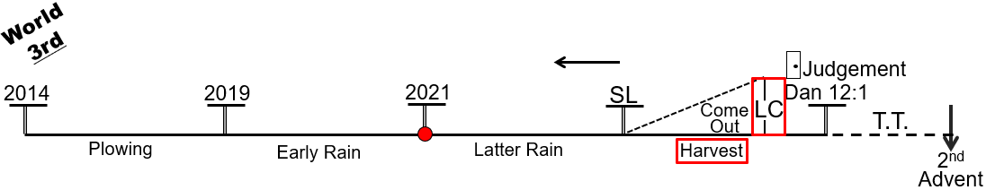
One of the points that Elder Tess taught in January of 2021, and why she had said that the teaching of the radical feminism particularly began in January of 2021 is because she taught that for the Nethinims, their change of leadership happens here, 2021. So, whoever has been teaching them, come by that point, we should start to see there are serious problems with the leadership of the world, the voices they are hearing. We know that we’re doing that work of harvest. Any external stream is not capable of doing that. Which is why it is so important we see the problems with the left-wing as well. The left-wing, however good it might have looked in 2019, is not capable of doing that work because they have endemic issues.
It is so important the work this movement does. No one’s joining this movement as a pre-made radical feminist. Well, there might be some, but most won’t. We still have a lot to teach them. But everything done decently and in order. The disciples, first of all, had to get their message straight which occurred from the birth of Christ to Pentecost. And then, from Pentecost forward, it wasn’t that the disciples had this great learning experience after Pentecost; it was that their first duty was to go to the church. That is our work now. Like the disciples, the message is packaged. It was packaged when we understood LGBT, and when we understood radical feminism. That packaging was done, but our first work is the church. Only then, can we have the united front that we need to do the work at the Sunday Law. Is that ok, Josephine? I know that some of those answers, responses are not necessarily what you would say to them, but does that make sense? Help in any way?
Josephine – Yeah. That’s very clear. I’m sorry that I diverted you a little bit, but I had to ask because you were making the very points that you know, I was trying to explain last week. In defense of the fact that we weren’t hiding. I didn’t know any more than what I just explained, but it makes a lot of sense to me to mention it that way. There’s a, it’s almost like an order or a priority list: the priest had to be trained, and then … but I couldn’t tell them that we were priests. I didn’t want to say that. I just said that there was no hiding. The movement wasn’t hiding anything. It was all out there, and then that if you were really searching and want to know, you would find the message like I did.
Elder Tess – I would suggest that you take them back to the Gospels in the book of Acts. You might not need to use that kind of parable phraseology. They might not understand; the priests Levites, and Nethinims which will not make sense. But if they could just see the Gospel and the book of Acts, they should see that God always works in a systematic order.
Josephine – Thank you very much. I appreciate it. I’m going to listen to the video again and again.
Elder Tess – No worries. It was a good point to cover. So, history, moral majority, Pyrrhus, Battle of Ipsus, 1996, formalization of the message, but that becomes, because people are, there’s a resistance to two streams of information in December of 2018, particularly, the line of the Nethinims which if you wanted to word that in another fashion would just be the order of reform lines which the movement should have been familiar with that concept. But, by the end of 2018, it was the fundamental foundation.
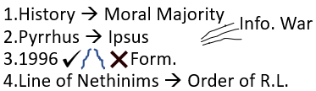
Those are the four that Elder Tess had in mind. Is everyone ok with that? We’re all good on that? How they interconnect? By the end of understanding all of that in the history of 2018, it was impossible to justify this position of being in the right-wing. It necessitated a swing to the democrat party, politically, and connected with that party all the streams of information that characterize both sides.
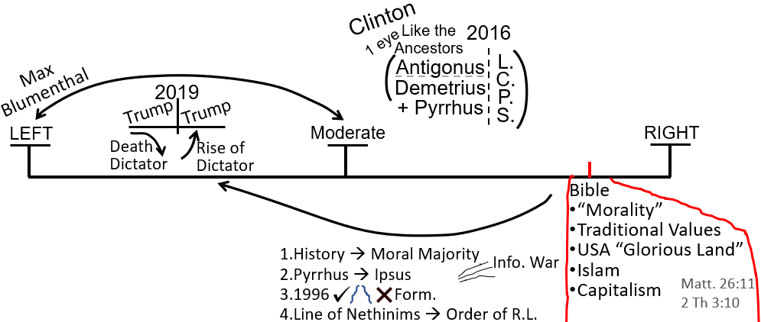
Brendon. How would you have a go defining what it means to be a right-wing? Looking for just some simple concepts. What does the right-wing stand for, and what does the left-wing stand for? As we do this, if we could attempt to not answer prejudicially like someone who is actually has a political position and doesn’t like the other side. If we could just answer a little bit more factually, just from a point of view that we think would be accurate to describe the ethos of the two sides. You could start with either the left or the right-wing.
Brendon – Right-wing would be concerned about the morals as they interpret the country. You have already written it there.
Elder Tess – I kind of want to ignore this at the moment. So, don’t be afraid to double up.
Brendon – They generally have a biblical foundation that they stand on, and it all comes from that. So, no matter what area they’re looking at, they tend to frame it in a religious fight.
Elder Tess – So, there’s no atheist in the right-wing.
Brendon – Oh, there probably is. Of course there is. I’m not sure how to characterize it.
Elder Tess – I got to this point in our studies where I realized that just saying that we moved from the right to the left was unhelpful to me, if I didn’t look in and understand what this right side is, and what this left side is. What do they subjectively stand for? So, this is kind of what I want us to do now. We know that we swung. While you think about that, Natakarima, your hand is up. Do you have a thought?
Natakarima – Just based on the shift between the right to the left: the studies have moved on ahead of what I’ve really come back to understand is, what’s really shifting? Is it the moral mindset of the right-wing that’s shifting over to the left?
Elder Tess – So, is this about the moral issue?
Natakarima – The moral mindset, like the character changes between, making that decision to shift to the left side. I guess there’s more information that ties into that, but I haven’t got that information. If that makes sense. I just needed to understand the big picture for the mindset of the right-wing information and then using that to switch over to the left side. What made the decision for that information to shift to the left?
Elder Tess – I think I cut out on my side. Could you repeat yourself? Sorry.
Natakarima – When there’s a character change between the right-wing and the left-wing, are there changes between the mindsets? When I say mindsets, I guess it’s probably more of the information base.
Elder Tess – If you look at the 2016 election and you look at Hillary Clinton, and then you look at Donald Trump, they’re just two people, but those two people represent so much; so much about how America should view itself, how much from how they perceive Russia, to how they perceive Black Lives Matter, to how they perceive welfare, to how they perceive LGBT rights, to how they perceive concepts of religious freedom. So, 2016 is kind of that litmus test where you see right-wing versus left-wing. If you don’t mind, I would rather not go into your question now, because what we’re starting to do is define what the right-wing stand for, and then define what the left-wing stand for. And, after we’ve done that, we’ll be at a better place to discuss your question. It becomes difficult to answer your question until we’ve shown what right-wing politics stands for. Then, we can go in and say, do we agree with the left side or with the right side.
Natakarima – Yes, I understand.
Elder Tess – So, I’m not ignoring your question. We might not get to it today; actually, we won’t. We’ll have to pick that up next week. But I would like to define both sides before we go into that.
Natakarima – Yeah. I understand.
Elder Tess – Thank you. Brendon, you had some time to think about it.
Brendon – If I was to look at the overarching principles of each side, I would say that the right are conservatives. They look back, and try to keep the status quo. So, they look backwards, trying to preserve what has always been. That’s why there was “Make America Great Again,” because they’re always looking back to try to conserve all these topics. Whereas, I guess the left, they are interested in progression. Looking forward. An example is, no, America hasn’t attained the fullest democracy and freedom that it should. We need to keep progressing towards that, whereas the right would try and interpret the Constitution the way it used to be interpreted. So, one looks forward to progress forward. The other looks back to try to conserve what has always been. So, from that foundation, all these topics, whether it’s traditional values, it all stems from that sort of methodology.
Elder Tess – So, I’m hearing conservative versus progressive. Those are political terms which you’re saying means conservation versus progression. Am I hearing that correctly?
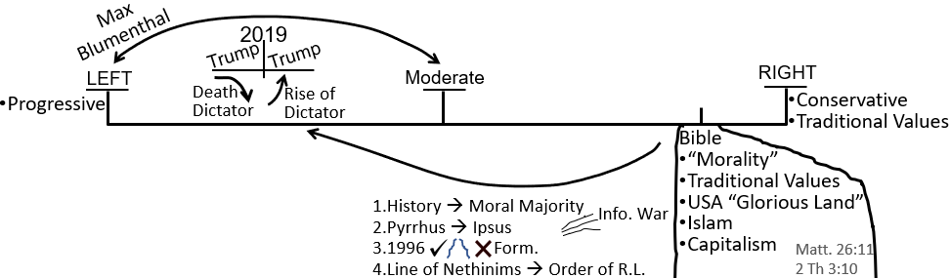
Brendon – Yeah. If I was, something like that. If I was to try and label it very briefly. I’m sure other people have got to be able to fill lots of gaps in. I’m just trying to get the overarching principle.
Elder Tess – Sure. That’s a good place to start from. Graeme.
Graeme – Couple of studies that you have done in 2018 you explained for me very well when you said the phrase, again being over simplistic, that the two streams of information distorts how we perceive reality. And, if we say that the right-wing or the conservative group, you see the focus of America first.
Elder Tess – Can I call it nationalism?
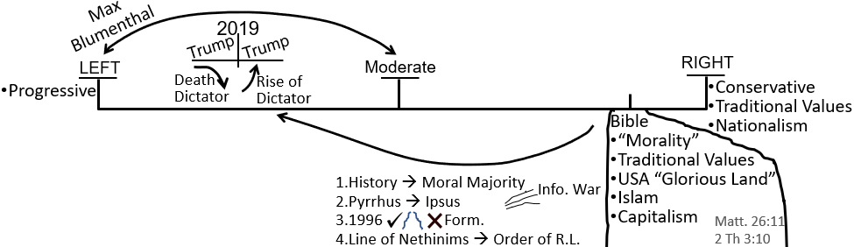
Graeme – Sure. There’s lots of titles you can give.
Elder Tess – Thank you Graeme. Was your thought finished? This is what you wanted to add?
Graeme – Yeah. I’ll let others have a go.
Elder Tess – Sure. Thank you. That’s a component that would be good to add in. Josephine. We’ll add one or two more, and then we’ll pick this up next week.
Josephine – The right wants to impact their morals. They, the right-wing people, want to have a part in politics. They want to have their morals impact the government.
Elder Tess – Can I put that under traditional values?
Josephine – Yeah. I think that’s good.
Elder Tess – You’ve described it a little differently, but I think the two can kind of be condensed into that one phrase. Because when someone has their traditional family values, which is what they want to impact politically, then you come to everything surrounding 2014 and gay marriage. Were you done? Sorry.
Josephine – Yes. Yes. I’m done.
Elder Tess – I’ll just summarize. What we have done is we’ve added a couple of points to what caused us to swing from the right-wing to the left-wing. We have the history of the moral majority, seeing how Republicanism and the Christian right united really in the 10-year history prior to our reform line, and how that set off a chain of events, how it led up to 2016, Ipsus, Donald Trump as the representative of that Reagan-Falwell, moral majority union. We have seen two streams of information externally, the history of 1996, how that played out again in the history of Ipsus when you have these two sides. And then we see how important all of that is for the world once we call them out of Babylon.
If we can’t understand these two sides, and where the people of God should stand on them, what hope is there when we go to the world? Because, they’re already being prepared for the harvest by these two external sides; by how they respond to 2016. Then we ask the question, wait a minute. What changed anyway? What does it mean to go from the right-wing to the left-wing? What is the ethos of the right-wing, and what is the ethos of the left-wing? You’ve given a few different thoughts: progress versus conservation. When they break that into political terms for people, you talk about the progressives, and you talk about the conservatives.
This is a very accurate way to describe it. And then, a little bit was expanded upon with the right-wing, talking about the traditional values, and also tying in that sense of nationalism which is particularly associated with the right-wing. When we come back, we’re going to expand on those points a little bit, but I want a one-word title to describe the ethos of what the right-wing stands for, and one word to describe the ethos of the left-wing. What is the key phrase or key word that these two sides, what’s the hill that those two sides are willing to die on, if I was to put it that way? We will come and do that next week.
Prayer - Amen

