END-TIME EVENTS AND THE CONFLICTING ETHOS

TMW VESPERS

MARCH 11, 2022

ELDER TESS LAMBERT
https://www.youtube.com/watch?v=fD-DnMyOJqk&list=PL6-Mv8H520RncgAlBdn_u3bAlt_kGZZhH&index=7
Elder Tess won’t repeat again the journey that we’ve been on. It’s behind her on the board, and it was quite a journey.
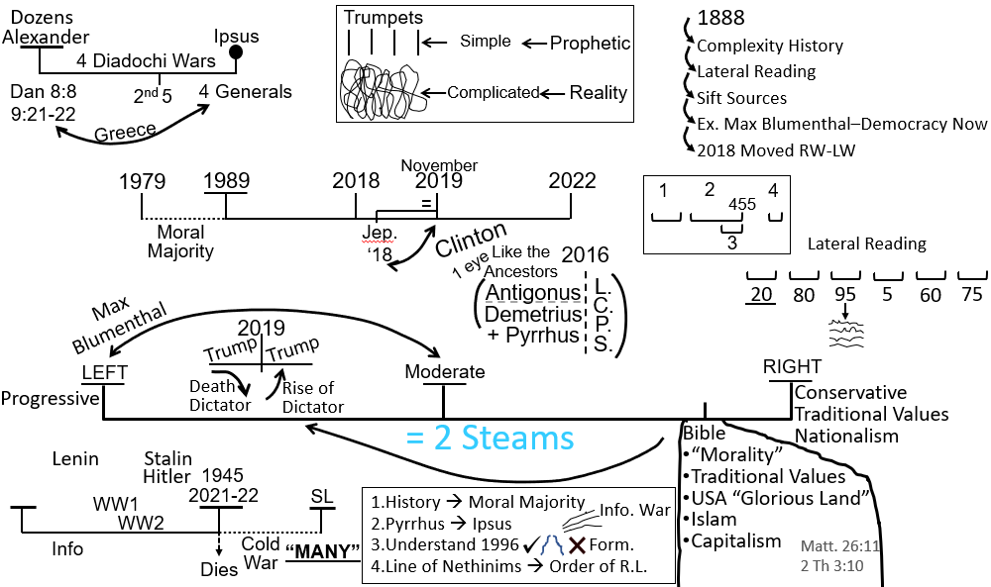
But what we’re doing at the moment is covering the subject of our rightward to the leftward swing, and when we had defined what exactly moved us leftward in 2018, stretching through 2019, we asked what do the left-wing and the right-wing stand for that gives our change of position meaning.
So, we wanted to know what the left-wing stands for and what the right-wing stands for. That’s what we’re doing last week. Everyone contributed. Lots of people contributed which was wonderful. Elder Tess doesn’t think that she agrees with everything that’s on the board or everything that was said. But there was a lot of truth that was said. We took it all in, and then we tried to distill what the fundamental ethos or defining characteristic of left and right is; to try to get to the heart of this rightward/leftward swing.
Elder Tess felt like we were a little bit in the wilderness period until someone said, big government, left-wing and small government, right-wing. And then, we asked, why is that? Why does one need, not just want, but need a bigger government; and one doesn’t just want a small government, but only needs a small government. It’s not that one side just believes we like big, and one side says, we just like small. The underlying principles with which they operate either demands a big government or demands a small government. We asked, why that was; why this difference in the size of the government.
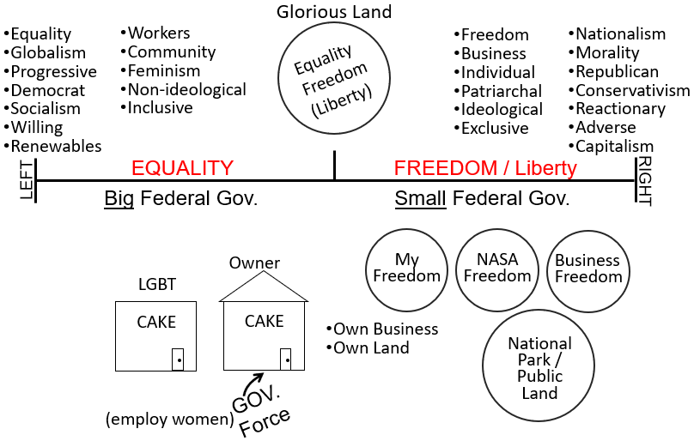
And, when we did that, other people contributed to continue with that thought. One side demands big government, because they run off the principle of equality; while the other side demand small government, because they run off the principle of freedom. When we sift all of the muck, all of the noise, and distill down to the central point, it is equality versus freedom. If you’re going to have your government run on the principles of equality, and we started to explain this, it demands a big government. And, if you’re going to have a country that principally runs off freedom, then you only need a small government. We started to kind of flesh that out a little bit more.
We started going to some scenarios, and Elder Tess made up a hypothetical scenario about a man who has a business, and he only wants to employ men because it’s in a traditionally male dominated industry like construction. And we tried to use this to explain the difference between freedom and equality. Often, when equality comes up, people just put in freedom as if the words are interchangeable, and they are not. So, to really explain that these two words are so different, we went to a court case that was from 2017: Masterpiece Cake Shop versus Colorado Civil Rights Commission.
Elder Tess put the full quote and the reference that was relevant, to the forum that we have, because she didn’t read all of it, and she thinks that she missed a couple of key points. But, just in the names what she wanted us to see is that the owner of the business doesn’t want to sell a wedding cake to a homosexual couple. It’s his business, his time, his ingredients, and his property. So, this is his freedom, to do with everything that belongs to him, including his own time and his own skill, his freedom versus, and you know if this is the Civil Rights Commission, versus equality.
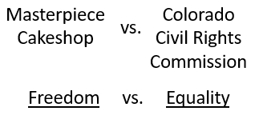
And, to prove that point, because sometimes her word is not quite satisfactory, but also to phrase it in a very precise way which she doesn’t have the words for, she went to the website of the American Bar Association; where they say, “No case before the U.S. Supreme Court in October Term 2017 received more attention or raise more important issues than ‘Masterpiece Cakeshop Ltd. v. Colorado Civil Rights Commission.’ The underlying issue is profoundly significant. Does a business have the constitutional right [aka freedom] to discriminate based on the owner’s beliefs?”
So, does the owner’s freedom give him the constitutional right to not enable someone else’s equality?
“All antidiscrimination statutes pose a tension between equality and liberty [or freedom]. Any law that prohibits discrimination-whether based on race or sex or religion or sexual orientation or any other grounds-denies the freedom to choose who to serve or who to hire. Indeed, this was a key objection to the Civil Rights Act of 1964, which prohibits places of public accommodation from discriminating based on race and forbids employers from discriminating based on race, sex, or religion. The law interferes with the freedom to choose one’s customers or employees.”
This was the issue at the heart of this Supreme Court case. Is a business’ freedom to choose its customers more important than the government’s interest in stopping sexual orientation discrimination? This court case pretty much ended with a kind of a draw, to be honest. They still haven’t resolved this issue.
That’s kind of a summary of where we got to, trying to illustrate this tension between equality and freedom. Because you know just on this court case, just down to the make-up of the Supreme Court itself, you have this, it was the cake shop that won, but it was a hollow victory; because they refused to allow that victory to set any type of precedent. Which is why, she put up an article on the Media Broadcast this week saying, everyone involved in Vespers please take note, because there’s another court case coming up. And why these court cases continue to arise is really because it has never been finally decided. It has on race but hasn’t on gender, and she thinks that we’re going to come back to that point.
You know where Ruth Bader Ginsburg (RBG) stood with that Supreme Court Case. The conservatives went with the freedom, and RBG went with equality with other liberal Justices. So, this is the conservatives versus the liberal fight. Does anyone have thoughts or questions? Anything that has arisen during the week that you wanted to ask or say? That’s pretty much our review.
So, we’re not saying that one side only believes in freedom, and one side only believes in equality. Both sides can value both principles, but when equality and freedom inevitably come into conflict, it’s all about which one wins. And of course, in our history, the one that we know is a test subject is gender.
Elder Tess just wants to ask one thing before we move on. We said, what makes this Movement up to 2018 right-wing? And we could really just blame our heritage; we came from Adventism. Adventism is right-wing. It’s a right-wing church. Why is Adventism right-wing? We listed all of these on the board, but she thinks we can put a major one.
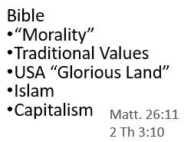
What is Adventism taught to fear? Ray or Marie. Marie?
Moli – Sunday Law?
Elder Tess – Marie, are you there?
Marie – Yeah. Sorry. (Confusion) Our fear has always been Catholicism.
Elder Tess – Yes, I agree. What are we afraid Catholicism would do? What can Catholicism do to us?
Marie – Persecute. Make us keep Sunday.
Elder Tess – How does Adventism frame that? What are they attacking?
Marie – The Ten Commandments.
Elder Tess – All your answers are good, but they are not the ones I wanted. Why are they attacking you? What are they taking away from you?
Marie – Your freedom.
Elder Tess – Your freedom. They’re taking away you, Marie, they’re taking away your freedom; and that is Adventism’s greatest fear. We’re taught from the time we’re born into the church or join the church that we’re coming up to this momentous climax where, we say Catholicism, this nebulous secret societal government entity Catholicism/UN amalgamated beast is going to come for your freedom. All of Adventism is paranoid, terrified, waiting, to have to stand up and fight for their freedom. Does that make sense? Marie, do you agree with that?
Marie – Yes. I agree. That makes sense.
Elder Tess – Do you relate to that in your past?
Marie – Yes. I had a real fear of what was going to happen when The Sunday Law (SL) was passed.
Elder Tess – I relate to that. I remember growing up even with some friends of mine, mostly boys, who were just waiting for that day to pull out whatever weapon they could find and attack and kill whoever they needed to attack and kill to protect their family’s freedom. They were raised like mini-warriors just waiting for this day to go to war over freedom. It’s so easy, I think, when you’re Adventist, to be right-wing, to see a threat everywhere. But they’ve misdiagnosed it. Brendon.
Brendon – I like what Marie was saying, what you were saying because it’s like that Catholicism, that manifests, and it looks like big government over-reach. So, that feeds into the big government narrative, and that’s why when we see all these restrictions, whether it’s based on pandemic, you see a threat of the big government coming in and attacking everyone’s freedoms and that’s a precursor to the Sunday Law, and that’s religious freedom deteriorating. That’s like a big threat. I just find it ties straight back into the big government every time. And, that’s why you have, I guess it’s always big government fights for equality, and then you’ve got the states who fight for freedom. So, that’s why the Republicans always trying to bring down the big government and make it a small government so the states can have the freedom to do what they want.
Elder Tess – Yes, because it’s not just freedom for individuals. It’s freedom for individuals, states, businesses etc. They are run by individuals. Is that all you had to say?
Brendon – I think so. I had some questions written down, but they’re sort of, I guess I wanted to look at some more examples because I see this dialogue that we’re having between freedom and equality being really helpful. I think it would be really helpful moving forward. And I guess I had some questions like, when A.T. Jones in 1888 would say, I’m going to fight for your right to worship on Sunday, is he fighting for equality or is he fighting for freedom? Or is this getting away from… Feel free to stop and move on to where you wanted to go.
Elder Tess – No, no. I expected we would go backwards in history. It’s hard not to. I think over the last, I guess, 170 to 200 years, it has become more defined. If you go back to, let’s go back from 1888, why don’t we go back to the history of slavery; would you say that Civil War was over equality or freedom? On the part of the North?
Brendon – I would have to say equality.
Elder Tess – Why?
Brendon – They were trying to… It’s complicated because I know they weren’t really many true abolitionists. So, it’s hard to say that they were after equality, in a sense, but I feel like I’m going to get caught if I say… I’ll still say equality, because they were trying to bring about human beings, albeit, only males at that point generally, to… It doesn’t bring him up to equality with the white people though, so I guess it’s the beginning stages of equality. I’m not actually sure how to answer that.
Elder Tess – It’s more defined now, this fight, than ever been; but I would suggest if we went back and actually dissected the arguments in history, it’s always been this way. There are a few sources that I think are worth downloading, saving, re-reading, and re-watching. One was posted yesterday on the Media Broadcast about Operation InfeKtion: How Russia Perfected the Art of War | NYT Opinion (https://www.youtube.com/watch?v=tR_6dibpDfo&t=1773s).
But there is an article that is from August 29, 2019, and I read it at the Germany international camp-meeting. And, this is the one I re-read today and think that everyone should have downloaded, go back and re-read them. So, many people think that Elder Tess changing her position on things because they’re just forgetting what has been said in the past; but this is a brilliant article, and it’s titled The Reasonable Rebels.
“Conservatives say we’ve abandoned reason and civility. The old South used the same language to defend slavery.”
And what this person does, who has been largely a conservative person, is they compare and contrast the language used by the reasonable right-wing today with the language used by the south and defenders of the south pre-Civil War. And it’s really worth reading. She might share it again, but anticipating that we would go back into history, she went to the article and just took a few of the quotes.
Talking about present day, she [the author of the article] says, “They [the reasonable right] present their concerns as, principally, freedom of speech and diversity of thought.” It’s about freedom of speech, freedom to think, to say, to be prejudiced. So, she says she felt frustrated when she listened to Shapiro or Jordan Peterson and others, including some women who call themselves feminists but are critical of feminism. She was reminded of the pre-Civil War south. She goes back and explains the arguments the south actually had.
Why do people in the south today fly the confederate flag and say it does not represent racism? What do they think that flag represent? Brendon?
Brendon – I think they look at it as freedom of expression. It’s freedom.
Elder Tess – But even back in the Civil War, they thought the South was fighting for freedom. It’s a revisionist history, but it’s one that millions believe. So, she is saying America’s pro-slavery faction back then styled itself the guardians of freedom and minority rights. It sounds crazy to us today, because we’re 170 years later. But, for back then, that was the argument. They were the defenders of freedom and minority rights. They were the oppressed, not the oppressors. She talks about Steven Douglas who insisted he didn’t necessarily support slavery. Instead, he said he was duty-bound to defend the South’s right on the basis of certain fundamental American principles, including the right to freely choose how you live.
So, what comes up?
She [the author] makes another point. One reason slavery was not abolished in America through the political process as it was in Britain, that those who truly believed in abolition were rhetorically straight-jacketed by the preposition that they were the hard-liners who sought to curtail freedom. So, why it didn’t get resolved in the political process in the U.S. is because abolitionists were branded as these radicals trying to curtail or take down freedoms which was styled as the chief American principle.
So, it sounds crazy to us today, but if we went back then it was freedom versus equality. Elder Tess won’t give the country, because it might narrow down the issue too much for those involved, but there’s a woman in Africa who has been going through the process of getting a divorce from her abusive husband. She separates from him physically, but he stalks her. She goes to the head of the local police, and the head of the local police says to her, I don’t care what our country’s constitution says about the rights of women. In the day-to-day living, we do not operate via our country’s constitution, because constitutions can kind of sound progressive. They’ll put nice things into writing, but on the ground, they say, no. We don’t run by constitutions; we run by culture, and culture says that you are the property of your husband. You belong to him.
So, if we’re going back to this model of the business owner, the owner now doesn’t have cake but a wife. She is property. So, if we assist a woman leaving her husband, whose freedom is curtailed according to the chief of police? Ray.
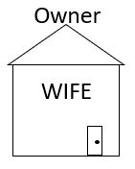
Ray – The husband.
Elder Tess – The husband, because she is part of his possession. So, for her to leave is for him to lose, to have stripped, to have taken from him, because she obviously doesn’t have her own mind, the Movement, other people have influenced her. According to them, she can’t think for herself; so, she’s being separated from her husband, taken from him. We are taking away his freedoms, because we are taking away his property. So, this is the lives of millions and millions of women. They are property.
So again, even today it’s freedom versus equality; and if we went back to the pre-Civil War America, it’s the same issue. It looks more obscure to us today, because we are 170 years later and things are in starker terms now. But, even then, the South saw that as the North are attacking their freedom; because it was attacking what to do on their land with people who were no more than objects. And, not just defending slavery itself and the freedom how they chose to live, but also their freedom of speech. You were cancelled in the North, in many places, if you defended slavery.
We asked last week, it came up, and someone said that the left side was tolerant and the right side was kind of cancelled. Elder Tess doesn’t actually agree with that. She thinks the left side does a whole lot of cancelling, about whether or not, we don’t mind that Trump gets banned from Twitter. Brendon, does that make a little bit of sense? I know it’s a little not clear when we go back.
Brendon – Yes. So, if I could say five seconds worth, just so you could correct me if I’m misunderstanding. But it’s equivalent of saying the South have their side; they’re fighting for their freedom to do with their property what they want; and they don’t want the big North coming in and interfering with their freedoms, but their properties is human beings. So, it’s the same principle as the cake shop. They don’t want… It’s the same principle. Or, wives in that example as well. It’s exactly the same principle.
Elder Tess – Yes. And their way of life is not just slavery. Slavery is an integral part of it, but it’s also the entire culture that wraps around that. If you’ve ever seen Gone with the Wind, the glamorization, the glorification of southern culture built on agriculture; built on state’s rights; built on this kind of image that they made look beautiful. A lot of people who defend the antebellum period, they don’t see themselves as racists. They are duped, willingly or unwillingly, by a revision of history.
They believe that the Civil War was the South fighting against the big government North for freedom. It becomes more obscure for us today, because if you have enslaved human beings then isn’t that a fight for their freedom? And in a way, it was. But I would suggest that we should re-read this article, so we can pull its bones apart a little bit more; and I think we would still see freedom versus equality, and how that has over the last 200 years only become more and more clear. Brendon, did you have any other…
Brendon – Thank you. I really appreciate that. Thank you.
Elder Tess – Ray. Your hand was up.
Ray – Yes. I only put my hand up incase Marie couldn’t answer. I couldn’t add anything to what’s been discussed already.
Elder Tess – Josephine.
Josephine – I had a question at the beginning, but I think little by little, you’re answering or through Brendon’s questioning, you were answering mine. But maybe I should just ask. Does the outcome, when there’s a conflict between freedom and equality, does the outcome stay constant? In other words, one side always wins or is it likely to change as we progress in our time period?
Elder Tess – I think it’s always messy. But, if you look at the makeup of the Supreme Court now, which one do you think is likely to have the upper hand? Freedom or equality?
Josephine – Well, the conservatives are more likely to win, isn’t? Then it would be…
Elder Tess – We have a Supreme Court built on freedom.
Josephine – Yes.
Elder Tess – We’re going to keep going over this point. I want to expand on this freedom a little more, so that it might become clearer as we go. Moli.
Moli – I was just hearing what you were saying. Because the other day, I was listening to the president of Ukraine. He was talking to the UN, and he was saying that Ukraine was fighting for their freedom, and they will defend their freedom to the death. I thought to myself, maybe it was the formalizer of the message, but I was just asking.
Elder Tess – By formalization of the message, do you mean the waymark of Panium?
Moli – Yeah, of the gender equality.
Elder Tess – Panium was 2021. We taught that since 2018. I think what we need to do is be careful that we don’t get pulled into Ukraine, because it’s a hot war. I’ve been saying since 2018 that the conflict is between Russia and the U.S., and their respective allies. So, Russia, China etc.; U.S., NATO, etc. But it’s this conflict that is heavily based on information warfare, and that’s what we saw in the late months, particularly surrounding October of 2019. And, what I see people do, I see the comments online is like hooray; look how our message is vindicated; now, we can pin it to a hot war. And, I think that is sad, frankly, because if we have to wait to see a hot war to trust in the waymark of Panium, then we never believed in 2018.
It’s centered on information. They’re fighting for global opinion. That’s one of the reasons that Elder Tess encouraged you to go and watch the video that was posted from the NY Times yesterday on the Media Broadcast. It is through information that the west is winning in a form. Ukraine is a small part of a much bigger story, a bigger puzzle. But, just bringing it back to freedom versus equality, Elder Tess is not demonizing freedom. Freedom is good, but when they come into conflict, one has to kind of slide underneath the other, and that issue, that seemingly simple issue of one just sliding underneath the other, is what has created a polarized world.
The issue that the whole world is clashing over is gender; women, LGBT. That is where the collision is happening. We see that in Australia. We see that in Australian schools, Australian religious schools. They are not fighting over whether or not they will allow someone of a non-white race into their school; or allow, even in Florida, whether or not they will allow someone to admit that other races even exist. What they are fighting over is just to allow children to know that LGBT people even exist. Everyone is colliding on the subject of gender, and two sides are fighting for freedom versus equality. Of course, freedom is valuable, but when it comes at a cost, then it will come into conflict.
Elder Tess wants us to look at some examples. So, let’s go with her to Australian politics. What is the right leaning Australian political party? Ray.
Ray – That’s the Liberal National Party Coalition.
Elder Tess – Go further right.
Ray – Hammer United? Or One Nation?
Elder Tess – I get criticized by some people not in the Movement that I don’t keep a close enough eye on Australia. They wonder why I’m so focused on other parts of the world. So, I could get this wrong. I was thinking of the United Australia Party. Is that separate to One Nation?
Ray – That’s Clive Palmer’s one, United Australia.
Elder Tess – So, that’s Palmer’s. So, there is, it’s very confusing. Left-wing is Labor, and right-wing is Liberal, which doesn’t sound like it should be. But then there is United Australia. If you drive down the highway, you see their billboards. What’s on all their billboards? What are they fighting for? We’ve gone left-wing, right-wing, but now we’re going into the far-right in Australia. I’ll screen share. Rachel, were you going to answer that?
Rachel – It’s ok. I’ll wait until after you show the pictures; make sure I am right. It does say freedom. Freedom for Australia.
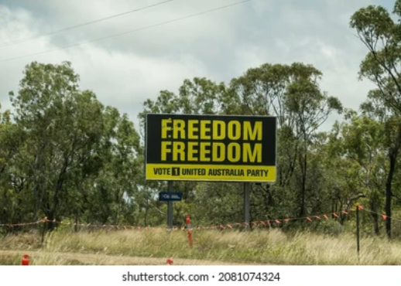
Elder Tess – What are their billboards? “Freedom. Freedom.” More of it. “Freedom. Freedom. United Australian Party. We can never trust the Liberal or Labor parties Again.” You can’t trust the mainstream parties anymore. What do you think they’re trying to sell? What are they screaming? What do they think is under threat? Rachel. I’ll let you finish your thought.
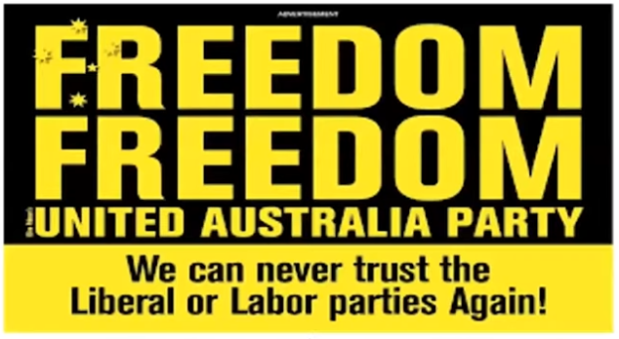
Rachel – I was thinking, I’ve seen quite a few of their freedom, and yeah, making Australia great again.
Elder Tess – You go into a little country town in Australia, you go to the center of the main street, and there’s a big billboard with Trump’s face on it. Why? He stands for something kind of global, and they use his image. They use that ‘make a country great again.’ But it’s plastered with freedom, because that is what they’re saying is under threat. That’s what they see as under threat.
Canada, truckers, what’s it called? Moli. Did you follow the news with Canada and the truckers? Do you know what that was called?
Moli – I thought it was ‘Freedom Fighter.’
Elder Tess – Freedom. What are they afraid of? What’s under threat for them? You have Covid. All of a sudden, what’s going to come in conflict? Freedom. Freedom versus equality. It’s so easy. We know with the floods up north. Some of these towns, that probably one of the, or the worst, hit town is where I used to live. I know those streets. I know every business they put up when they talk about it where they show the footage. I know those businesses. So, I know what is lying lower and what goes uphill. So, when you have the news crew come around on a helicopter, are they going to take their helicopter and show you all of the miles of land that’s a bit under water, or they’re going to take you to the very epicenter. Where do they take you, Moli?
Moli – The epicenter.
Elder Tess – Yeah. They take you to the epicenter of the disaster. So, when you have news crews come and film the trucker protest, they’re going to take you, if they see a Nazi flag, they’re filming that. That’s where they’re going to. But, surrounding that little minority, who are for sure neo-Nazis, you stretch that out, and what you have is a lot of people who have seen freedom and equality collide, and they are terrified of losing freedom. If we lose sight of that kind of majority who are not neo-Nazis, we lose sight of what the conflict is actually about; we lose sight of the people we need to actually try and reach. Because a lot of us were right-wing before 2019, and I don’t think that anyone still in the Movement for sure would have ever considered themselves a neo-Nazi or would have flown a confederate flag. We need to just not see the epicenter. And this is something that the media does, and we should be aware of it.
Sure, you can pick some of the concerning elements in colors and go into that, but the issue is freedom. “MANDATE FREEDOM.” This is what they’re all shouting.
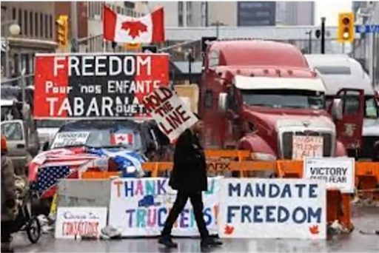
Here is another photo: “PEACE. LOVE. FREEDOM FOR ALL.” There are grandmothers out there. Their concern is freedom. And, that freedom is being eroded on behalf of equality. And, many people find that frightening. Conspiracy theories certainly play a large part in aggravating that.
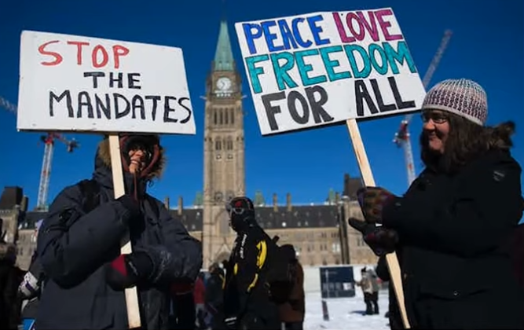
I have one more. This one, I just wanted us to consider, when we see this type of thing go around on social media, (another photo: a black woman wearing a mask) what are they saying? What are they saying here is happening? What’s happening to this woman? Sandy.
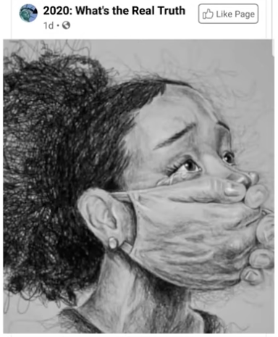
Sandy – Just by the picture, wearing the mask is taking away her freedom. She can’t speak. She can’t say what she wants to say. I suppose the mask mandate is a freedom that it’s taking away her freedom. Is that right?
Elder Tess – That’s what I see in that photo. That’s the issue that people in the Movement are confronting, and they’re seeing photos like this and saying, I support that. And my question is, if that’s your response to the mask, and your fear is erosion of freedom over mask mandates, where do you stand on the Midnight Cry (MC)? Because, we’re still fighting two streams of information: equality versus freedom. And, if what you’re afraid of is the erosion of freedom, because of a big government equality, you never accepted 2018, and it’s 2022. We’re a bit a way along. Sandy. You had a thought or question.
Sandy – Oh, no. It’s ok. It was from a way, way back. It was just a comment I was just going to make, but it’s sort of way back in the past. It’s ok.
Elder Tess – We ca go back.
Sandy – I was just going to say how the word freedom, I think today, the left, talking about America, use the word equality a lot. If you go back to the, like 1960’s in the Civil Right movement, they use the word freedom for their cause, for race, freedom for the races which was probably really equality. So, I think we were saying like freedom means a different thing for the right and for the left.
Elder Tess – I think it would depend. I don’t know what sources you’ve gone to see that. Freedom certainly gets pulled into it. But the ones I read speak of equality. I think it depends a bit on the sources.
Sandy – Ok.
Elder Tess – Freedom certainly gets thrown around, but I think it would depend, at least a bit, on the sources that one goes to. Some are more precise than others. But I do want to go back to the Civil Rights movement as well, so it’s good to go back there. Because I want us to just complicate our picture a little bit. Ray, did you have another thought or question?
Ray – No, I was just going to answer the freedom convoy question. That’s all.
Elder Tess – So, just to complicate things a little. We looked at Australia’s far-right party, which I think is emblematic of a lot of them. We’ve looked at the freedom convoy, just to give some examples. Two other comments that I wanted to make: one is from the Washington Post (WP) article from 2004. I don’t agree with all of these articles; this one and the next one. They are, I think, coming from somewhat conservative voices even though it’s the WP. But, covering the 2004 election, they say today as for the last 200 years, the left and right divide is defined by different valuation of equality and freedom. So, they’re seeing that in the 2004 election. That’s the divide between the Democrats and the Republicans, the left and the right.
A 2019 article said the same thing. “What is more important to you: Freedom or equality?” And then, breaks that down via Democrats and Republicans. This one, I might just refer to it a little. It’s from the Renton reporter because they go back into history. They say that, “If you’re a Democrat today, equality is more important [than freedom]. If you’re a Republican, it’s freedom [that is more important than equality].” Then, they go back 154 years, from then to the Civil War. And, they show how that system changed. “Current Democrats favor equality for women, immigrants, minorities, and gays [homosexuals]. Before the Civil War, though, Southern Democrats favored slavery and states’ rights, while Republican abolitionists [the North] worked for a level of racial equality and the end of slavery.”
So, even in this article, the point he is making is that today, Democrats/equality, and Republicans/freedom. They’ve switched. Because if you go back to the Civil War, what you would find is the Democrats, which was then the South, were for slavery and states’ rights and states’ freedom, and the North was for racial equality and the end of slavery. So, even going back then, it defines it in terms of South/freedom and North/equality.
“Southern Democrats felt that giving equality to former slaves only diminished white’s power and status and took away their freedom. They fought violently to reduce equality...” They are then post-Civil War into the history of the Jim Crow era. So, even after the Jim Crow, they’re fighting racial equality, because they believe it takes away from their freedom. I just thought that was an interesting article that was just going to trace it right back to that history. Brendon, and then we might move on just to complicate our picture a little.
Brendon – In danger of simplifying this way too much, are we looking at the beating heart of what the Sunday Law is going to look like, this clash between these two, where the left actually compromises on equality towards freedom?
Elder Tess – I don’t know what the left-wing compromise looks like, because they already are. If you had today, put it this way, a few white pop stars who had a history of racist language and violent attacks on African-Americans, would you take these white pop stars, put them in the center of the ring at the super bowl and have millions of people cheer them? Would you see that? White pop stars with extensive history among some of them of varying race-based abuse, would you see them championed at the super bowl?
Brendon – No.
Elder Tess – You wouldn’t; but when it becomes gender, and it is gender that is at the core of the issue, where is the complaint? Where are the voices? No one wants to complain. Because like the article shared earlier this week on the horrific case of abuse, as the lawyer said, domestic abuse is common, and it’s a relatively minor criminal conviction. So, democratic compromise, the vast majority of the world has been in compromise if we just take it prophetically from 1989. They are not going to correct that. Whether or not we take that and pin it to the Sunday Law, sure, lot of them will compromise, but it’s still going to be, just looking at the Supreme Court, it’s not a Democratic compromise that actually does that.
Elder Tess thinks that’s the only point she would perhaps be nervous about agreeing with what Brendon said. A Democratic compromise isn’t, she would suggest, at the center of the Sunday Law. Not that we have a full visibility of what that looks like. 1850 was a history of failure. That was clearly compromise; but being a history of failure, she doesn’t think we can take that exactly to today. Otherwise, yes. She thinks that she agrees with what Brendon said. We’re looking at the absolute heart of the Sunday Law issue.
Brendon – Thank you. I knew it was going to be in danger of being too simplified.
Elder Tess – I don’t think it was too simplified. We have seen compromise at every step of the journey. Find me a Democrat in Congress who’s a radical feminist. It’s just part of the story now.
So, to complicate, we have the principle on freedom. We’ll go over the right side. It should be, my body, my property, my life, my choice. So, I don’t have to take, I don’t have to eat, I don’t have to sell to anyone, I don’t have to employ anyone, that I don’t want to. It’s my own independence. And, that’s the center of freedom.
So, let’s come to gay marriage. Let’s say that this person is gay. And this man wants to marry this man. Why would a party that believes in freedom disagree with this scenario? Who does this hurt? Isn’t this their bodies, their marriage, their choice? All of that’s an introduction to try and get people to talk about the complication in this picture. So, if anyone has thoughts or questions, now would be good. Otherwise, I’ll just start monologuing. Josephine.
Josephine – Because they believe in traditional values, so they…
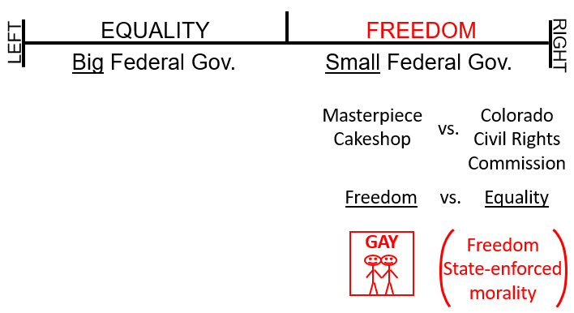
Elder Tess – Yes. So, if we’re going to talk about the Republican Party, you turn to traditional values. They have a combination of freedom, but it’s not pure freedom. The Republican Party does not operate on pure freedom, and that’s the complication I want us to see. This is equality, and the Democrats operate on equality with all their compromises. The Republicans operate on freedom, but they also compromise because they combine freedom with traditional values. And traditional values, I will just call it, state-enforced morality. And, that does become a compromise with freedom.
Elder Tess wants us to consider a political party that doesn’t do that. Does anyone know the political party she’s is talking about? It’s the third biggest political party in the U.S. You have the Democrats, the Republicans, and then number three. Brendon.
Brendon – Is it the Libertarians?
Elder Tess – Libertarians. So, what the Libertarians believe in is freedom without state-enforced morality; pure freedom. I don’t know if you’ve seen political charts drawn up this way, where you have left and right, but you have this other scale down the middle, and this [top] stands for authoritarian, authority, obviously control, and this [bottom] stands for Libertarians. And, what they would teach is that this is the left authoritarian, right authoritarian, left Libertarian, and right Libertarian.
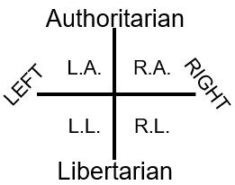
And before Elder Tess asks you where to find a hole in that graph, she will explain a little more of what the Libertarian party believes in. It’s the third biggest political party in the U.S. Libertarianism believes in freedom without any type of government restraint unless it becomes dangerous to other people. So, Libertarians say that you have the liberty to say, eat, smoke, buy, sell, learn, and do whatever you want with whomever you want, so long as you don’t hurt another individual or another group and take their stuff along the way. Live and let live is the Libertarian motto.
She will quote from their website. “Other political parties prioritize the rights [or freedom] of some, but not others.” They’re talking about the Republican Party here. They are trying not to target them, but they’re saying the Republican Party prioritizes the rights or freedoms of some but not the freedoms of others. “Libertarians value the right of all to live in whatever manner they choose, so long as they do not forcibly interfere with the equal right of others to live in whatever manner they choose.” They “also believe the government must treat all people fairly and equally before the law.”
So, the government has to treat everyone with equality. The government has to treat everyone with equality and then allow everyone all the freedom they want as long as they are not actively hurting someone else. So, a Libertarian position will support, what are some of the things they will support? If you are in this position, if you’re a Libertarian, how will you go with… James?
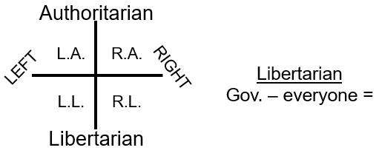
James – Marijuana, or certain jobs like marijuana.
Elder Tess – So, one of their mottos was that you can eat, smoke, buy, and sell. So, yes. Definitely marijuana. They want the decriminalization of drugs. So, they would say no to the war on drugs, for example, or they would say no to tough on crime. You don’t need government intervention, aka a police force, unless someone is actively hurting another person. Absolute freedom to smoke marijuana. Anything else, James?
James – No. That one just popped in my head.
Elder Tess – Ray.
Ray – Would they be in support of gun rights?
Elder Tess – Guns. Yes. Anything else?
Ray – Maybe abortion?
Elder Tess – Technically, yes. Technically. The reality of it isn’t actually…
Ray – I was actually thinking of asking this as a one of your complicated scenarios before you started talking about Libertarianism.
Elder Tess – You should’ve asked.
Ray – I didn’t speak up. We can come back to it.
Elder Tess – Josephine. Do you have something for the list?
Josephine – I was just thinking of the holes in that. It sounds to me a little bit like the cultural feminism, you know, do whatever you want. My mind was just running away. What about marriage?
Elder Tess – Gay marriage, absolutely. They’ll support gay marriage. Freedom. You brought up cultural feminism. My problem with cultural feminism and liberal feminism is not that I’m a conservative, and I have a problem with the way people want to dress. The problem is… Marie.
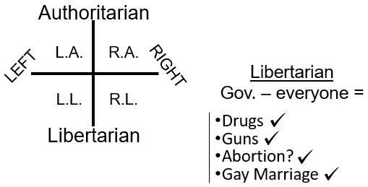
Marie – I’m just wandering about vaccines. How they would go with the vaccine mandate.
Elder Tess – Oh, not at all. No force. No one can put anything in... I eat what I want; I ingest what I want; I smoke what I want. Complete freedom. I just want to pull up about cultural feminism. What fight are we having from 2018 to today? The fight we’re having, when I’m presenting such things as, when I’m doing presentations, and I’m titling them with names such as, “Don’t I have the Freedom,” and the inference is, no, you don’t. What am I saying in that? Brendon.
Brendon – You’re saying that you don’t have the freedom. You’re saying that you’re a radical feminist, I guess. Is that where you were heading? There’s restraint.
Elder Tess – So, I’m presenting in 2019 in Germany. I present the Eden-to-Eden model and teach equality. I’m walking out of that room. I haven’t even left the room, and the male board member of the ministry comes up to me and says, “Love this message. Love it. Now, I understand this Movement is going to have small government, because everyone has the freedom.” I know that I’m not even ordained yet, and I know the battle that I’m about to go into; and I know just how wrong he is. And, I also see that he and I are going to fight, and we’re still fighting today. So, what’s the issue? What has he heard? I presented equality.
Brendon – He’s heard freedom. He heard unrestricted freedom.
Elder Tess – And the key to knowing that’s what he heard is because his first thing he said was small Movement government. We don’t need a big government in this Movement anymore. We don’t need ministry boards and continental elders because we don’t need control because this Movement has finally learned to practice freedom, and this was the issue that started in 2019. Lots of people heard me present equality, and they loved it because they were conservative, and what they heard was what they wanted to hear. It was what they thought, “I’ve believed in this for a really long time. I’ve believed for years that this Movement was just controlling, and was not giving members the freedom.” And they wonder why over the next months and the next years, they’re clashing with the Movement leadership because they did not understand what I was teaching. Trousers, was that about equality or freedom? Brendon
Brendon – Equality.
Elder Tess – Equality. Ear rings. Was that about equality or freedom?
Brendon – Freedom.
Elder Tess – Freedom. Every fight that I had since 2019 with people has been about me presenting equality and saying you don’t have the freedom, not in this Movement; because we are not a right-wing Movement. You’re not going to like the way we operate. You’re not going like the vows. Why do people all of a sudden not like vows from 2019 forward?
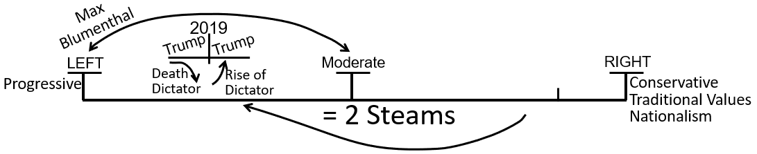
Brendon – Because it’s taking their freedom, in their minds.
Elder Tess – To vow for something is to take away freedom. This is the clash that’s being had. We have not stopped fighting over the two streams of information. It’s the Midnight Cry over and over and over and over again. It’s right-wing versus the left-wing; it’s freedom versus equality. And what I’ve said since 2019, when I’m saying, don’t you have the freedom, I’m saying why haven’t you moved? Just shift already. Just give up the principles of freedom that are conflicting with gender-based equality. The controversy in Africa about the dowry system where they say, women have the choice. Women have the freedom to choose the dowry system; and I’m saying that they don’t have the freedom, because they claim to believe in equality.
They claim to believe in equality, and if you claim to believe in equality, then you don’t have the freedom. So, when we look at liberal feminism, we’re not fighting with it because we think they’re immoral. We’re fighting with it because they compromised. We’re fighting with it because they are on the right [freedom], in every way they want to be that makes them feel good. Cultural feminism is on the right. That is the compromise. We’re constantly confronting compromise, and the compromise is not people sliding into some type of immorality. The compromise is people saying, ok, I’ll take 80% of equality, but I’m going to latch hold of all the 20% of freedom. I’m not going to move left-wing. Josephine, did I get to you?
Josephine – Yes. Yes. I asked a question.
Elder Tess – Ah. You’re the one who gave us the road to this, because you brought up cultural feminism. Raymond.
Raymond – I only put my hand up to answer the question.
Elder Tess – Marie.
Marie – Is it simply that people don’t understand the constitution? That’s what just keeps popping up in my mind. It just seems that people just don’t understand the principle of the constitution, or is it more just, it’s convenience for people.
Elder Tess – Freedom is a convenience? Do you mean people inside or outside of…?
Marie – I mean both. Like to me, it seems the principle behind is the constitution, where you would choose equality over freedom, if you were honest with yourself, but could it be that people, and I might be wrong in the way I’m understanding it, but could it be that people are just, it’s convenient to choose the freedom path?
Elder Tess – It has an appeal that equality doesn’t have. If you were to think about a movie, I’ve watched a lot of movies in my life. I haven’t always been in the Movement, and I think it’s interesting to keep an eye on pop culture. You don’t have to watch movies to do that, but maybe other people were better Adventists than I was. If you look at what movies celebrate, what sells? What sells movie tickets? What inspires people or rallies people? What makes them want to be, what’s that anti-Semitic actor? He does the Scottish movie. Mel Gibson.
If you think about movies, there was a 2004 movie with Will Smith called “I Robot.” The most selling point of a movie is, if especially they are going to appeal to young men, which I think we’re going to tie in a little more, as we go along, they are going to have that kind of appeal. I’ll give you kind of the plot of “I Robot,” and then see if you can pin it, if you’ve watched other movies, to what they kind of embody. You have a humanity that treats itself badly; WWI, WWII; on-going discrimination; Iraq war; conflict. It’s a mess. And then, you have, in this movie there’s a robot. Sometimes it’s a billionaire or an alien, but you have this entity that has a high degree of power, and this entity says, you know what? So, humans stop hurting each other, we need to take away human freedom.
There was a really cute animated movie that I liked called ‘WALL-E.’ Similar principle. Again, it was like a robot, and because humanity had destroyed the planet, it’s not in a kids’ movie, but you would assume millions of people have died. What the robot knows it needs to do is to take away humanity’s freedom. Just put them all in these tight little bubbles where they just eat what they’re told to eat, do what they’re told to do, follow rules, follow orders by the letter, and lose all their freedoms. And then, what do you have? You have Will Smith, and always in Hollywood, of course, with a gun, lots of guns, and what he is going to do, whether it’s 007, or Mel Gibson, or some animated creature, what they’re going to do is to take down, often kill, the alien robot or billionaire who is taking away people’s freedoms to try to force through equality, to try to stop humanity from hurting itself.
That is the plot of movie after movie after movie. That is what Hollywood sells, particularly, they think that demographic is young men. And Rachel, who I’d wanted to actually speak tonight because she has something she was going to do for us, but she’s going to do it next week, and I’m sorry Rachel because I wanted to hear you. But Rachel presented on gamergate. These young men are not radicalized just by their little community or just by their video game culture which is also runs off similar principles. They’re watching these movies that are targeted, the demographic, at young men. That’s what sells and inspires people.
That’s what sells music records. Fighting for freedom, fighting for individual freedom. The music that gets you amped up and going. You don’t sell movies of, to young men, about a slow progressive struggle for equality. That’s not glamorous enough. Honestly, Elder Tess thinks one of the problems with Adventism is that the Adventists’ model of the end of the world, based upon freedom, allows for so much inherent selfishness. She doesn’t think that even their ideas of martyrdom for the Sabbath are selfless. Instead, she thinks for a lot of people, it’s incredibly selfish. All they want to be is Will Smith, Mel Gibson, that hero, gun toting or not. But, if they’re a member of the 144K, no one can touch them.
How smug do we get to be? If we are martyred, we are heroes, and then we’re raised up again, and we can say, I told you so. It’s us against the ugly masses who are trying to take away our freedom. And, it has become inbuilt, especially for young Adventist. With a type of apocalypse end of the world scenario that puts them as that superhero. And, it is appealing in a way that is incredibly selfish. What our message is done is strip that away, every last shred of it, and the only thing left is a selfless position for equality. I can’t remember exactly how I started talking about movies.
It’s going to tie into what she wanted Rachel to teach us tonight, but she’s going to do that for us next week for sure. But this is what sells to people, and it sells through Hollywood even though many of those actors are left-wing. What sells movies is not equality principles. Just like what sells video games. And, if we go to gamergate, they’re watching, you know, the marvel cinematic universe, they’re watching superhero movies, and lot of these things that appeal to them. We should be aware of that, and this is part of compromise. It’s part of the problem with some people who now try to watch a movie because sometimes their mind just gets so full, and so sore, and they try and escape. They come to me, and they complain, I can’t escape anymore because now I see it everywhere.
But Elder Tess thinks Adventism has a similar problem, where even if they didn’t, even if they were good conservatives and never watched a movie, their end of the world scenario is movie-like, and it is freedom based; and, they are the superheroes. And, it’s more about getting proven right and defending their freedoms, and for the young men that she grew up with, ready and willing to kill whoever they had to kill to protect their families at the end of the world. Essentially, they were looking forward to it. None of that is about saving people. And, what we need to do is also to be careful with the right-wing, that there are good people there who aren’t necessarily, inherently, believing in sexism, or racism, for that matter. Sexism is deeper and more complex today. They might believe in headship for a different reason, but we can’t make it all ugly. We have to see that they have a problem with that underlying principle and know how to reach them.
We are out of time, but we went to Libertarianism. We discussed what Libertarianism stands for.
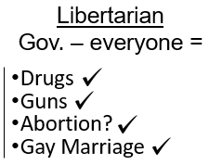
And Elder Tess asked, what’s the hole in this? Where does it fall apart? I’ll give you the answer, but not explain why, and she’ll ask someone next week to explain why. Left-wing Libertarianism. Explain how that works or doesn’t work. But they stand for freedom, supportive of freedom without any state involvement.
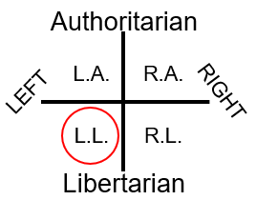
So, they support gay marriage. They support women taking on any job women want to take on. Women, full freedom. If a woman wants to enter the workforce, if a woman wants to run for president, run for president. If someone wants to smoke marijuana, smoke marijuana. If someone wants to own a gun, own a gun. Prostitution, religious freedom, they have so many positions that we would agree with. Supportive of gay marriage, supportive of applying for a job, or studying a particular field, they support all of that.
But Elder Tess makes one point just to warn us. This is a reference that we’re going to come to, going to go into detail next week. Libertarianism has an alt-right problem. Many prominent leaders of the far-right have at some point identified as Libertarian. What they recognize is that leaders of the far-right today, they are more likely to come through Libertarianism which means they agree with gay marriage. They, some of them agree with abortion. They agree with women in the workforce. More leaders of the far-right come through Libertarianism than any other avenue, including Republicanism. We want to see why because the greatest threat, if we’re going to talk about the far-right today, isn’t elderly male Republicans.
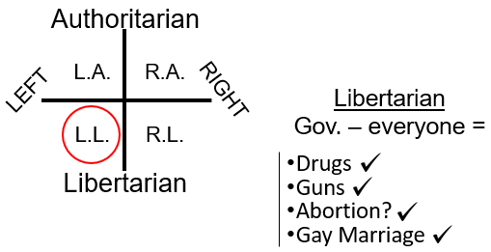
We’ll go further into that next week, and Elder Tess is excited that Rachel is going to help us. She will not be able to take any more questions or comments now, but if you have any, hold on to them. Don’t let them drain away, even if you have to go and write them down, because she wants to hear them.
So, to review, we reviewed and broke down this essential ethos of the right-wing and the left-wing: freedom versus equality. We started a discussion that Elder Tess is sure for many, might not have gone and answered all their questions about history; why the North versus the South was still equality versus freedom even though it has been more complicated at different points. We explained the other complications when it comes to the idea of a person as a property, and how women are viewed as property. Probably, the vast majority of the world believes so to varying degrees. We went to couple of quotes to kind of shell that out a little bit more.
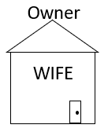
Then, we started talking about Libertarianism. We did give a few examples of Australian politics and the freedom convoy to just show how freedom is just what the right is pushing, and the erosion of freedom as what they see as the great threat from the big government. We also touched on the Adventism’s love of freedom. Love of freedom, because the loss of freedom is what their biblical mindset has taught them to fear. And, that ties into Hollywood’s mind as well. So, we discussed a lot, but we’ll review next week. We went to Libertarianism and discussed just how beautiful that model is. Elder Tess wants us to see it as beautiful. And then, she wants us to see why it’s the most dangerous political model there is.
Many of those in the far-right, many of those who we would see as the greatest threat today are young, mostly male, but not old white men in congress fighting gay marriage. We’ll go into that next week with Rachel’s help.
One last thought before we close. There is an article that she wants everyone to read. She might send two articles: first of all, the one from 2019 on the Civil War titled The Reasonable Rebels, and if you read that with what we said tonight in mind, it might help clarify things a little. It is on the Media Broadcast. She thinks that she posted it there in the early days of the broadcast as one she just wanted people to have, but also save and keep and re-read.
There is one other article that was written in 2015. It’s by VOX titled The Internet Is Full of Men Who Hate Feminism. It’s quite long, but Elder Tess would really like everyone to read it, even if you read it soon, and then re-read it, if you could just before Vespers next week. It’s from 2015, and what this journalist does is he goes and speaks to some of the men who were involved in gamergate. Some of you have heard Rachel talk, present on gamergate, and she is going to do that for TMW next month. So, for some of you who have already seen her present on gamergate, the context around it will make a little more sense. It is still worth reading. There are some key points that’s in that article that she wants us to pick up because a lot of this centers on Libertarianism and a younger demographic of men. So, homework, if you don’t mind.
Prayer – Amen

