A Purer Form of Freedom

TMW Vespers

March 18, 2022

Elder Tess Lambert
https://www.youtube.com/watch?v=f3_SIRzBqfk&list=PL6-Mv8H520RncgAlBdn_u3bAlt_kGZZhH&index=7

Review
We’ll start with just a mini review. This is where our journey took us, but we’ve moved on quite a bit from then. We’ve moved on to the other side of the board just because we’ve run out of room. We’re still discussing this switch, this bottom half of the board that has the political scale of left wing to right wing. So, we’re still covering this subject, but because we’ve run out of room, we’ve switched the board.
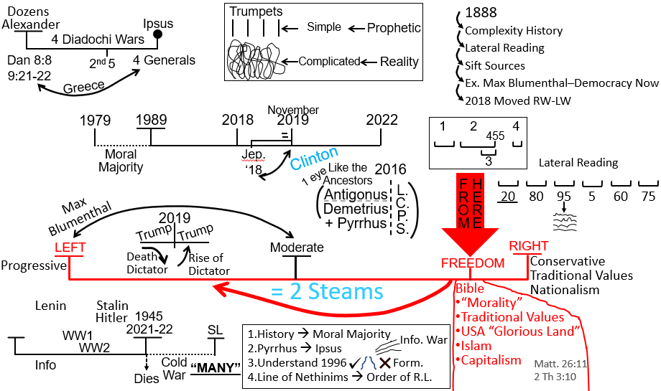
Left wing – its predominant ethos is equality. Right wing – its governing ethos is freedom.
As a movement we’re about here [pointing to right wing]. Everyone seems confident that this is where we were. We have, since 2018, had to move from the right political spectrum to somewhere in this political spectrum [motioning to mid area, moving from right wing to left of moderate]. We didn’t do that [move from right to left] because of news articles or my personal bias. We did that because of our prophetic message. And we condensed that prophetic message into roughly four key points or parts that from 2018 was summarized as two streams of information.
What we were saying was externally, one stream, a second stream. One is good and one is bad; one is good and one is evil. And we also had a discussion on how that is very simplistic terminology and the problems with seeing something simply. So, we know it’s not just good versus evil; it’s not that simple. And we’re going to demonstrate that once we get into the left wing. But right now, where we were up to was, we were saying that we moved from right wing to left wing because of a prophetic message. What does that even mean? Unless we can define what the right wing stands for and what the left wing stands for, we have no concept of the significance of that change in our political leaning.
We began to define right wing and left wing. And when we did that, we saw that the fundamental ethos of right wing is ‘Freedom’ and the left wing is ‘Equality.’ That is very clearly typified in the 2016 election; you have Clinton versus Trump. You have really equality versus freedom. And it’s hard for some in the Movement to see that Donald Trump stood for freedom, or that the right wing stands for freedom; because we see that as this persecuting political party now, but I want us to see the nuance. I want us to swim past the media spotlight on the neo-Nazis, and get down to what they actually believe in; because we disagreed with neo-Nazis in 2017, and every year before it. What do we disagree with? We didn’t start from 2018 to say, “you know we have a problem with Nazis.” That’s not what happened. We had a more fundamental disagreement with right wing ideology.
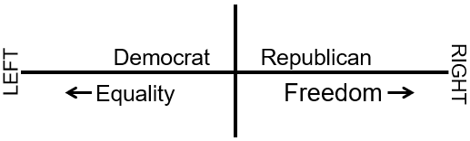
So, this is the discussion of freedom versus equality. We went to the dictionary and defined “freedom as the condition or right of being able to or allowed to say, do, think, etc, whatever you want to without being controlled or limited.” So, whatever you want to do, say, think, you’re allowed to do that.
A lot of people on both the center and the right wing disagree with hate crimes. I want to slip that in there for a second. How is it that when someone kills/murders an African American man, they are charged by the courts for murder? So, they’re charged with murder, they receive a life sentence, and no parole. But then they are charged with a hate crime. And that same murderer now is going to get another sentence, possibly another life sentence, because when he murdered this man, he did so from a mental position of racial hatred. So, someone on the right side of the political spectrum, they’ll say I’m not racist. But when you charge someone, convict someone of a hate crime, who’s already convicted of murder and going to serve a life sentence, and now you’re going to convict them of having hatred. What you are convicting someone of is a thought. Does that make sense? Can we see that charging someone with a hate crime is giving them, in this case, possibly a life sentence, for a thought? They are charged with two things: murder and conducting a hate crime. Both are life sentences. Murder is an action; hate is a thought. These are two real life sentences.
So, someone on the right wing will say, I’m not a racist, but hate crimes. You’re convicting someone for a thought. And we believe in the freedom to think anyway you want to think, even if we don’t like the way this person is thinking. Obviously, it’s awful the thinking that this racist person had in their mind. But you’re still giving someone a sentence of years or full life term for a thought. So, that will very much agitate someone on the right wing, someone who will say they are not racist, who possibly isn’t racist, but still sees that as a dangerous precedent for freedom.
Now obviously, I disagree with that. I don’t believe that is an accurate portrayal. But I just want to demonstrate how fine some of that logic is about freedom, especially when we start getting into hate crimes and these finer elements; because, they are convicting someone for a thought. If people have a problem after I’ve said that, with why we, as a Movement, and the left wing, believe that it is acceptable to charge someone with a hate crime, then we can explain why I think that person is wrong that I’ve described. But otherwise, I’ll just move on.
Just explaining freedom versus equality. Freedom is to be able to do, say, think, including hate thoughts, without being controlled or limited.
Equality is a situation in which men and women, people of different races, religions, etc. are all treated fairly and have the same opportunities.
If you have thought more about those definitions, I hope they are starting to get more established, as they individually are, but also the differences between freedom and equality. It’s easy for people to throw the word freedom into all kinds of situations. But we need to see the difference.
Then we went to the American Bar Association, which because of their profession has to see the difference between two such loaded terms, and they described how all anti-discrimination statues pose a tension between equality and liberty. So over and over again, you have right wing freedom and left-wing equality coming into conflict. Someone in the right wing will also believe in equality, to a certain extent. Someone in the left wing will believe in freedom, to a certain extent. America, because it is the ‘Glorious Land,’ was founded on principles of freedom and equality. They are both good; but when they come into tension, one has to give way. The right wing says equality has to give way to freedom, because freedom is all important, even when people do, say, or think things that we don’t like. Left wing says freedom needs to give way to equality, and it is equality that needs to matter.
When we were trying to define right wing and left wing, Greg made a comment about left wing government is large because they need more representation. They want more representation from different communities. So, left wing government might have five people and right-wing government might have three, because left wing believes in big government and right wing believes in small government. And Greg said that the reason one government is big and one is small is because the left wing he says want more representation from minorities from different groups of people, and I did challenge him on that. I think he was right, but I wanted to get to the fundamental point and he wasn’t quite going deep enough to where we wanted to. But he wasn’t wrong.
All the big government can all be white men, and in the small government could be a trans person, a gay person, and an immigrant. So, even though it is partly about representation, it is not the underlying division between the two. The reason this needs a big government is because they do want the representation (that’s where he’s right), but all those people need something to do. You have people who are part of right-wing government from minority communities, but they do not believe that their side of government has the responsibility to promote equality even within their own communities. It is about the government’s job function is. Left wing government is big because they have a lot to do. Equality takes a lot of effort to oversee, to monitor and then to enforce. Freedom doesn’t take that much effort. It doesn’t take that much effort because you are leaving it up to individuals, corporations, etc to do, say, think, to employ, however, whoever, whatever they want to.
We discussed why freedom means so much to Adventists. That is a key of part why Adventism finds themselves right wing, how they fear the Sunday Law and how they perceive the Sunday Law threat to be. They believe that their freedom is imminently under attack, so they are very sensitive to freedom, especially religious freedom.
We got pulled away from that in 2018 and we need to clearly be able to understand why. We have been dealing with the ramifications of that political pull ever since. I want to keep this [Masterpiece Cakeshop vs. Colorado Civil Rights Commission] before us because it is a neat illustration whenever we need to conceptualize the between freedom and equality. You have a business owner and everything belongs to him, his own time, his own talent, his own business, his own money. And the Supreme court had to decide whether or not his freedom to discriminate is more important or less important than someone’s right to not be discriminated against. More important or less important than someone else’s equality in society. And that is the court case that our quote came from.
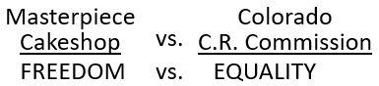
This is the issue that we find the culture war centered on today. So, we gave a couple of examples. We went to Australian politics. We saw that when you move towards the right wing and the farther and farther you went into the right wing, the more and more you saw freedom advertised and the notion that everyone’s freedoms are under attack are weaponized. Then we went to the trucker protest in Canada and just gave it a second witness for that.
Then we also started to go back into history; we didn’t do a whole lot on that, but we started to discuss freedom versus equality in the context of slavery, in the context of Millerite history. We didn’t do that to a great extent, but through 1888 and civil rights movement. We are going to go back to the civil rights movement. Going back to slavery I shared two articles on the Vespers forum. That’s pretty much our review, where we’ve come from, where we’ve gotten to, and bringing up those articles.
Does anyone have any thoughts or questions or quotes that have arisen during the week or while you read the articles? This is our break between our review and when we move on.

Questions
Ray: I just had a question as we were reviewing just now. When we say a lot smaller and big government, what exactly do we mean by that? The number of people in congress doesn’t change. Are we talking about passing more laws, or are we talking about having more civil servants, or what?
Elder Tess: I’m going to leave that for now, and I’m going to task you with defining that for us next week. So there, you have a project; is that okay? In two weeks, come back and you’ll explain to us the difference between big government and small government in relation to size and job function.
Josephine: Did I get this right? In the civil war, the North was fighting for equality and the South was fighting for freedom; and then there was a switch? Is there a switch today? Did freedom and equality switch side?
Elder Tess: When you talk about the switch, do you mean the political parties, particularly the Democrat party? Or do you mean the freedom and equality itself.
Josephine: The parties.
The parties? Yes, there was a switch. There is a good article that explains the switch that occurred between the North and the South. Because the Democrats were the party of the South, and they were fighting for “freedom” and small government against the large government, dictatorial Abraham Lincoln, and those northern states.
So, there was a switch between the ethos of the Democrat party and that of the northern party, which was forming as the Republican. So, if it’s okay we’ll send something after Vespers that will explain the political switch. I think it’s a short video, but it does a really neat job.

Moving On
So, we went from here [Masterpiece Cakeshop vs. Colorado Civil Rights Commission] and then we started to complicate it a little, because we talked about the Republican party. The Republican party stands for freedom and yet we often see them oppose things that we consider to be freedom.
I’ve drawn up boxes and I’ll put people in these boxes. 1st one is a white man. 2nd one is a woman. 3rd one is an Islamic woman. 4th one is a trans man. 5th one is a lesbian.
So, the Republican party says they stand for freedom and yet they’re going to treat all these people differently.
So, say this white man, he wants to own a gun. I don’t know where they get that, from the Bible or their own history, and they’ll say that’s his God given right. It’s his freedom; he has to own a gun.
This woman wants equal pay, or the right to an abortion, and they would say No.
This Islamic woman wants to be allowed into the country the same way anyone else would be allowed into the country, going back to Donald Trump’s ban from majority Muslim countries. She might just want to get a visa alongside someone say from Sweden. So, they’re going to treat her differently.
A trans man wants to have gender affirming surgery. Does that affect the Islamic woman, or this other woman, or this man? No, that’s his body and you would think that is his right, but they will oppose his right to surgery.
The lesbian woman wants to get married. And they’ll also oppose her right to get married.
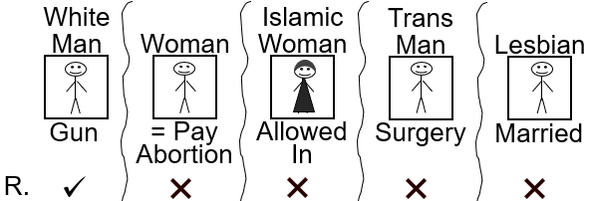
So, when they see freedom, it’s this freedom (I’ll put down here Republican). It is freedom, but they are going to combine it with morality.
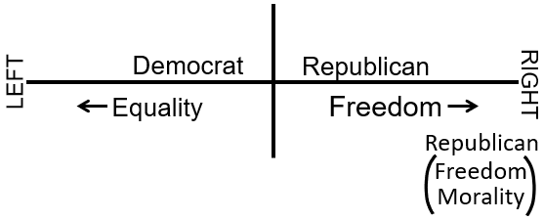
So, we began to discuss the right-wing spectrum and we complicated it a little and said if you go online and you look up political spectrum, they’ll do the following:
You have left wing and right wing; but you have this line down the middle, and they will call that authoritarian and libertarian. Authoritarian believes in more control; Libertarian believes in more liberty. And then they will say that there is left wing Authoritarian (LA), right wing Authoritarian (RA), left wing Libertarian (LL) and right-wing Libertarian (RL). I am not interested in discussing the Authoritarian side. I suppose, to give away my position a little, I think it is nonsense.
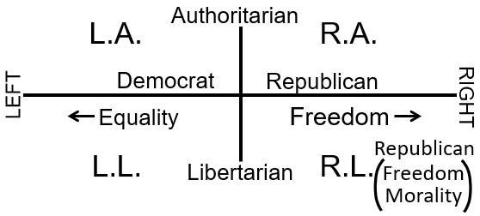
I want to explain what Libertarianism is because it is the third biggest political party in the United States, and it has an incredibly profound impact on everything that we’re discussing.
The Republican party will say freedom and morality. The libertarian party will say just freedom.
I want to try and sell Libertarianism to you. I’ll do my best, and then I’ll ask you if I’ve sold it.
A libertarian will say that all of these people, each person, should have the absolute liberty to say, eat, smoke, buy, sell, learn, do, whatever they want to, with whomever they want to, so long as the person doesn’t hurt, harm the other person/people. And when they talk about harm, they’re not talking about feelings or thoughts; they’re talking about material physical harm. Live and let live. We did go into this last week; but I just wanted to review it a little, because we said a lot of things last week.
Reading from their website: Other political parties prioritize the rights of some but not others. Libertarians value the rights of all people to live in whatever manner they choose so long as they do not forcibly interfere with the equal right of others to live in whatever manner they choose.
So, this woman has the freedom, the right, to live in any way by whatever religion in whatever manner she likes to. This trans man has the same. This lesbian woman has the same. She can do whatever she wants, with whomever she wants, including marry them.
A Libertarian position, in many respects, is very progressive. In social respects, it is quite progressive.
Gay marriage: They’ll support.
Not all of these [on this list are] necessarily progressive.
Prostitution: They’ll support. Do whatever you want with your body as long as you’re not physically harming, with a strict definition of harm, someone else.
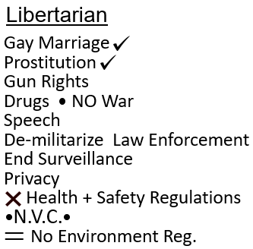
Gun rights: [They’ll support.]
Decriminalizing drugs: [They’ll support.] No to the war on drugs.
They want to protect freedom from religion, association, speech. They’ll talk about asset forfeiture laws, which I fully agree with their position; asset forfeiture is a big problem.
Demilitarize law enforcement agencies. I’m not sure that if they would like that summarized as defund the police, but it is similar. Because what do the police have to enforce if they’re not caring what guns or weapons people are carrying, what drugs they’re carrying or taking, what they’re saying, what they’re selling. What do the police have to do? They don’t have that much to do after that, so they can be disarmed to a certain degree.
End surveillance: The Libertarians are very, very, very, much against government surveillance. So, you can imagine what they think of the Patriot Act, which as you would expect was the position the Movement had. And when I came in 2018, I said that the Patriot Act is actually not that bad. We discussed that in 2019. And if you remember going back before 2019, it was like the greatest and most awful thing that happened in 2001 through the government, was the Patriot Act. A lot of bad things were done with it. The principles behind it and a lot of it were actually positive things. You can see why, I’m saying in 2019, the Patriot Act is not that bad; whereas FFA just saw it as awful. It’s because it was connected with right wing.
Privacy: Protect internet freedom and privacy. That’s connected with ending surveillance and their view on the Patriot Act. They say that those who have not been convicted of a violent crime (nonviolent offenses) should have all of their rights to vote back. We would agree with that. Right now, if someone is charged with possessing drugs, they can lose their right to vote. And with the war on drugs and the racial motivation behind that, it has done incredible amount of harm to minority communities and their voting rights. So, there is much in what they’re saying that is progressive.
It is just Liberty without government enforced morality. And if you hear them speak, it’s all about being passive, all about changing society through education and bottom-up pressure. So, if a company has bad practices, say a company is not very good with health and safety, then the government should not come in and force health and safety regulations. Instead, it is the workers who will tell the company that we’re not going to work for you unless you give us appropriate amounts of safety. So, they also have an issue with health and safety regulations and everything like that.
All of these regulations on individuals and businesses need scrapping. And then where society goes wrong, where society is racist, where corporations are greedy, societal pressure will bring around that change. It is societal pressure and education. They are not advocating for a racist society. They are advocating for a society that is built on absolute liberty that can then change through education and societal pressure and not forced government intervention.
Who’s bought in? Have I sold it? I heard lips move, so if you have, raise your hand.
Ray: Sign me up.
Moli: Yeah, I agree. All these things that have been said are all progressive.
Elder Tess: Gun rights – everyone gets a gun? Is that progressive?
Moli: The idea that has been discussed and said is progressive.
Elder Tess: So, you think the mindset behind it is progressive? Now I’ve sold it, I want to dash it for you. Is that okay?
It sounds beautiful and when you go to their website, when you hear them speak, it is beautiful. I’m not sure if you’ve heard about something called “nonviolent communication.” Tim Mullin is a particular advocate of it. He’s a Canadian Libertarian podcaster, blogger, activist, and politician. He was the leader of the Libertarian party of Canada from 2014 to August 2021, a total of seven-year stint. He, in one of his podcasts, will explain how nonviolent communication is a Libertarian principle, because it is in line with their Libertarian objective principles. You want to change someone through nonviolent communication, through no force, through little to no judgment, just seeing their needs, working around their needs, educating, etc. So, if you’ve heard about nonviolent communication, which has been huge in this Movement over the past couple of years. People have tried to sell that to me, and I’ve dashed their hopes. It is because nonviolent communication is connected to Libertarian principles. And the people that are buying into nonviolent communication are buying into not a prophetic message, but a political position that I would suggest is as opposite to this Movement as you’re going to get.
So, you have left wing – equality. You have the Democrat party, left wing, equality. Moving centrist, trying to balance the two with a bit more emphasis on freedom.
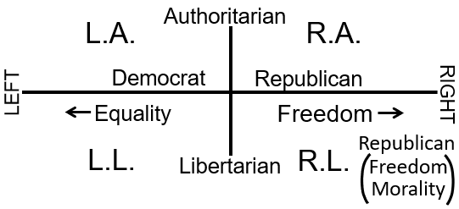
Republican- freedom over equality with some morality. You’re going to go further into the right wing and it’s going to be more and more liberty. I asked last week what’s the problem with left wing Libertarianism (LL). Why is this model broken? Who wants to answer that for me?
Katherine: Because they are prioritizing freedom over equality?
Elder Tess: So, this side [right wing] is saying freedom over equality and this side [left wing] is saying equality over freedom or liberty. So how does the LL work?
Katherine: I don’t think it does.
Elder Tess: It doesn’t. So, if you see a political spectrum on line and shows this [LA, LL, RA, RL], know that is not reality.
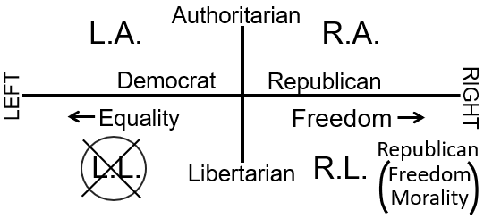
Brenden: I was going to say exactly what Katherine said. It can’t work; you have equality and liberty clashing. It doesn’t make sense. It can’t work. You’ve got to prioritize one over the other. It’s a binary decision. You can’t mix the two.
Elder Tess: You can’t have a left-wing political party prioritizing freedom over equality. It doesn’t work. Did you have anything to say Brenden?
Brenden: No, that’s all, I agree with Katherine.
Katherine: I just thought that perhaps the confusion is because I sort of sound a big progressive and maybe that’s why people think the left-wing kind of just- you don’t delve too deep into it.
Elder Tess: Yes, it’s what Moli said. This is progressive, isn’t it? Progressive ideology. But it can’t be, because they prioritize liberty over equality; and they make that sound beautiful. They think that in practice it would be beautiful. And as a theory, it sounds that way. I want us to get below the theory.
Josephine: I think I had the same idea as others, but I was going to describe in a slightly different way. What they’re promoting their libertarian will take them to the right side instead of the left.
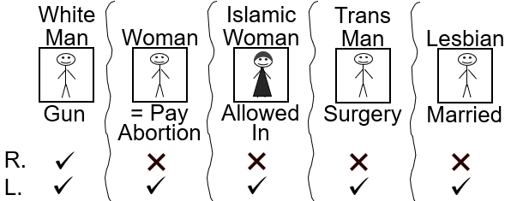
Elder Tess: Yes, so you’re seeing that’s going to pull them towards the right side, but they would still disagree on many points with Republicanism. That’s why they are a third political party. They disagree with so much that is traditionally Republican that they form a third political party. And we’re talking about the social in all of this. There is the economic. They have a very defined economic model. I think Steve Bannon probably tore apart their model most clearly. But they also disagree very strongly when it comes to economics as well.
Brenden: Is it almost like by sheer coincidence that a lot of the Libertarian outcomes in some of these things are like Ramsey theory- it just appears to line up with things on the left, even though the ideology is completely opposed, it this happens to agree in some instances, by chance. I’m not sure if using the Ramsey theory is the correct way of saying it, but it’s almost like it. It’s probably a bad way of saying it.
Elder Tess: I knew that inequality was wrong all my life. I knew it was wrong. Never taught it until the message started developing in 2016; and in 2016 to 2019 including in 2018, I never spelled out that inequality was wrong. So, you have here [2019] about 18 months. We get to the beginning of 2020. I’ve said headship is dead. Equality must exist between man and woman. We say that in November 9, 2019, that’s the waymark that is connected with that event; we say equality. But that is after a long time of knowing that, first of all, it is morally wrong, and then a long time of seeing that the message is also saying that it is wrong. But I couldn’t present it until the Eden-to-Eden model came together, which did not come together until about a month before the German camp meeting.
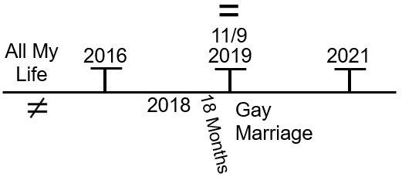
So, you have a long period of waiting to be able to say that there should be equality between men and women. We’re waiting on the prophetic message. As soon as this [November 9, 2019] hits, what do people start saying in the Movement, mostly those who have now left? They start saying here [2019] that gay marriage is acceptable in the Movement, in the kingdom of God. And from here [2019] to 2021, which is a little bit over 18 months, some people are saying that gay marriage is fine, why aren’t the leaders saying this? And people are feeling let down, because I’m not teaching that gay marriage is acceptable in the kingdom of God. The issue that happened here is that those that didn’t change their political position just embraced their own version of freedom. They never gave up freedom for equality. They just became more encompassed with freedom and more, especially when it comes to the externals, more connected with freedom than they had ever been before. So, when we teach Eden-to-Eden, we teach equality. They say freedom and they say gay marriage is fine and they think they’re supporting a left-wing position and they’re not. They supported gay marriage through the principle of freedom and not equality. And the reason they were able to preach gay marriage in the beginning months of 2020 is they would approach the LGBT subject from the position of freedom. And we had to wait as leadership 18 months past then until we could approach the same issue from the platform of equality and that takes time.
Elder Jeff knew; we knew that we would end up supporting LGBT people in this Movement. Just the same way I knew that headship was wrong well before the German camp meeting, but it had to be taught not from freedom; it had to be taught from equality. So, I am only saying that because of what you said Brenden that you think that there is progressivism in this. It depends on the approach; because when someone here, an employee in the Masterpiece cakeshop, doesn’t want to bake a cake for a homosexual couple, the Libertarian position will side with which side? They will support their right to get married, but you’ll find that the Republican party here [with the Masterpiece cakeshop side]; and you’ll find the Democrat party here [with the Colorado C. R. Commission] and you’ll find the Libertarian party with the Republican side with a stronger provision than the Republican party.
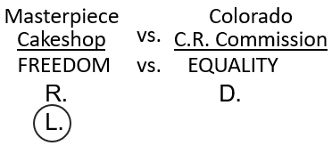
So, it looks progressive. Just saying that you support gay marriage is not necessarily a left-wing ideology.
Do you have anything else to say Brenden?
Brenden: No, I thank you. That was wonderful. Really appreciate it. Thank you.
Lynne: I was just going to make a comment, sort of ask a question in regard to the right. You’ve got the Republicans, the conservative Christian right, and you compare that to the Libertarian right. It seems to me that we said before, that the right wing focuses on their morality freedom. Like it’s freedom within the confines of their idea of morality. So, it is limited in that framework, if you like. Whereas the Libertarian kind of broadens that perspective, and doesn’t really confine it with morality as such, or so much, other than in the broad terms so long as you’re not doing any physical harm toward another person. So really, you can see how it is very extreme right but broader and larger and encompassing more. And I guess the confusion comes in like when it seems like there’s a similarity, but really when you look at the overall what they’re standing for, it’s really just a very extreme right position. It is almost as far as you can go.
Elder Tess: I just want to build on what you said, Lynne, about it being a more extreme position. The Daily Beast put out an article a few years ago that caused a bit of a storm and made a lot of Libertarians very unhappy. But their position is actually fairly easy to defend. I just want to quote a little bit from the Daily Beast article.
It’s titled ‘The Insidious Libertarian-to-Alt-Right Pipeline.’ They say that “Libertarianism has an alt right problem. Many prominent leaders of the alt-right (or the far radical, dangerous right wing), have at some point, identified as Libertarian. I’m curious as to… why?” And then it starts to name them: “Milo Yiannopoulos has billed himself (and has been billed by others) as libertarian. About a year ago, he came clean about that.”
Then there lists more: Tim Gionet, Gavin McInnes, Augustus Invictus, Stefan Molyneux, and Richard Spencer. “It is also true that many of today’s far-righters are disaffected conservatives. However, there are many more conservatives in this country than there are libertarians, which suggests a disproportionate number of today’s prominent alt-righters began as libertarians.”
So, you have a massive amount of conservatists and small amount of Libertarians. Then why are so many of the leaders coming from the Libertarian pipeline disproportionately to the conservative pipeline. It suggests that a disproportionate number of today’s prominent alt-righters began as Libertarians and not conservatives. “Jeffrey A Tucker, content director for the libertarian Foundation for Economic Education (FEE), lists five differences between the alt-right and libertarians (so they differ on points). And yet, it seems observably true that libertarianism is disproportionately a gateway drug to the alt-right. Again, the question is…why?”
So, we want to discuss why? Why does the far-right come more through the Libertarian than through Conservatives. When we started teaching in 2018-2019 about the problems with right wing, we were talking about Christianity. We’ve said since then that we’re in a post-Christian world. What we’re trying – or who we’re trying to get through is FFA and everyone who surrounds them; and then as we moved forward in our timeline, through to Adventists. So, we’re talking to Conservative Christians. So, what we are saying is being said in a bubble. Therefore, we’re going to highlight the connection between Mary Stewart Relfe and Walter Veith. We’re going to talk about Christianity. We’re going to talk about the Evangelicals supporting Donald Trump. We’re going to talk about Jerry Falwell. But we need to know that we have been saying that over the last few years, because we are speaking to a Christian bubble still. And if you expand that out and look at the United States as it is, it’s not an accurate picture of where the real threat truly comes from. Certain amount of it, yes. But elderly, Republican, “moral” conservatives in Congress, on the Supreme Court, that’s a problem, but even that is kind of in a bubble. And this is why what Rachel taught on Gamergate is so important, because that starts to dismantle the bubble so we can see the bigger picture of what’s going on.
I don’t think that this needs to complicate, or be that complicated. I’m hoping that people don’t feel overwhelmed. I think it can be simple. But we are living in a post-Christian world. The United States is not a Christian country anymore. It’s not heading that way. Whoever wins, whatever elections come next, it’s not heading back into Christianity. And the threat is not just elderly Conservatives that are losing power. And what this article is saying, and others like it, when you look at the far-right and when you look at something like January 6, there’s a reason you don’t have a priest January 6, you have a shaman. That’s not a Christian symbol. And he’s not elderly.
So, coming back to Libertarianism, this looks like progressive. So, how would a libertarian handle the Civil Rights Act of 1964?
Graeme: I’m guessing it would be positive; they would be for it.
Elder Tess: So, they would be positive of the Civil Rights Act?
Graeme: Yes.
Elder Tess: I’m going to say that you’re right, on part of it. But if you go to Title II of the Civil Rights Act, it says, “You have the right to full and equal enjoyment of the goods, services, facilities, privileges, advantages and accommodations of any place of public accommodations. You cannot be treated differently by any place of any public accommodation because of your race, color, religion, or national origin.” So, the Huffington Post article, I might share this one with you after Vespers because I think it is good to read. Its titled ‘Why Libertarians (and Rand Paul) are wrong about the Civil Rights Act.’ Do we all know who Rand Paul is? It always helps to connect the face and name. If you ever watch the problematic Jon Stewart from his Daily Show days, Rand Paul would come up in a lot of those contexts. He is a Republican, but his history is predominantly Libertarian and his father was a Libertarian politician. So, he is more Libertarian than anything else.
Rand Paul
This article from 2010 continues, “Following his tea-party insurgent Senate primary victory over the establishment Republican candidate in Kentucky, Rand Paul created waves when Rachel Maddow forced him, uncomfortably, to admit his opposition to parts of the Civil Rights Act. To many in the civil rights community, and to the political center, this comes as a shock. It shouldn’t be.”
It shouldn’t come as a shock, because Rand Paul is predominantly Libertarian and Libertarians have major issues with the Civil Rights Act.
“For years, libertarians opposed government interference with private business, whether that means opposition to environmental regulation, labor laws, or anti-discrimination laws”.
NO environmental regulation is also part of their platform. That would seriously start to conflict with freedoms of individuals and businesses.
“The son of libertarian presidential candidate, Ron Paul, it’s not surprising that Rand Paul also believes those things.”
So, they’re saying that even though Rand Paul is Republican, he has Libertarian roots. His father ran for president as a Libertarian candidate. So even as a Republican, he has that leaning.
“Rand Paul has made it clear that he’s not in favor of a repeal of the Civil Rights Act of 1964, and that he supports the vast majority of it. What’s the problem then?”
The problem is through different parts of it, but it is especially with Title II; and this is where Libertarians come into conflict with civil rights. “You have the right to full and equal enjoyment of the goods, services, facilities, privileges, advantages, and accommodations of any place of public accommodation.”
So, if I own a hotel, it’s my business, it’s my money, it’s my time, it’s my facility, and I say I only want white people staying at my hotel. The Civil Rights Act says, I am not allowed to do that. But the Civil Rights Act is about freedom or equality? Is the Civil Rights Act predominantly about freedom or equality? I know that someone said last week, if they went back and read articles of the Civil Rights movement, and all they see is freedom, freedom, freedom. And I said it depends on the articles you read and also how you sift them, because I don’t see that. Is the Civil Rights Act predominantly led by the principle of freedom or the principle of equality?
Katherine: It’s equality that takes priority. You can especially see it in Title II, where it has got to do with the accommodation. So, the equality takes precedence over freedom of the hotel owner.
Elder Tess: It’s equality. Yes, those running any form of public accommodation and they make accommodation a very broad term, by the way. Brenden, was that what you were going to say?
Brenden: Yes, I agree with Katherine.
Elder Tess: Moli, you said equality like the others, and I would agree.
Moli: Yes, in a sense that it’s for everybody. It’s broad. There’s no boundary, it’s for everyone.
Elder Tess: No, it means that individuals do not have the freedom to discriminate against an African American. Even when that conflicts with someone’s freedom, the right of (and it covered more groups) a black person to equality trumps that of the freedom of anyone who has a business, school, all of those things. So, a Republican today will not so openly oppose the Civil Rights Act. They just let it all slide. Expanding it, they will have complaints. But a Libertarian, if you push them on it, still has serious problems with the Civil Rights Act.
Quoting again, “Libertarians did not grow out of this view after the Civil Rights movement won. They just became more quiet.” Rand Paul said, “he would have opposed the Civil Rights Act ‘because of the property rights element.’” But while he liked the Civil Rights Act where it prohibited the government from discrimination, the Civil Rights Act didn’t just prohibit the government from discriminating; the Civil Rights Act prohibited this [white man] person from discriminating against a black person, an African American. Or, also if they allowed it to be expanded, it would discriminate against other minorities as well. That’s what they opposed.
So, Libertarian agrees that the government shouldn’t discriminate. The government shouldn’t even be big enough to make it able to discriminate. But everyone should have the freedom to discriminate, because their freedom to discriminate trumps anyone’s right to equality.
Quoting Rand Paul, “I don’t like the idea of telling private business owners... I abhor all racism. I think it’s a terrible business decision to exclude anybody from your restaurant. But, at the same time, I do believe in private ownership.” I’m going to call that private freedom.
“In the CATO symposium of 2010, they debated the 1964 Civil Rights Act (because for Libertarians, apparently it is still up for debate). The panel of four white men (I’m sure it’s just a coincidence) tried to figure out whether (A) prohibiting discrimination was bad but could perhaps be justified by how bad Jim Crow itself was or (B) prohibiting discrimination was never justified under any circumstances. Jeffrey Miron, an economist at Harvard (who is, rather alarmingly, Director of Undergraduate studies for his department), was unequivocal. His fellow panelists had ‘trotted out arguments about historical context and social norms to defend the positions that seems antithetical to everything libertarians believe.’”
Quoting him continuing, “Libertarians should not only oppose Title II [of Civil Rights Act]; they should shout that opposition from the highest rooftops... Title II is a bold-faced assault on a principle that libertarians hold dear: that private property is private. This means libertarians should be incredibly suspicious of Title II and insist on an overwhelming case before violating this principle. No such case exists... If the law turns restaurants into ‘public accommodations’… then restaurants become places where the law can impose public health concerns and where customers have ‘rights.’” And he goes on and on.
Some libertarians try to soften their position by saying let’s consider how bad Jim Crow was. So, the 1964 Civil Rights Act was kind of necessary. But they still are very uncomfortable with it, and the most outspoken like this individual violently opposed to any part of the Civil Rights Act that steps beyond pure government.
So, if Jerry Falwell wants to open a private school that is segregated, what would a libertarian have to believe in? And I remind you that Rand Paul hates racism. He hates it. But freedom trumps equality. So, Rand Paul, what would be his position on Jerry Falwell’s segregated school? He would allow gay marriage and he would allow segregation.
I’m explaining what happens with libertarianism in practice, libertarianism and the right to discriminate. The fact that in allowing freedom or liberty, they allow many things that a progressive would support. And yet it also puts them into a position where more than anyone else, more than any mainstream Republican, they become violently opposed to any form of civil rights that interferes with someone’s freedom or right to be racist, to be sexist, to be homophobic, to discriminate. Because freedom and liberty always have to trump equality even when we don’t like what people do, say, or think.
Any thoughts or questions? Brenden, was that your hand again?
Brenden: Yes, as you’re explaining, it’s hard not to trace the libertarian mentality all the way back to 1860s. So, it’s more that mindset that was fighting for people’s property rights in slaves. They were the ones that (I mean I could be wrong, but it’s just hard not to see) they were really motivated and enthusiastic ones that were fighting for those property rights for the southern slave holders. Whether they were slave owners themselves, I don’t think it mattered. It just appears that they were the ones that were enthusiastic fighters. Is that right? Is that the origins of where all this came from or does it go back further? It’s hard not to go back there and think through those eyes. Is that correct?
Elder Tess: I think Libertarianism has developed a little more since then. Because they would believe that you’re not allowed to kill or beat another human being. If you planted today’s libertarian back into 1860, they would oppose slavery. But if you saw libertarianism as it existed in American culture in 1860, where it didn’t seem wrong for that spectrum of society to see human beings as property, then yes. Freedom being their governing principle. People are seen as property. Today they would oppose that. Back then, if you saw libertarianism, then absolute freedom. You don’t want to own a slave, then don’t own a slave. If want to, no one else has the right to interfere. It becomes much more stark in today’s concept where we bring it into the subject of gender; because the idea of ownership when it comes to gender and then how that interconnects with marriage and relationships and culture, even indigenous culture all across the world, then the concept of owning a human being feels right and normal to vast majority of the population. Does that make sense Brenden? I don’t know if I’ve answered your question.
Branden: Yes, thank you. That’s great. And thank you for bringing it back to gender. That’s exactly right.
Elder Tess: We’re going to talk more about libertarianism and gender, that’s why I directed it there. Because as you might imagine, when we talk about this pipeline between libertarianism and the alt-right, we’re going to talk about the ‘Proud Boys.’ They’re not the proud white men, or the proud white people; they’re the proud men for a reason. So, 2014, Gamergate and gender are going to come into conflict.
Josephine: My question is taking us back a little bit to that line right behind you about the gay marriage and the people that were supporting the gay marriage from the position of freedom. And you taught it from the position of equality, so you can both believe in gay marriage, but the motives were different? Or the position is different? And why did they leave? Couldn’t they just switch? Was it too painful to switch?
Elder Tess: The issue from 2018 to now has always been the same. It has always been the Movement is here [Right-Freedom], who will shift [Left-Equality]? Many people in the Movement still haven’t. That’s why people think I use “aggressive communication techniques” in camp meetings, on the Media Broadcast; because people aren’t switching. And it is life and death. So, it is possible.
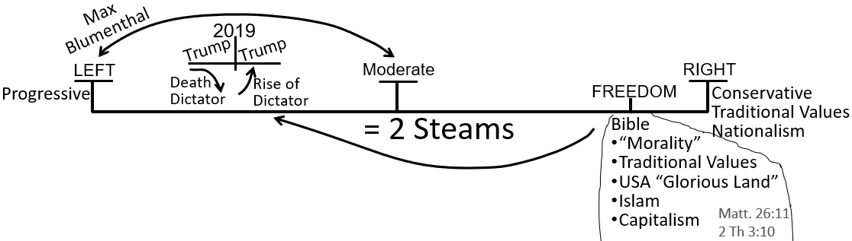
There was a fight in Australia in the Movement in 2018, but it was earlier in 2018. There was a fight about gay marriage, because that was when gay marriage was about to be legalized in Australia. And it caused a fight in the members in Australia where one part of the members said we need to stop gay marriage being legalized politically; and other members within the Movement in Australia said, what right do we have to force the government your moral conviction? This is like the Sunday Law. If they want to be married, they should be allowed to get married. This is early 2018, if I have the time right. And the side that said that, through the Australian government, gay marriage should be legalized are the people that are still in the Movement today.
We’ve always recognized that the government should not enforce their version of morality on the people. So, we supported gay marriage. The discussion, the issue, is about the kingdom of God and what is and isn’t sin. When it came to approaching it from that direction, just like headship, just like we did from Eden to Eden, just like I waited 18 months when it came to gender, we had to approach it from equality. It was only equality that was going to… (someone said it was 2017, so even before 2018). But when it was going to be viewed as sin, we needed to approach it from equality. Yes, you can believe in gay marriage, because you believe in freedom; but the issue, if we bring this internally, is if we’re going to switch and become left wing and if we’re going to see the battle of Ipsus and say Clinton, then we needed to defend a person’s right to be married by an elder of this Movement into the kingdom of God. That wasn’t just okay, that made God happy; that had to be done from the position of equality. Does that make sense, Josephine?
Josephine: yes, thank you.
Elder Tess: I have one more quote on libertarianism. This is from currentaffairs.org and it is titled Why Libertarians Oppose Civil Rights. They just mention a couple of things. “From a legal perspective, discrimination should be permitted in any society that honors freedom of association.” So, if you’re a society that honors freedom, then discrimination should be permitted. This is a libertarian argument. “We should condemn people who practice such discrimination, even as we insist on their legal right to do so.” This is another way of saying, ‘I will disagree with what you say, but I will defend to the death your right to say it.’ Your freedom of speech I will defend to the death, even if I don’t like what’s coming out of your mouth. So, condemn people who practice discrimination, but they have a legal right to discriminate. So, society, according to Rand Paul, should condemn a school that segregates black and white students, but we should insist on the legal right of the school to do that. This is the problem with libertarianism.
We’re going to have to close, so I’m going to take a few thoughts or questions if we have them. But I just want to give a couple of thoughts before we close just to add to this a little. I named a few, about seven, far right leaders today, who have all traveled through the libertarian pipeline. One of them I named Gavin McGinnis; he founded the Proud Boys. He identifies as libertarian. I want to talk about their chairman Enrique Tarrio.
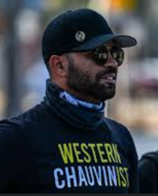
He was also director of Florida’s branch of Latinos for Trump. He’s Afro-Cuban by heritage. Enrique Tarrio, chairman of the Proud Boys. I want to quote him. You might have seen him in the news this last couple of weeks. He was charged a while ago, that was also in the news, for stealing and burning a Black Lives Matter flag. This was January 4, 2021, 2 days before January 6. He stole a Black Lives Matter flag from a historically Black church and burnt it. I want to remind you he’s not white.
Why does he feel the way he does? In regard to his views on extremist groups and ideologies, Tarrio has been quoted as saying, “I denounce white supremacy. I denounce anti-Semitism. I denounce racism. I denounce fascism. I denounce communism and any other -ism that is prejudiced towards people because of their race, religion, culture, tone of skin.” In regards to his own ethnicity, he said, “I’m pretty brown. I’m Cuban. There’s nothing white supremacist about me”.
When he was charged with taking and burning this Black Lives Matter flag, he was convicted because the judge said his attempt to show remorse were not very convincing or genuine, but he apologized profusely in court. And he insists to this day that he is sorry for having taken and burned the Black Lives Matter flag, because he took and destroyed someone’s private property and that conflicted with his libertarian beliefs. So, he’s libertarian. You don’t take someone’s private property and burn them. That church has the freedom to fly any flag they like according to him. He thinks that a white church should be able to fly a confederate flag. So, he should think that this historically black church should be able to fly a Black Lives Matter flag. He felt angry. He stole it and he burnt it; and he knows that was wrong, not because of equality, but because it conflicted with libertarianism.
If you look him up, and I suggest you do so, you’ll get a better picture of what the Proud Boys stand for. And again like 2014, you see the context of racism and nationalism. But he’s their chairman, and none of the people under him have a problem with having a non-white chairman. They are not the proud white people; they are the proud boys for a reason. And we need to see the significance of this in the context of Gamergate, and in the context of a post-Christian world.
I said last week that I would share an article; and I didn’t, because I thought it would be better after we discuss libertarianism a little bit more. It’s a long article by Vox and it is titled, ‘The internet is full of men who hate feminism. Here's what they're like in person.’ And someone, Emmett Rensin, has gone and spoken to some of the men, not the main leaders, but some of the lower key men who were involved in Gamergate. It came out mid 2015 just post Gamergate context. So, I’d like you to read this article and then I would like you to highlight the specific paragraphs that you think were most important. You’re going to find the word libertarian encased in those paragraphs. So that is something that would really help us if you did that over the next two weeks.
Rachel: What was the Cuban man’s name?
Elder Tess: Enrique Tarrio.
He’s just one of a significant number. Many of them have renounced libertarianism to some degree, but the pipeline is still visible. And what they tend to renounce is not the social beliefs of libertarianism. When they turn from libertarianism to republicanism, it is often more to do with economics. That’s why you still see Republican leading people like Enrique Tarrio, who is being charged for being involved in January 6, supporting Trump. You find Rand Paul, a Republican, but they have been heavily impacted by libertarian thinking, perhaps not in a lasting way by the economic model. Because so many, I would probably send you to Steve Bannon, will tell you what he thinks about the libertarian economic model. Lots of other people will. Former libertarians will. It doesn’t work. But what they hold on to is the social beliefs of libertarianism.
I’ll send that article out, and if you can read that while we have two weeks away. And then we’re going to continue to talk about the article; I think there’s some key parts to that article that are significant. And we’ll come back to libertarianism, and to the right wing, and close that off when we come back.
Is there any final thought or question or anything they want to say? And then we’ll close.
Sorry I know I started speaking a little fast, but I hope that some of that makes sense. If it, over the next couple of weeks, stops making sense, please let me know. We might do what we did a few weeks ago (when we come back together again), and have more time for discussion, especially in the beginning to make sure that what’s behind me [on the board] makes sense.
Lynn, I’ve missed your voice tonight. Would you mind closing for us?

Closing Prayer
Lynn: Dear God in heaven we come before you again. We give thanks and praise to you. We thank you for the privilege of being able to have these meetings. We just thank you for the blessings. We ask that you please help us to understand better. Please help us to be more clear on these important issues. We just pray for all those who perhaps have not been able to join us tonight, and we ask that they’ll be able to watch the recordings. We thank you again for all your blessings and we just ask for a restful night’s sleep as well as we continue to go through this Sabbath day. And again, I ask for a blessing on all the meetings tomorrow as well. And we pray all this in Jesus’ name. Amen.

