FROM GAMERGATE TO JANUARY 6

TMW VESPERS

APRIL 8, 2022

ELDER TESS LAMBERT
https://www.youtube.com/watch?v=eVYQPMOP2tk&list=PL6-Mv8H520RncgAlBdn_u3bAlt_kGZZhH&index=9
----------------------------

Boardwork from last presentation, ‘The Far-Right Trinity’
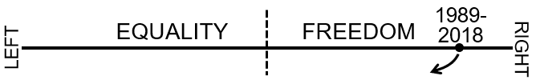
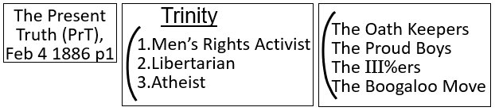
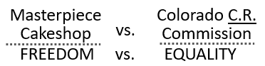
----------------------------
It’s good to see everyone again. The weeks go quickly. I’m going to redraw the boardwork from the last presentation just a little different to see if that helps what we’re doing make more sense. We had the Spectrum. Someone gave this quote. We’re tying back this election to both sides of that curtain of the great controversy. If we talk about that curtain that separates the spiritual fight that Christianity understands between Christ and Satan, if we peel back that curtain and see that fight, and then right in front of us in the political world around us in the US we see that fight. If we peel back that curtain, we see that it’s all the same thing, because it is all centering on an election; a choice between two governments, two types of government, and that’s the significance of seeing Ipsus, seeing 2016. This is the danger of Adventism thinking that they shouldn’t understand politics; misusing Ellen White’s (EGW) quotes to that end.
I’m going to leave this [“The Cake Shop”] here [on the board], because I just love that visual to bring our minds back to the fight between freedom and equality and what that looks like in reality.
We went into Reddit to see that far-right community.
We talked about the trinity.
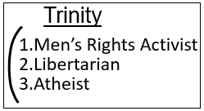
We started to discuss the militia group in the US.
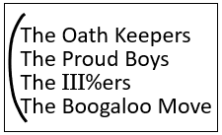
There was an Atlantic article recently, maybe a month ago, that discussed teaching in the US like professors, school teachers; and how these teachers or what category of teachers were explaining current events, especially in an informative, progressive light. And to understand what these teachers were saying about the most significant turning point events in recent history, they looked at how these teachers were instructing their students on five historical turning points.
I tried to find it just before we started. I can’t remember what they all were, but I know it was something like the fall of the Berlin Wall, 9-11, Arab Spring, and January 6, 2021. It goes in a list with 9-11 for them, and I think it is a legitimate perspective of the significance of January 6. We definitely need to and we’ll discuss January 6 in more detail.
Instead of having the line as it was before, just this straight line, I want to just try to illustrate it slightly differently. So, a question was asked. We were discussing 1888, and a question was asked; how do you, Tess, because you were asking me, how do you sift left-wing sources? Because, you take some and leave much. You might leave more than you take. You might discard more than you take. So, how do you decide what to take on board and what to discard? How do you know what you’re discarding is even wrong? How do you know that what you’re taking is even right?
My response to that would be that I understand what to take and what to leave, because I’m doing so, have done so from the very beginning, from a prophetic perspective with rules. It’s not based on what I like or don’t like. So, the question centered on the left-wing. How do you sift the left-wing? But, the problems with the left-wing are intrinsically connected to the problems with the right-wing. So, it didn’t do us much good if, to go into the issues the left-wing has if we don’t understand the problems with the right-wing. So, instead of just discussing the left-wing, we pulled back, and we’ve spent the last weeks, and we’ll probably spend a couple more discussing what the right-wing and the left-wing even stand for; what their ethos is, and breaking down the complicated political soup that is the right-wing.
Instead of drawing the line as we had it before, I kind of want to draw it in this way. You have the center, and then you have the left-wing, and then you have the right-wing. Now Rachel, I’m going to squish this Movement a little bit back towards the center than we were before. If anyone objects, that’s fine. But, let’s say we circle maybe this faction, and I want to title this faction, Protestantism. So, this is left-wing, and this is right-wing.
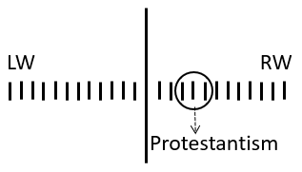
In 2018 and 2019, we start identifying the role of Donald Trump in prophecy in a way that hadn’t been done before. Before, it was recognized that he had a role in prophecy, but in 2018, we become much more formalized in saying this is not just Trump, but Trumpism. This is not just one man, but republicanism. This is not just the Republican Party, but this is the entire right- wing that now needs to be understood from a prophetic perspective; and in 2018, we go from just talking about Trump as this one figure completely cut-off from the right-wing context to a dangerous prophetic figure. In 2018, we put him back in that context and say, this isn’t about one man; this is about everything that he stands for. This is about the entire right-wing political spectrum.
And, when we say that in 2018, it shakes this entire Movement because when we attack the right-wing political spectrum, we attack this Movement because this Movement is in the right-wing political spectrum. And, this Movement is in the right-wing political spectrum because Protestantism, Evangelicalism, is in the right-wing political spectrum, because Catholicism is in the right-wing political spectrum; and we all have a problem over not shedding our link to the source of apostasy; Christian apostasy.
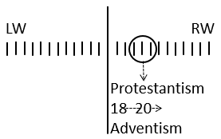
That’s the significance of 2018. Trump was already understood as a prophetic figure; but in 2018, we really say, we need to stop seeing him as just this isolated evil figure, and it could have been Clinton. It could have been anyone. He stands for an entire political party that is appealing to an ideological base that is the right-wing in the US. From 2018 to 2019 into 2020, and we are continuing to, and we won’t stop this side of the Second Advent, we continue to link Adventism to where Protestantism sits on the political spectrum.
We did that by tracing Adventism history back through the Millerite history, through seeing the first and second great awakening and the role of the Millerite movement in the second great awakening. We went to the article by Goldstein, “How the Constitution became Christian,” over and over again; the book the Evangelicals, we kept highlighting this portion of the right-wing, and we did that because that’s where Adventism is, and therefore, that’s where this Movement is. We needed members of the Movement, because that’s who we were speaking to prior to going to work; we’re speaking to each other. We needed to warn members of this Movement that you’re here [right-wing spectrum], because Protestantism is here. And, the Protestantism is here [on the right-wing political spectrum], because it carried that over from Catholicism. And you, if you wish to be a member of God’s political party, you need to move over here [to the left].
That’s why we are saying that over and over and over again. What I’m saying does nothing to undo that. I hope we can see that. There is none of that that is erased or diminished in value. But, as this Movement has progressed especially from the end of 2019 to now is, again, remember what we said before about things being more complicated, you know you see this simple picture, but it is more complicate than that. And, the problem is that people saw Christianity and this [pointing to the right-wing spectrum] entire problem, and it’s not. And, that’s the point I’m trying to make now, but it’s not a new point. I’ve been trying to make this point for probably about 18 months with a level of knowing what I was doing without necessarily having it as clear as it is now.
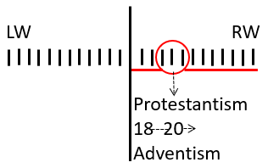
We going from this [the small circled portion of the entire right-wing spectrum] and expanding it out and saying, look, this is only part of the story. If you want to see what is wrong with the US today, you need to see all of this [the whole right-wing spectrum]; and if you’re going to see all of this, then what is the underlying ethos that’s driving the right-wing? Because it’s not Christianity. I don’t want to say that it’s not traditional values, because traditional values come through many cultures, many religions, and atheism itself. But, it’s more than Christianity.
If you are running for the US election, and this doesn’t matter if you are running for president or if you are running for the senate. If you’re running for any election in the US, and you want people to vote for you, you want as many people to vote for you as possible, don’t you? So, if it’s the 1980’s and you’re Jimmy Carter, and you’re a Democrat, you want the Protestant vote too. So, you’re going to stand up as a candidate for presidency, albeit a Democrat, and you, Jimmy Carter, are going to start saying, I’m a really good Christian. I really love my faith. I treasure my relationship with God. I pray every day. You’re going to appeal to the Protestant vote. You have to.
When you look at the US government, and you see US presidents like Donald Trump appealing to Protestantism, that isn’t because that’s the entirety of their base. It’s only part of it. Does that make sense? Josephine. Does that make sense?
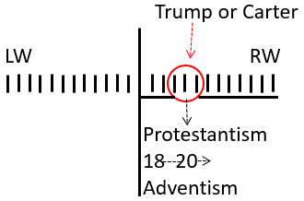
Josephine – I think I’m beginning to get the picture.
Elder Tess – I’ll repeat that, and then I might ask you again; because I didn’t phrase that very clearly, so I wanted to make sure. This is the left-wing, and this is the right-wing. And, if you’re Trump or Carter, and you want votes because you want to win elections, you’re going to appeal to this [the Protestants], aren’t you? You’re going to start talking about the role of God in your life.
Josephine – Sure.
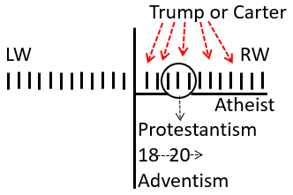
Elder Tess – But, that’s not the entirety of what you’re appealing to. They might not even be the majority of your base. Someone over here [right-wing spectrum] will be an atheist. They don’t really care whether or not you’re a Christian. If they’re right-wing, they’re going to vote for you whether you’re Christian or not. So, if you sell your faith, even if like Trump, everyone knows it’s fake, if you sell your faith, you’ll get a portion of votes. But you are not going to turn these [the right-wing spectrum] people away from you. They’re used to Christians in congress. They get elected because they’re vying for these votes, whether they believe in God or not.
So, when you look at Congress, and you look at the history of the American Presidents, you’re going to see people who sell their Christianity. But that doesn’t mean that they are driven by Christianity. That doesn’t mean that they’re genuine, that they actually even believe what they are saying. Does that make sense, Josephine?
Josephine – Very clear.
Elder Tess – So, Donald Trump, he has to appeal to the Evangelicals. And, we know that he does. We’ve taught that for a long time, but all he had to say to appeal to the Evangelicals, what did he need to say to appeal to an Evangelical? To get an Evangelical vote? Marie. What do you think Trump could say to appeal to an Evangelical?
Marie – He would say that he read the Bible.
Elder Tess – He read the Bible. So, he’s going to sell his Christianity. But, what about his politics?
Marie – Well, he would have a conservative rhetoric that would appeal to the Pentecostals as well as many others.
Elder Tess – Conservative rhetoric. I agree. Do you want to specify parts of that rhetoric or do you want to leave it as the conservative? You can leave it as a conservative if you like.
Marie – He even appealed to the Q-Anon people. It wasn’t just the conservatives. It was the extreme right movements that he would appeal to as well.
Elder Tess – But, Q-Anon isn’t necessarily Protestant. If he’s trying to get mom and dad down there in Texas or, if he’s trying to appeal to this kind of traditional values Protestant, laid-back farmer, family, country living down in the South, it’s not necessarily Q-Anon that’s going to be the selling points for these kinds of close-knit Christian communities.
Marie – He would say, let’s make America great again. So, let’s go back to when we first became this country, and we were Christians. We had solid values, and that’s how America was raised up.
Elder Tess – So, values, Christian heritage, how is he going to do that?
Marie – He’s going to go along with changing the history, and painting a nice Christian church and state combined picture.
Elder Tess – So, church and state. Do you mind if I put morality?
Marie – No.
Elder Tess – Yes. If you want to change a law in the United States, if he wants to change laws, what does he need to change? What is the mechanism for changing significant laws in the US?
Marie – The Constitution.
Elder Tess – The Constitution. And who gets to define what the Constitution means?
Marie – The Supreme Court.
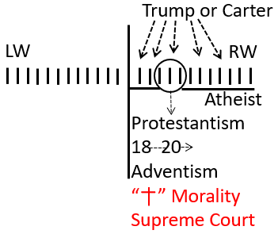
Elder Tess – The Supreme Court. Thank you, Marie. So yes. Christian morality. But there’s going to be a few key phrases that he can say to appeal to Protestantism. Josephine. You had a thought.
Josephine – Just one. Just morality that Marie already said, tied to abortion, moralizing the law.
Elder Tess – I agree with you, but I’m going to avoid trying to be general about morality, because we will go back to Rachel. We’ll make Rachel review Reddit and then we’ll see Reddit; we’ll see one in three American men on Reddit; we’ll see men’s rights groups; and we’ll see men’s rights groups where I think it was 86% atheistic foundation. And, men’s rights groups are all about tradition, and they’re atheist. So, I’m trying to target Protestantism. I’m trying to be a little bit narrow, little bit specific here because yes, there is a morality here but it’s based in a specific biblical style morality. He’s going to talk about the Supreme Court. He’s going to talk about abortion. Those are the phrases that’s enough for him to get the Protestant vote. He didn’t need to say more than that.
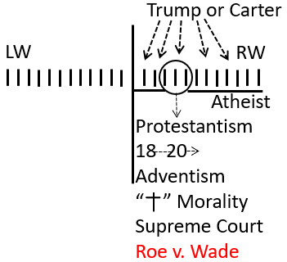
But the problem is, if you look back and list, see all the things that Trump said and did, he appealed to a lot more than the Evangelical vote. That was only a part, only a portion of his rhetoric was designed to appeal to this [the Protestants]. What about the whole rest of the right-wing? What about the 86% atheistic, 90-something percent libertarian men’s rights activists that exist over here [right-wing]. Trump only has to say a couple of limited things to appeal to the Protestant vote. Protestants don’t like the way he’s acting. I’m being general.
The vast majority of the Protestants don’t particularly like to see him swearing, carrying on, abusing people, calling people names. They weren’t necessarily attracted to the anger, the bad behavior. The success as a supposedly extremely rich billionaire who could supposedly have any woman he wanted. That’s not appealing to the Protestant vote. But he appealed to the right-wing in a way that has not been seen in history, to a radicalized right-wing that has not been seen in history, and that radicalization element is not Protestant. So, I wanting us to expand our view from what we’ve spent years doing where it is this narrow picture of Trump elected by Evangelicals, Evangelicals feeling threatened and therefore becoming emboldened in their efforts to link church and state. That’s not what is truly happening in the US if we come out of our bubble. Katherine.
Katherine – It’s ok. I was going to mention something you were asking earlier. Thank you.
Elder Tess – Then, do you mind repeating it in your own words for the benefit of all of us?
Katherine – Sure. I was just going to mention how Donald Trump had, he was talking about placing judges on the Supreme Court that would be put forward by the Federalist Society. That was something that really appealed to the Protestants at the time.
Elder Tess – Thank you. And, you’ve brought in more detail there, the Federalist Society. He knew what he was doing. He knew who he needed to appeal to, and the catch phrases that would make sure that they understood that he was on their side, that he definitely had their agenda at heart. Brendon.
Brendon – I was going to say the Supreme Court as well. And also, he met them and explained to them how they’re not going to be downtrodden anymore. So, he met them as victims, and he was going to fix Christianity not being downtrodden anymore. Part of that story was the Supreme Court.
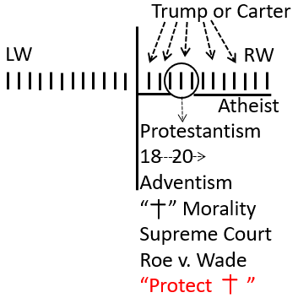
Elder Tess – And this is coming back to our document, that feeling that they’re threatened, that Christianity is under threat. But they vote for him despite his behavior, because they believe that he can protect them. So, a large part of his behavior isn’t appealing to them. They vote for him despite that behavior. So, who is that behavior there to appeal?
Brendon – I would say the radical right that we’re going into now, that has celebrated that behavior on these forums that we’re going into now, that sort of behavior even though it’s despised by the Evangelicals.
Elder Tess – Yes. Exactly. The type of behavior that made them think this isn’t great, but we’ll vote for him anyway because he will protect us. He is the monster who will protect us; protect Christianity and biblical, traditional values. Lynne.
Lynne – I was just going to say that he was going to appeal to their desire for freedom. In other words, he is referring to things like the establishment, draining the swamp, all of those things because they’re all oppressed. So, he wants to restore their freedoms to be able to do, like their gun laws for example, to be able to have their guns and other things like that, plus he wants to build the wall, that keeps out people who are going to threaten their jobs or whatever his excuses were for that. So, basically, he is appealing to the right in overall on the basis of maintaining or re-establishing their freedoms, and he throws in bits of Christianity with things like abortion laws. He also, just from his behavior illustrates, regardless of what he says about women, his behavior certainly shows that he puts women in their place. That would appeal to those far-right extremist groups; I would think. Those are the thought I had. I’m not sure if that’s picking up on what you were talking about or not, but that’s it.
Elder Tess – At this stage, I was being specific to what he said to appeal to Protestantism, because build the wall, drain the swamp, they aren’t phrases that necessarily bring you to here [Protestants].
Lynne – Sorry, I thought you…
Elder Tess – But yes, they are things to keep in mind for the whole of the right wing.
Lynne – Well, no. I actually thought you were asking for something broader. I thought your question was okay, we’ve discussed that, sorry.
Elder Tess – We will go into the broader soon. Josephine.
Josephine – What about immigration? Saying America is a white nation, and not bringing in all of these different immigrants? Does that fit in there? Immigration laws? Maybe that comes in later.
Elder Tess – Times coming when I’m going to get into trouble. I know that. I know that I already am, because I’m pushing back on putting white nationalism and racism in front of everything. He did even better with the Hispanic community over time than he did in 2016. Why? I’m not asking an answer to that, but we need to get deeper, and the problem I’m going to start complaining about the left-wing prematurely. There was an article recently, I think we are all aware what happened at the Oscars. And, the article said, why do black women always have to be the butt of the joke?
And, I thought about it and thought, you know, what this author is doing, if he just said why do women have to be at the butt of the joke, no one is going to click on it because it isn’t appealing enough to whole lot of people who still feel uncomfortable with feminism, and standing up for women’s rights. But, if he makes it or takes what happened at the Oscars and the joke that a black man made to a black woman and brings it into away from sexism and into the sphere of racism, then he knows that he will get through the people; because at least one of those issues, enough people care about. At least one of those issues, not feminism, no longer has that extent of stigma attached to it. You can talk about racism. You talk about feminism and stuff, someone starts to feel sick in the mouth.
It has to be tied to that; but just seconds before he makes a joke about a black woman, he made an awfully sexist joke about a Hispanic woman and her marriage. The subtext of that joke being that woman, this Hispanic woman, are jealous and difficult and like making their husbands’ lives miserable if they aren’t satisfied. Before that, you had female comedians through other parts of the Oscar’s ceremony making jokes about women’s sexuality, about women’s body hair, about women’s body weight. The entire Oscar’s ceremony which now in 2022 can no longer stand alongside Trump and look progressive, now they don’t have Trump to make them look good anymore. The entire Oscar’s ceremony was centered on jokes about women. But, the author of the left-wing article can’t say that. He has to say that black women are always the butt of the joke.
That was not the issue at the Oscars. It was a sexism and misogyny issue, and it was much more than one joke. It was the entire affair. So, I am pushing back. And this is one thing I sift with otherwise good article that yes, even with immigration, there is a segment that is for a white America that has that strong and visible racist element. We did this at the camp-meeting. You’re going to get that segment, that third group of people who believe that they, that America, should be white and racial discrimination is good. But, the first group and the second group are just as much part of the problem. And, one of the reasons that the right-wing gets so annoyed is because they all get put in with here [pointing to the third group].
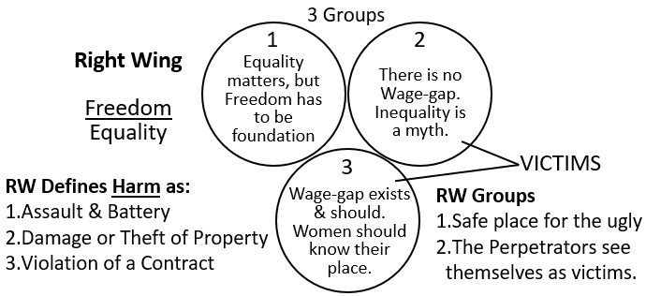
So, just to complicate the picture even more, I want to share screen. This is a member of the far-right militia Boogaloo movement meeting with the Black Lives Matter (BLM) signifying his support and marching alongside them. Okay, it’s complicated. This is a far-right militia group aiming for a civil war part two in America, allying themselves or trying to with BLM, albeit BLM leaders saying please don’t. Please don’t come. But there was an attempt by the Boogaloo movement to say, we are on the same page with the BLM. We are with you. We believe in racial equality, and we want to defund the police too. We have goals in common.
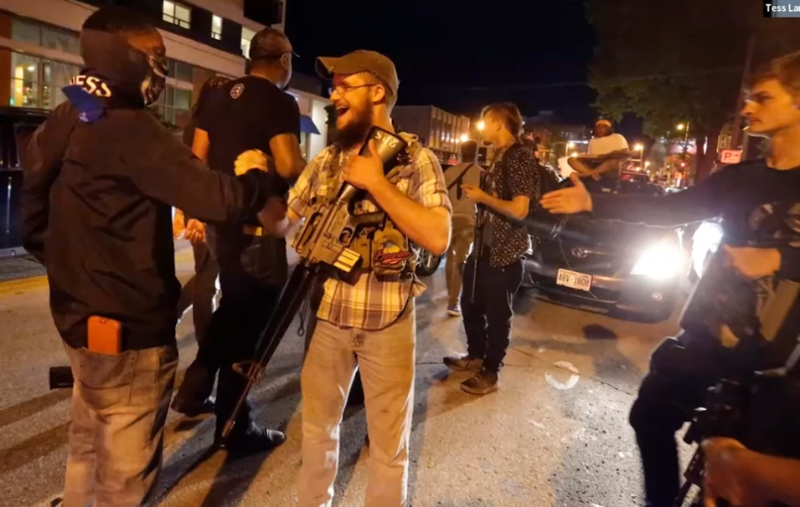
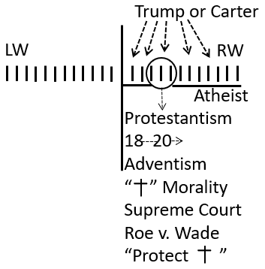
I want us to, I’m trying to get us to, see the complication. And, that is hindered when white nationalism is always put in every single context. It’s there. It’s definitely within that third group, but it goes beyond that. And, I’ll bring it back to the words by Enrique Tario, the man who burned a BLM flag. We have to get beyond that and actually see what they’re standing for, which is what we start to get to when we get to the ethos of the Right-wing, when we get to men’s rights groups, and freedom over equality. And, the left-wing does this over and over and over again, when they are not willing to stand up for women’s rights, and they have to link it to racism; because if they just pulled out just the sexism of the Oscars, people will feel that they’re hearing something feminist, and they’ll cringe, and they’ll turn off. And, no journalist wants that.
So, I agree with you and understand what Trump is saying about immigration; but two points with that: First of all, it’s not necessarily just targeting Protestant Christianity. Again, we’re then expanding it out to something that appealed to the millions of votes that he got from Atheists. That’s definitely appealing, code words, “dog whistles,” as you said, Ray, to a larger segment of the political spectrum, but it’s not specifically Christian. And, I want us to see that. Graham.
Graham – My mind went to Donald Trump’s international endeavors, particularly with Israel, how that would gain a lot of attention for your Protestant group.
Elder Tess – Israel is a good one. It shows just one thing that he had to say or do that the rest of the right-wing wouldn’t particularly care about. But it enabled him to get this segment [Protestants] of the votes. And, when you consider that Hillary Clinton got more votes than he did, it matters. It mattered to get their votes. It genuinely did. It also mattered to get their [Atheists] votes. We need to get deeper into what the right-wing stands for, and what is motivating them.
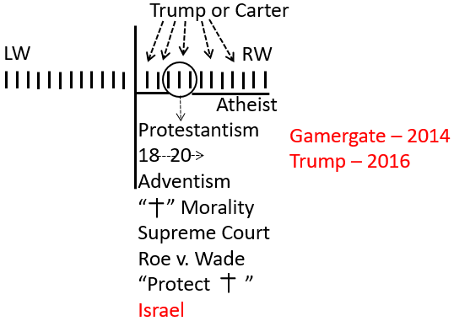
So, we’re looking at the right-wing soup; and Trump is appealing to the right-wing and different factions of it for different reasons. But there is that underlying feeling of being threatened, and also feeling, connected to that feeling, of being threatened, that freedom is being eroded. So, we moved beyond talking about republicanism, and we started to talk about libertarianism. I want to just remind us of something that I’d said a couple of weeks before, before Rachel taught us about Reddit. It was an article by The Guardian in 2016; and in 2016, December 1st of 2016, after Trump’s election, The Guardian wrote, “everything that we’re seeing today with Trump’s election had its precedent two years ago in 2014.” And, what they’re speaking about is Gamergate of 2014, which was the precedent that led to Trump’s victory in 2016.
Now, Gamergate, was any of that Christian? Remember, we’re talking about young men on video games, on line, the same kind of faction of the right-wing that you’re also going to find on Reddit, on men’s rights forums that as we saw was eighty something percent atheist and ninety something percent with a libertarian bent. Gamergate was not Protestant. It was not Christian. It was atheistic in nature, the people that is. Gamergate led to 2016, according to the Guardian. And, I would say they weren’t there, it was a few years too early; but January 6, 2021, it had its precedent in 2016 and in 2014. The January 6th insurrection was not some type of Christian Protestant revolution. It’s the same type of community. It’s the far-right; it’s the neo-right; it’s militia groups. And, I want to draw some distinctions between this right-wing soup. They have an underlying ethos that is the same; freedom over equality, and the feeling that freedom is under threat.
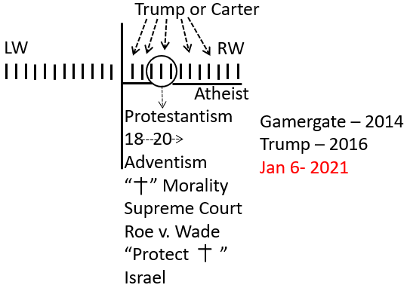
If we can picture it this way. You’re a republican. You’re alive, of age, following the events slowly of 2001, George Bush, his election, he comes into office, and then September 11 happens. And, from 2001, through George Bush’s two terms as US president, George Bush expands the power of the executive branch beyond what it had ever been before. And, he does that in the context, in the shadow, of September 11. So, the power of the executive branch grows exponentially. The problem with that, for a republican is, what happens if a republican loses power? This is the same issue the democrats are facing. The democrats are looking at the filibuster and saying, we should abolish that. And, the republicans are saying, you go ahead and abolish the filibuster. Just you wait till there’s a republican in office and see how that works for you.
The republicans are watching George Bush expand the power of the executive branch for eight years; and they’re watching the Patriot Act, quite broad expanses of American power, domestic as well as some international. And, all of a sudden in 2008, you have this massive left-wing populous movement galvanized around a populist newcomer called Barack Obama. I was 10 or 11 when George Bush was elected. I was 18 or 19 when Barack Obama was elected. So, I was coming into an age where I was paying attention to that feeling of pop-culture in the US and what was kind of here as well. And, I remember well, even then, the excitement, the fascination with seeing Barack Obama in 2008 stand up and speak. He is a fantastic speaker, orator. And, it was a populist movement. He was an outsider, not to the extent that Trump was, but still an outsider. He was still outside the swamp.
And, if you were a republican in 2008, and you have watched the power of the executive branch that much, you are going to watch all of that get handed over to this populist, left-wing, going to shut Guantanamo, going to make US progressive, relatively young Barack Obama, and that was terrifying. Now, if you were also racist, that was definitely a part of it. But, it’s not just a reaction to a black president. That’s part of it, but it’s much more expansive than that. They saw that expanded power in the executive branch get handed from George Bush, who had done that expansion in the shadow of 9-11, to this wildly popular young senator, Barack Obama.
So, in 2008 and 2009, America begins on a path of radicalization; and we’ve talked about this before, the Tea Party movement of 2009, we’ve connected that internally with Elder Parminder. There is this change of leadership, and in this Movement, what’s going to prepare us for the Sunday Law (SL) is also this external Tea Party radicalization that’s going to set the US on the path for the SL as well. And that path to the SL is heavily based on this radicalization within the Republican Party. That radicalization didn’t just start in 2009. It’s little bit like watching Vladimir Putin kill democracy in Russia. There are very clear markers, but 2009 was a major turning point marker.
I want to speak of another marker though. I’m going to quote from Chris Ladd. He is a republican. So, there are large parts of his article, and also the way that he uses the term freedom that I don’t think are technically accurate, and as he is a centrist republican, and he obviously has views that we in the Movement don’t agree with. But he also makes a point about the Republican Party that I think is worth listening to. Chris Ladd refers to himself as a Texan in exile. So, he is a Texan. He’s a republican, and he is conservative, but he writes this article in 2016 as he watches his political party, the Republican Party, follow Donald Trump. And, it’s deeply upsetting for him, because he is not within that extremist republican camp. He’s a centrist. So, he rejects Donald Trump in 2016. That’s why he calls himself a Texan or a southerner in exile. He really still belongs to them, he knows he belongs to them, but he’s not popular with them anymore, because he’s conservative but didn’t like what Donald Trump was selling.
So, he’s going to write this for Forbes magazine in 2016. It’s called “The Libertarian Civil Rights Paradox.” And he says, “The long, sad decline of the Republican Party as the primary vehicle of black political expression corresponds closely to the rise of libertarian philosophy as a force inside the Republican Party.” So, I’m going to read it, and then try to paraphrase it. He says the long sad decline of the Republican Party as the primary political party, political vehicle of black political expression, that corresponded with the Republican Party taking on a libertarian philosophy. So, Josephine. You asked a few weeks ago about how the Republican Party which was originally the party of Lincoln that was on the right side of the civil war became this right-wing, conservative, freedom instead of equality, party today. Josephine, were you able to watch the video that we sent you?
Josephine – Yes. I had looked at it.
Elder Tess – Did it make sense? How the Republican Party changed?
Josephine – Yes.
Elder Tess – Good. I’m glad. I’m just adding to that; he’s just adding to that, because he’s saying that this switch that happened, particularly he’s going to highlight the mid-20th century, that split corresponded with the Republican Party turning from its original roots of prioritizing equality to taking on libertarian philosophy. And, I like that he uses the word philosophy. So, we’re not saying that the libertarian party as a political party in the US matters that much. It’s weak. It doesn’t have much political power. I don’t think it’s ever going to have much political power. What we’re trying to show is the libertarian philosophy. And, that libertarian philosophy is embedded in the Republican Party. He calls it a force inside the GOP. And then, he’s going to go into the civil rights era and explain what we have already covered in our last classes about libertarianism in the civil rights era, and what he calls a paradox.
“Republicans began embracing libertarian ideas about a decade before the Libertarian Party was formed. Barry Goldwater embraced individual liberty as a paramount political value in the early ‘60’s. Libertarians formed a separate political party in the early 70’s...” “To this day figures like Ron Paul (we spoke about Rand Paul and Ron Paul) or Gary Johnson move easily between Libertarian and Republican circles because the boundaries are muddy. The libertarian movement today is still the heir of the Goldwater Republicans. It was Goldwater who launched the Republican shift toward libertarianism and it was under Goldwater that libertarian thinking flunked its first big test of real-world effectiveness.”
I think he’s referring there to the Civil Rights Acts.
“Modern Republicans troubled by their party’s racism are eyeing the Libertarian Party as an alternative. Ironically, it was Republicans’ flirtation with libertarianism (not the political party but the philosophy) that destroyed our traditional role as a political outlet for minorities. It was libertarian policy and rhetoric that converted the South into a Republican stronghold.”
Does everyone understand the point that’s making? Even if we’re not explaining what that means yet? Do we get the point that he’s making there?
Josephine – Yes.
Elder Tess - Josephine, I heard a yes with many yeses. It made me happy. Raymond says yes. So, I’m not saying that the libertarian political party has a major role in the SL. What we’re talking about is libertarian philosophy, and that philosophy is embedded throughout the right-wing, but especially throughout the far-right. And, it’s embedded through the Republican Party, which is why the Republican Party ceased being a party representative of minorities; it ceased being a party that prioritized equality and chose freedom, because it took on libertarianism; libertarianism saying freedom over everything; freedom over equality.
So, we’re not going back to Goldwater to illustrate that, but this republican in exile, looking with a sense of shame on his own political party, is blaming libertarianism for that. I just wanted us to see that that is happening. If we have no thoughts or questions on that point… Brendon, explain to me what “Tough on Crime” means, and be as negative as you like.
Brendon – “Tough on Crime.” In the context of, oh what’s that book, the “New Jim Crow,” in that context, is that what you’re referring to?
Elder Tess – I’m asking you to explain the phrase, and you can do that however you want to. Because this is like one of those slogans, isn’t it? But, what does it mean?
Brendon – I guess they call it a “dog whistle,” I guess. To deal with drug related crimes.
Elder Tess – So, you’re saying they’re talking about drugs?
Brendon – In the past, that’s what it has been used for. But now, if I was to look at it now, it was used to address a lot of the BLM protest around America as well.
Elder Tess – Sure. If you’re going to bring in BLM, I want to bring in “Defund the Police” because again, it’s attacking, do you see these two as linked?
“Tough On Crime”
“Defund The Police”
Brendon – Yes. They’re on opposite sides though.
Elder Tess – “Defund the Police?” I’m talking about “Tough on Crime” as negative, sorry, that looks a little deceptive.
Brendon – Maybe, I’m not understanding the question. Sorry.
Elder Tess – Let’s say we oppose the “Tough on Crime” approach that particularly began with Ronald Reagan. And, we support…
Oppose
“Tough On Crime”
Support
“Defund The Police”
Brendon – “Defund the Police.”
Elder Tess – Yes.
Brendon – Ok.
Elder Tess – Explain to me what these statements mean, because they’re saying very similar things. If you defund the police, they’re going to stop being tough on crime. I want to suggest they’re different phrases that are attacking the same problem. So, what’s the problem?
Brendon – What’s the problem? I’m not sure what the problem is. I feel like I’m not seeing something.
Elder Tess – What does “Tough on Crime” mean? If you’re not sure, it’s ok; and if you think of something, I can come back to you.
Brendon – “Tough on Crime.” Yeah. Maybe come back to me.
Elder Tess – Raise your hand if something comes back.
Brendon – I feel like I’m not seeing something at the moment.
Elder Tess – It’s fine. It’ll click. It will be my explanation that’s at fault. Josephine.
Josephine – I don’t know if this helps or complicate things. Give coercive forces less control on what’s going on. In other words, give us more freedom. Individual freedom.
Elder Tess – Individual freedom? So, we’re fighting for freedom now.
Josephine – Yes, but we worded differently.
Elder Tess – Freedom from what?
Josephine – From big government. Of course, forces from police, surveillance, control.
Elder Tess – So, you put freedom here; opposing “Tough on Crime” means standing for freedom. Supporting the work to defund the police is supportive of freedom. Is there anything else, Josephine?
Josephine – Yes. Supporting freedom. They just want a small government. They don’t want interference from the big government.
Elder Tess – Freedom. Small government?
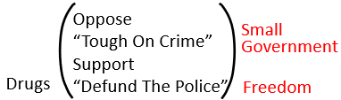
Josephine – Yes.
Elder Tess – Ok. Lynne.
Lynne – That’s more or less what I was going to say. They would be opposing big government, and therefore, they don’t want lots of laws that are going to be creating more crackdown on crime. As they see it that would be limiting people’s freedom, like Josephine said. So, things like defunding the police would reduce big government therefore it would be promoting small government and freedom. So, pretty much agreeing with what Josephine said.
Elder Tess – So, do we disagree with the BLM movement? Because the BLM is saying to defund the police and stop being tough on crime, which is a call for freedom and small government.
Lynne – So, I guess this is where some of the complications come in, because we don’t necessarily disagree with everything the BLM stand for; but if they’re standing for small government and promoting things there, then obviously, we’re going to disagree with that. So, it’s part of the complications, I’m assuming that you’re trying to bring out?
Elder Tess – Yes. Very observant, Lynne. Graham.
Graham – “Tough on Crime,” it’s a slogan to me that represents a group of people that are going to be harshly treated, who are generally found in the lower social economic status of the country, and who are categorized in the minority groups who then in turn removed from being able to vote which affects the whole of the US, and the world.
Elder Tess – You tied in voting there. Can you expand on that? Give a little bit more of an explanation of why you included voting.
Graham – When we’re tough on crime in the US, you become a felon, and you are unable to then vote. When you’re unable to vote, you’re unable to add your support one way or the other. So, it effects the voting. And if you’re in a lower social economic status of society that can often incorporate minority groups coming from lots of different areas whether you’re African-American, Hispanic, whatever it might be, lacking the opportunities that many other people in the US have; you don’t have those same opportunities. Pushing you into an area where you have to resort to some sort of crime to survive.
Elder Tess – So, you’re bringing in minorities. So, you took “Tough on Crime” and you narrowed that. It wasn’t tough on all crimes, and it wasn’t hurting everyone the same. Brendon.
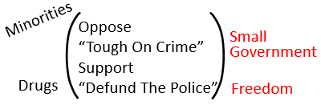
Brendon – You said there was a problem with this; and I’m, possibly, got no idea what I’m saying, but the problem appears that we’re in agreement with the libertarians on those two topics. Am I correct, or am I totally missing the boat?
Elder Tess – Now you know why a far-right militia group is turning up for BLM protests.
Brendon – And that’s the problem. They’re in agreement, and that’s the problem. And is that the problem you were saying? Or, is there something else?
Elder Tess – The Boogaloo movement, a portion of them, because there are definitely white supremacists within that movement, a portion of them saw the BLM movement, saw the death of George Floyd, saw that fight to defund the police and said, we’re on board with that. We’ll support you, my brothers. We will march with you. We will bring our assault rifles, and members of the black civil rights community, leadership within that community, were saying, we’re not on the same page, and they’re [pointing to freedom] saying, yes, we are, and they’re [pointing to the other group BLM] no we’re not. And the [freedom fighters] are saying, yes, we are. And the civil rights leaders are saying, no we’re not.
And, that’s the fight we’re having inside the Movement, and have long been having inside the Movement. People saying, we have the same platform within this Movement. We support what this Movement says it supports, and leadership is saying, no you don’t. We’re on different pages. You might keep saying that we’re on the same page, but we’re on different pages. So, this is where I want to show the complication.
This is where the right part of the left-wing, not the problematic part, the correct part of the left-wing, is saying similar things to the far-right, and we need to understand why. And, what I want us to see is that these phrases, they’re too simplistic, because they mean slightly different things to different people. That’s why I asked you to define them. What does “Tough on Crime” mean to you? To a person in the right-wing camp, “Tough on Crime” is bad because it’s impinging people’s freedom.
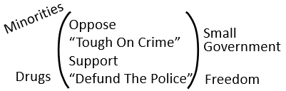
So, in France now, if a man harasses a woman on the street, that is a criminal offence. Someone in the right-wing will say that impinges his freedom to free speech; that does not do harm to her, and they don’t constitute harm as anything beyond really the physical. It’s his free speech, his freedom to speak to harass her on the street trumps her right to be treated with equality in society. So, in France now, it’s illegal. You’re not allowed to shout and harass women on the street even with your free speech. Someone in the right-wing would see that as being “Tough on Crime” in a negative sense. So, when the left-wing looks at these slogans and sees “Tough on Crime,” it doesn’t seem tough on all crime.
It sees tough on specific types of crimes that are targeting and harming specific communities. Does that make sense? Katherine, you’re nodding. Do you have another way to word it better than I just put it? You don’t have to if you don’t want to.
Katherine – So, the left-wing would see the problem with this “Tough on Crime” thing is because there’s minority groups that are being disadvantaged because of the way they’re being treated. So, the motives that they have for opposing the “Tough on Crime” issue is based on an equality perspective. They want to, they’ll actually want to be tough on discrimination. There are certain types of crimes that they want to be tough on; and there’s certain types of crimes that they don’t want to be targeting specific groups, especially disadvantaged groups. Whereas on the right-wing, they’re seeing it differently. They just want sort of like all hands off, and they’re not coming at it from a point of view of equality. Their priority is freedom aspect of it.
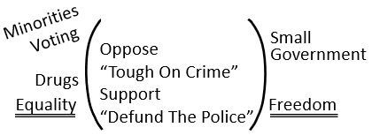
Elder Tess – Yes. I’m hoping that rephrasing in a slightly different way helped everyone. It helped me. You can have the same belief, seeming to be the same belief. This is why we could put other things in different context here, but we could put gay marriage, and you could see that a libertarian, someone in the right-wing and someone in the left-wing both might support gay marriage; but why you support that, where you’re coming from, really matters. It’s certainly mattered, matters at certain points in American history such as January 6. Then, all of these things start to especially matter.
“Tough on Crime” is not for someone in the left-wing saying that the US is too tough on all crimes targeting all communities. That’s not what that phrase has ever meant for the left-wing or for civil rights leaders. What that means is “Tough on Crime,” I specifically didn’t write it because it narrows it down immediately for us, is “Tough on Crime” also is another way of saying “War on Drugs,” because it isn’t all crimes. It is especially drug crimes. And it is especially drug crimes that has disproportionately targeted minority communities, because the police force, whether individually or institutionally, is racist.
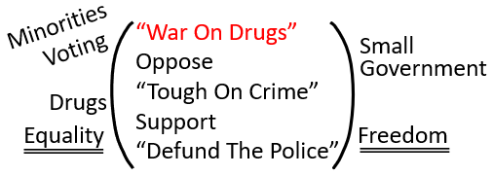
It’s targeting parts of the community over some crimes, and doing harm to those communities. That’s the left-wing approach to the opposition to the “War on Drugs,” to criticism of the “Tough on Crime” policies, and when they talk about defunding the police. How often do you hear the story of a man who is abusive, stalking, threatening, a female partner or ex-partner, and he’s let out on parole, he gets a slap on the wrist, no one takes her concerns seriously, and he kills her. How often does that happen? Over and over and over again.
The left-wing has never said that the US is too tough on domestic violence. That’s not what they’re saying. They’re not saying they’re too tough on men. They’re not saying they’re too tough on white people. That has never been the left-wing’s position on these simplistic phrases.
But, if you’re a libertarian, you’re going to hear the same phrase and say, that appeals to me. I agree with that. The BLM movement wants to defund the police. They should be defunded, because prostitution should be legal, because we’re impinging on people’s freedom left, right, and center. Freedom. And then, some of those members will turn up to BLM protests and, then they will also often be the instigators of the worst of the violence that occurred at those protests because there was violence, but it wasn’t all left-wing. Decent percentage of the violence was right-wing and far-right participants turning up fighting to defund the police, because that appealed to their fight for freedom.
I’m not sure where we got to with comments, so I’ll work backwards. Marie.
Marie – I was just going to say that the police force was a law unto themselves anyway. So, from a left point of view, defunding the police was, to take the power out of the police, from the police’s hand.
Elder Tess – They talk about institutional racism in the police force. It’s hard to get proper data on this, but from what they have done, they can see that the families of the police officer are two to four times more likely to experience domestic violence at their hands than the general population. You can bring up case after case after case. Thirty-year-old veteran police officer shot his wife and then himself in Colorado Springs earlier this summer. This is from an article from 2014. So, it’s a few years old. Tacoma police Chief, David Brame who perpetrated another murder/suicide in April. Sargent Ryan Anderson, a narcotic officer broke into his ex-wife’s home and fatally shot her before shooting himself. Crandall police officer shot and killed his wife before killing himself. Nevada police officer killed his wife, his son, and then himself. Joshua Boren killed his wife, their two children, his mother-in-law and then himself. Hours earlier, she had threatened to leave him and take the children, confronting him because he had been raping her.
It comes up over and over and over again. The misogyny and the domestic violence that occurs within the police force and then their ability to cover that up, because they know their way around the system, and they also have a whole lot of friends who think they wouldn’t do that. If anyone, anyone wants to bring in mental illness into those stories, if you didn’t over George Floyd, if you didn’t over racism, don’t do that now. Let’s be consistent. If you’re not concerned about the mental health of the police officers being charged with racial instances, don’t bring this into gendered instances. What you do then is you just make this a domestic issue, and it’s not. It’s power. It’s an issue of power and control.
So, the police force, the entire justice system has an issue, but it’s not an issue where they’re trampling down on people’s freedom. It’s an issue of power and control and abuse. It’s an issue with equality. So, the left-wing says the police force needs a radical rethinking, not because they’re being too hard on abusive men. Lot of the police force are abusive men, the very men who are meant to answer a call where there are cases of domestic abuse, and they abuse their own families. Two to four times more likely to do so then the general community.
So, the police force needs a radical rethinking. The left-wing understands that. The right-wing also thinks the police force needs a radical rethinking, and I’m not talking about the republican centrist right-wing; I’m talking about the far-right. I’m talking about libertarianism. They agree with the left and say we need to rethink the police force. The [left] side does it from a perspective of equality. The [right] side does it from a perspective of freedom.
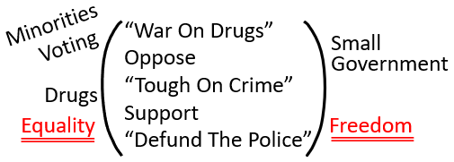
And, this is what we’re encountering over and over again within the Movement as well, because we have a position on something; and people say we agree with you, and we say, not really. You might agree with some of the conclusions, you might agree with gay marriage. I keep going back to that, because it’s a clear example between the left-wing and the republican agreeing for different reasons. But, whether or not you’re actually doing so from a proper prophetic perspective, again, bringing it back to both sides of that great controversy curtain, it matters. It matters what political party you vote for.
We’re kind of out of time. I’m not changing anything that we’ve taught before. We still will target Protestantism, and we did that, and we’ll do that going forward because we’re in the history when we’re talking to Levites. We are already talking to Levites, and as we do that, we’re trying to convince them that Adventism has a problem, and we’re showing them Adventism has a problem by showing them that Adventism is following Protestantism. And, if you read basic Ellen White, you should know that that’s really concerning.
So, we had to do that, and we’ve done that. But, in the light of Gamergate and Trump’s election, in the January 6 insurrection, in the light of the fact that many members of the Movement, some even still thinking they’re members of this Movement, they thought that they moved from here to here [from the Protestant right to the nominal left], and they just moved from here to here [from the Protestant right to the farther right]. And, I’m still calling out to them saying, the light behind you is going out. The light behind you is going out, the light of the Midnight Cry because instead of moving like you were supposed to in 2018, you’re just jumping into different camps of the right-wing soup.
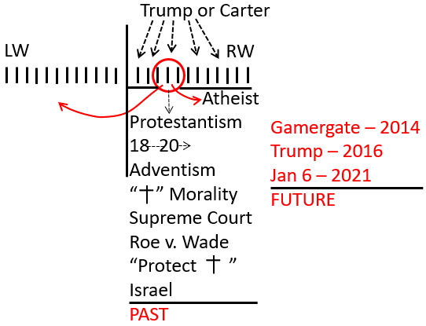
I’m wanting to put Protestantism to one side for the moment. We’re breaking apart the problems with the right-wing. We’ve got down to their fundamental issues which is what happens when freedom and equality collide; and I’m wanting to focus not on America’s past, the rapidly disintegrating Evangelical community. I want to focus on America’s future, and that is what Gamergate gave us a window into. Gamergate was not elderly people, elderly Evangelicals worried that they were losing power, and they needed to shore up church and state. That was not Gamergate.
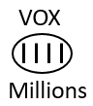
2014 showed us America’s future because this is especially young men, this is heavily atheistic. It’s not Christian based. It’s heavily libertarian which means they can use some of the same language that we use; but it is very opposed to equality, and when equality and freedom collide, some of them are the most dangerous. And, the VOX article, the point of the VOX article was to show us, those men who spoke out in 2014, that small group of openly abusive men are supported by millions who say, sure, they went too far, but it’s a fringe few, and they were driven to it. It’s not their fault. They’re still the victims. It’s supported by millions who still agree with the fundamental points that those men in 2014 were making, that anti-feminist, that hostile point.
We’ll close now, and we’ll come back to this next week. If you have questions or thoughts, please bring them. If it helps you, you can write them to me during the week. If you’re going to forget them and then I’ll make sure that when we start again (I might not answer you privately because that would really take away from the classes a little bit) we can incorporate them early on into next week. So, I don’t want to move beyond wherever each one of you are comfortable. I don’t want anyone to feel left behind or to have a point or a question that we don’t get to. So, please, if you want to put them into writing, write them down and send them to me, and next week, we’ll go over it again. We’ll discuss it more and answer any questions you have and any thoughts you have.
I want to start addressing the some of the militia groups just to make a few points as we were going to do on the Proud Boys, the Three Percenters, the Oath Keepers. We have to understand January 6 as a prophetic turning point, and all that it represents. I did make the point, and I’m hoping that people don’t misunderstand me when I’m saying that simplistic phrases that bring in white supremacy can miss the point of what’s happening. It misses, it can be a way to highlight the ugliness that these groups can incorporate, but it doesn’t necessarily represent their fundamental ethos; and we need to get to the fundamentals if we’re going to understand them.

Closing Prayer
If you kneel with me, we’ll close in prayer.
Dear Lord in heaven. Thank you for our blessings. Thank you that you are helping us to understand these complicated political events and changes within the US. We understand that it is a Glorious Land for a reason, but it has so much to teach us about your government and about the opposition party. I pray that we’ll understand it so that we can understand the SL, so that we can understand current events, but much more fundamentally so that we can understand your government, the way it should have been, in the way that you’re promising it can be again if we vote for you, if we decide to follow you wherever you go, even if it requires a deep look at self, even if it requires a high degree of unlearning.
Thank you for this group that’s so willing to wrestle over these things alongside of me, and I pray that you’ll bless their Sabbath hours. Bless them during the week as they think on these things, and as they think of questions or thoughts or contributions to share, I pray that you’ll continue to bless these studies. I know that you are with us. I pray this in Jesus’ name, Amen.

