How Do I Share My Screen?

https://support.zoom.us/hc/en-us/articles/201362153-How-Do-I-Share-My-Screen-

Overview
Zoom allows for screen sharing on desktop, tablet and mobile devices running Zoom.
- The host and attendee can screen share by clicking the Share Screen icon.
- The host does not need to "pass the ball" or "make someone else a presenter" to share.
- The host can "lock screen share" so no attendee can screen share.

Prerequisites
- Zoom desktop client
- Zoom mobile app

Sharing your Screen
- Click the Share Screen button located in your meeting controls.
- Select the screen you want to share. You can also choose an individual application that is already open on your computer, the desktop, a whiteboard, or an iPhone/iPad.
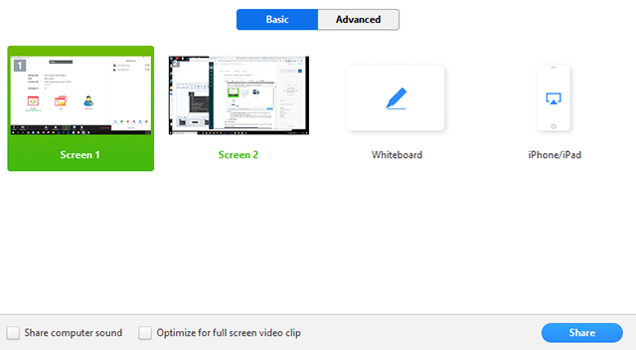
- (Optional) Enable these features:
  - Check Share Computer Sound: If you check this option, any sound played by your computer will be shared in the meeting.
  - Check Optimize for full screen video clip: Check this if you will be sharing a video clip in full screen mode. Do not check this otherwise, as it may cause the shared screen to be blurry.
- Click Share.

Screen Share Menu
When you start sharing your screen, the meeting controls will move into a menu that you can drag around your screen.
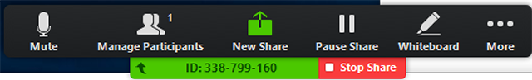
- Mute/Unmute: Mute or unmute your microphone.
- Start/Stop Video: Start or stop your in-meeting video.
- Participants/Manage Participants: View or manage the participants (if the host).
- New Share: Start a new screen share. You will be prompted to select which screen you want to share again.
- Pause Share: Pause your current shared screen.
- Annotate: Use screen share tools for drawing, adding text, etc.
- More: Hover over move for additional options.
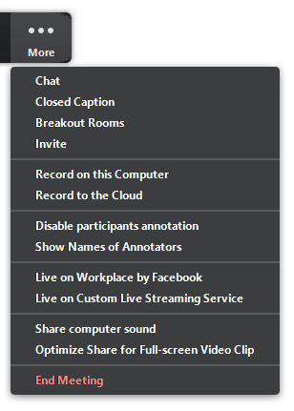
  - Chat: Open the chat window.
  - Invite: Invite others to join the meeting.
  - Record: Start recording locally or to the cloud.
  - Allow/Disable participants annotation: Allow or prevent the participants from annotating on your shared screen.
  - Show/Hide Names of Annotators: Show or hide the participants' name when they are annotating on a screen share. If set to show, the participant's name will briefly display beside their annotation.
  - Live on Workplace by Facebook: Share your meeting or webinar on Workplace by Facebook. Learn more about live-streaming a webinar. Learn more about live-streaming a meeting.
  - Optimize Share for Full-screen Video Clip: Start optimizing for a video clip in full screen mode. We do not recommend using this if you are not sharing a full screen video clip, as it will blur your screen share.
  - End Meeting: Leave the meeting or end the meeting for all participants.

Annotation
Select Annotate to begin annotating on your shared screen.
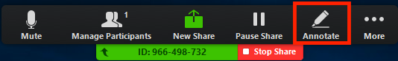
This will open the annotation menu.
You can use the following annotation tools:
- Mouse: Deactivate annotation control and switch back to your mouse pointer.
- Select: Select, move, or resize your annotations.
- Text: Insert text.
- Draw: Insert lines, arrows, and shapes.
- Stamp: Insert predefined icons like a check mark or star.
- Spotlight/Arrow: Turn your cursor into a spotlight or arrow.
- Eraser: Click and drag to erase parts of your annotation.
- Format: Change the formatting options of the annotation tools.
- Undo: Undo your latest annotation.
- Redo: Redo your latest annotation that you undid.
- Clear: Delete all annotations.
- Save: Save all annotations on the screen as a screenshot. The screenshot is saved to the local recording location.

Dual Monitors
If you are using a dual monitor set-up, you can turn on the Use Dual Monitors feature to see the screen sharing on one monitor and participants on the second.
Note: On Mac OS 10.15 Catalina, you need to allow Zoom access to Screen Recording to share your screen. You can do this in your System Preferences > Security & Privacy > Privacy > Screen Recording. Check the option for zoom.us.
