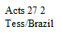
Pioneer Writings
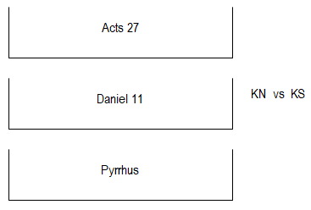
Great Empires of Prophecy 17
Empires of Grecia – Alexander’s Successors
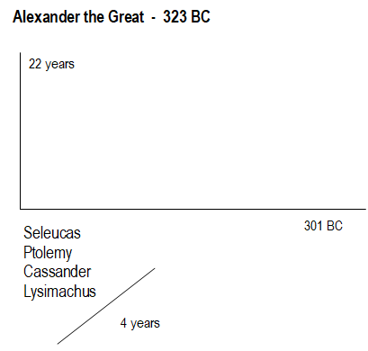
Parable

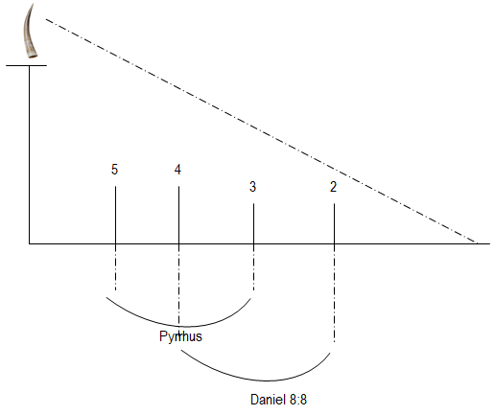
Adramyttium = “I shall abide in death”
Alexandria

TOE
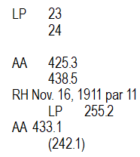
“severed”
Caesarea
