Structure of our lines

We are the priests, and to understand our history and how it looks like we draw from different models. a point of reference for us: is the line of the 144K. The line of 144k gives us 5 primary waymarks: 1989, 9/11, 2014, CoP Dan 12:1 to end intercession and human probation, 2nd Advent. This line of the 144K is the model for the history of the priests.
We can superimpose another point of reference upon this line of the 144k. And as we do that on top of it, it gives us additional info, which informs what our history looks like. Other than the line of the 144k, another important line of reference is Millerite history.
When we superimpose the millerite history on the line of the 144k, you see that 1989=1798, 911=April 19, 1844, SL=July 21, 1844, CoP=Oct 22, 1844, 2nd Advent = 1863. That Millerite history corresponds to the line of the 144k. As we look at millerite history from July 21 to October 22, 1844, we see additional waymarks in this history. These are Aug 1 = camp meeting in Concord, August 15 camp meeting in Exeter. This is the history of the MC.
When we look at the line of the 144K it corresponds with the history of the Loud Cry. But as we look at it from the history of the MC, we see a pattern: from July 21st where we mark the unsealing of the MC in Boston, (this is where the message began to have force on the minds of the people), so we represent that as unsealing, then we have Concord – which we can mark it as increase of knowledge, and then August 15 = Exeter= the message is empowered. Then on Oct 22 you have the shut door = Test. when we look at this history of the Millerite and when we call Oct 22nd a test, there is something that we need to understand from the perspective that it is not from Oct 22nd you begin to being tested. At the close of probation you demonstrate whether or not you have correctly understood the MC message.
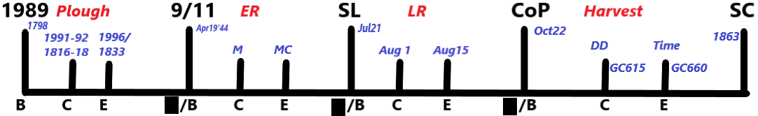
We have message unsealing at Boston, increase of knowledge at Concord and then it is empowerment at Exeter, followed by the test in Oct 22nd 1844.
So in this history of the MC we have a structure that we see reflected at the beginning of the Millerites history, and at the beginning of the line of the 144K. At the ToE the message is unsealed. which is what we saw in Boston, there is an increase of knowledge.

When we look at the line of the 144k the Increase of knowledge was in 1992, and formalization in 1996. We have this pattern being repeated (B,C,E, B,C,E…)

When we look at the history from the CoP to the Second Coming you can read GC650 we can see a waymark identified after the CoP: death decree passed by the wicked against the 144k, permitting the killing of the God’s people at a certain time. In GC640, it tells us that just before the 2nd coming the day and time of the 2nd coming is announced, and that is followed by the 2nd coming.
This structure that we see at the MC comprises of 4 waymarks that we can symbolically represent as B,C,E, we seeit not only between the SL – CoP and 1989 – 9/11 , but also between the CoP and the 2nd Coming. In this case, the CoP=Boston, DD=Concord and Time=Exeter, followed by the 2nd Coming.
When you look at Exeter at each of those waymarks, you can see similarities with the waymarks in each of these dispensations:
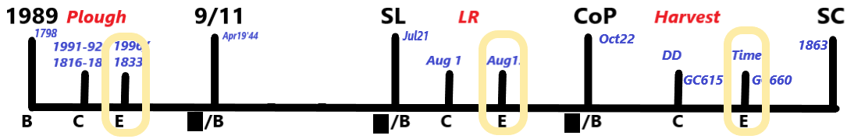
Exeter: definite time is announced, message of time is empowered, 1996 = Time of the End magazine is formalized. So we see within the Millerite history as well as the line of the 144k 4 distinct dispensations or phases. The structure of each phase looks the same. We see 4 waymarks from 1989 to 9/11, 4 waymarks between the SL and the CoP, and 4 waymarks between the CoP and the 2nd Coming. Therefore, there are 4 waymarks between 9/11 and the SL. The missing waymarks are Midnight and the Midnight Cry:
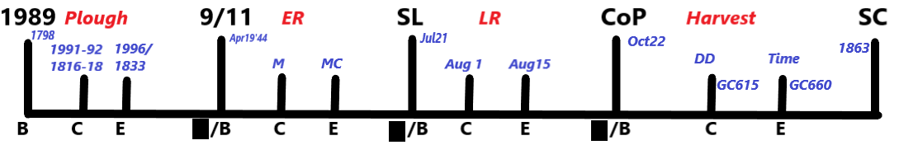
So from 9/11 to SL we also have Boston, Concord, Exeter, then a test.This is the line of the Milelrites and the 144k.
On top of these two lines you can superimpose the agricultural model. Within the agricultural model the history between the 1989-9/11 represents ploughing. You can go to the agricultural model and you can see that the ploughing represents preparing the soil for the sowing of the seed. And this message comes at 9/11. At 911 we have the seed=message and after we have the outpouring of the Early Rain. The Early Rain is followed by the Latter rain which prepares the God’s people for Harvest which begins at the close of probation. So, you have Ploughing, Early Rain, Latter Rain, and Harvest.
These 3 models are then used to populate our line. The line of the 144k feeds certain information about our history.
The agricultural model feeds additional information about our line. And the Millerite history feeds same and also different information on our line. Each Model contributes information to fill the puzzle of our history. But now we come to the history of the priests. The history of the priests is a fractal of the line of the 144k. We will speak more about fractals, as there is a certain that we are going to make in connection with fractals.
Line of the priests begins in 1989, we see the same Increase of Knowledge and Formalization, SL =2014, CoP=2019, and paralleling 2nd Advent=Panium. From SL to the CoP we have 2 waymarks which in Millerite’s history is Concord and Exeter. But in the line of the priests Concord=2016 and Exeter=empowerment of the MC message, where we also see time being brought into view is 2018. So we know that between 2019-Panium we have 2 waymarks. In the history of the priests we have the same Ploughing, ER, LR, and Harvest.
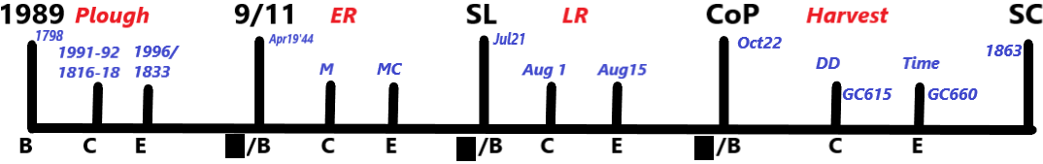
|| || || || || 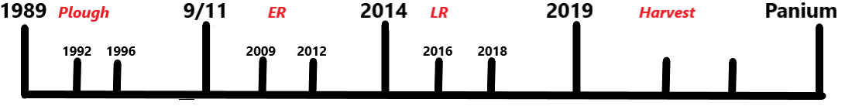

Now, when you look at the line of the Levites, when is the harvest of the Levites: Between Panium and the SL. This time period between Panium and the SL is Harvest for the Levites.
So, as we populate their line going backwards, we know that their harvest must be preceded their Latter Rain, which according to the structure would be Panium to 2019. Their Latter Rain will be preceded by their Early Rain which according to the structure which we populated going backwards would be 2014-2019.
So, their Ploughing according to the structure would be 911 to 2014. We have the same 4-part structure between each of these phases
So, this is the structure of our line from 1989 to the Close of Probation:

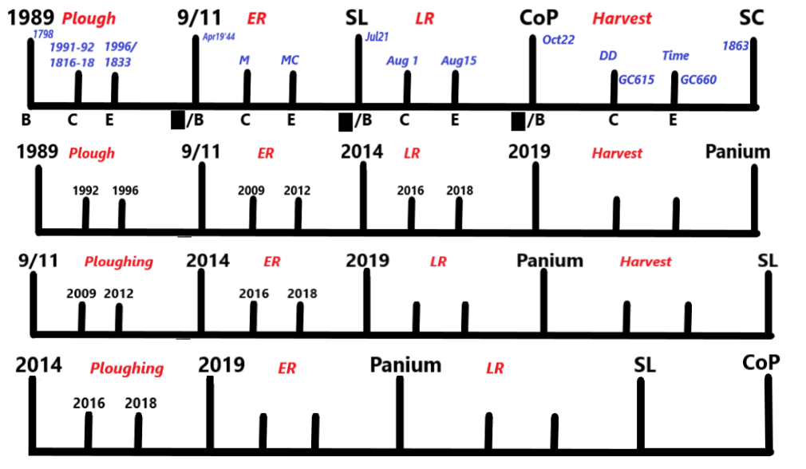
We see that the Harvest for the priests is from 2019-Panium.
Let us look at the Harvest or the CoP. 2019 is the Cop for us, 2019 lines up with Dan 12:1, which we correctly understand to be the CoP.
When we look at Dan 12:1 we understand the concept of fractals, that the line of the priests is the fractal of the line of the 144k. We understand that what happens in Dan 12:1 should be reflected on November 9, 2019.
In Dan 12:1 Michael stands up and ends human intercession:
And at that time shall Michael stand up, the great prince which standeth for the children of thy people: and there shall be a time of trouble, such as never was since there was a nation even to that same time: and at that time thy people shall be delivered, every one that shall be found written in the book.
From this point on there is no more intercession for sin. So it can be expected that in 2019 it can be the same thing. When we come to Nov9, 2019, that is the CoP, no more intercession. How many of us understand it that way? That when we come to 2019 there can’t be any sin in your life, and here in 2019 the intercession ends. Every now and then we still find people who think that way.
But I would like to propose that that it is not that simple. Not quite correct. We understand the CoP because our line is a fractal of the line of the 144k. Dan 12:1 informs us what we should expect in 2019. But if we understood it just that way Panium lines up with 2nd coming. Yes? And here at the 2nd coming Christ literally comes to the Earth. And Paiunm lines up with the 2nd coming. So, are we saying that Christ is coming at the Panium? – No, right? No one is saying that. So, only certain characteristics from the line of the 144k are seen in the fractal. When we look at fractals, we understand that if we look at this pattern, we call this an object and it comprises of 3 elements. And these 3 elements form a pattern. A fractal of this object would be if we took 1 element of this pattern and opened it up into its constituent parts. If we take 1 and open it up to see what one looks like, we would see a repetition, of the pattern seen in the larger object. We will call this A and B.
1 2 3 A
|
1 2 3 B
Object A comprises of 3 elements that form a pattern. If you take a part of A and break it down you see a pattern of a larger object and B becomes a fractal of A. 1A tells us what 1B look like, but they are not the same. Different. 2A tells us what 2B look like. 3A tells us what 3B is going to look like, but they are not the same object, but we see the characteristics of A reflected in B.
So, when you look at the 144k line, as telling us what the line of the priests is going to look like, Panium [parallels the 2nd coming, but it is NOT the 2nd coming. The CoP Dan 12:1 parallels 2019, but they are not the same object.
When we look at our line the Macro line – line of the 144k, there is only 1 place where the intercession is ended, where Michael stand up – Dan 12:1. But what we do see in 2019 is not the end of intercession but something that looks like it, in the same way that what we see at Panium is not the 2nd coming but something that has similar characteristics.
How is 2019 is a CoP?
When there is only 1 CoP in a truest sense? – it becomes a symbolic CoP or we say prophetic CoP. What took place in 2014?
So, Cop is Dan 12:1 helps us to understand what 2019 looks like but it is not the CoP – end of intercession, because there is only one CoP Dan 12:1. In the same way as there is only 1 2nd coming. The fractal of it is not the 2nd coming in its truest sense, but something that looks like it. So 2019 becomes a symbolic CoP. It looks like the CoP, but not the end of intercession, as just like with the 2nd Coming, it happens only one time.
What does 2019 look like?
We are tested by the messages in each dispensation. Each of these dispensations the message is unsealed. When you come to 2019 if you fail to pass the preceding test, you place yourself in a position when in the next dispensation you will not be prepared to receive the light in the subsequent dispensation. In 2014 peopple were called to study Dan 11:40-45, and emphasized centrality of the methodology of the reform lines, that is the basis of this message. In 20914 light is unsealed, this was Ezra 7:9, and what ensued was shaking over that line. But what happened was that many people did not take time to ground themselves in the methodology.
If you are not grounded in methodology, when you are like Cain in Ezra 7, which is based on the methodology, you are unprepared to receive it. Those people separated themselves from the movement. So when we look at 2019 as the CoP, it looks like the CoP, - there is a prophetic test that is happening in this history, but when you come to this waymark, if you have not passed the prophetic test in this history, you put yourself in a position where you are not able to receive the additional light, not advancing on. Intercession ahs not ended, and Christ is still interceding for sins, but it looks like the CoP. Even if the intercession is not ended, if you are not able to advance on with the light, you are lost. But that does not mean the intercession is ended, because that only takes place at Dan 12:1
So 2019 is a prophetic close of probation. It looks like it. If you come to 2019 with regards to the prophetic message and not grounded in it, and you are in a situation where Holy spirit cannot reach you, you are effectively lost, even if the intercession has not ended.
For the Levites it is the same thing. They are presented with the prophetic test. Their harvest is from panium and SL and they are tested by the requirement to receive the testing message in this time period. From SL to the CoP we also have a prophetic test with the nethanims, but as far as the CoP goes, the moral close of probation is at Dan 12:1.
So moral intercession, intercession for sins, does not end in 2019, this is the prophetic test. Intercession for sins does not end at the SL either, it ends at Dan 12:1.
As our test is prophetic in 2019, it does not mean that if you sin after 2019 (not that you should make a provision for sin), but it does not mean that on the 10th of November you do something bad, that you are done, and you might as well commit suicide because there is no more forgiveness for this sin. That is not the case. 2019 is a prophetic CoP. We are being tested by the requirement to receive the prophetic message, and to receive it in a way that we will be prepared to received the further light in the next dispensation. But it is not a moral CoP.

