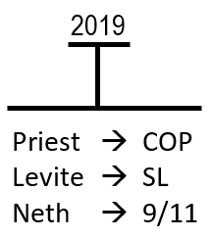
We covered a lot of material yesterday it went quite quickly so we'll do some review We traced some histories from the first line new Earth to New Earth We're identifying changes depending on the dispensation in what God is requiring of his people. A statement like that and scene is automatically wrong or at least dangerous to say that what God requires of his people in one dispensation is complete opposite of what he instructed in another generation. But this is a principle that we exercise all the time we have just been used to that whether it seems obvious to us or we were raised that way but we use these Concepts all the time. Put simply in Genesis 9 God said to Noah every moving thing that lives will be your diet he is giving Moses instruction exactly what is meant to eat but I believe everyone in this room especially everyone baptized recently so that will let some of you off the hook, understand in our vows how we relate to diet so just in that one simple issue you are already understanding God is requiring something of you that goes directly against his instructions to Noah we're dealing with the issue of race and we will highlight one point before we move on 2019 is a waymark on our reformed line what is that way mark if you are a priest it's a close of probation if you’re a Levite it's a Sunday law if you're an Nethinim it is your 911 depends on what group you are coming to is what this way marks means to you, but we said before that the test facing God's people is similar or the same for each group so if you are a Nethinim in this dispensation the challenges they are facing relate to the issues of racism and sexism how is God going to bring these subjects in this particular year closely to the attention of the Nethinim they don't care about a 220 they have no idea about a 126 but everyone can understand a 400 year anniversary.

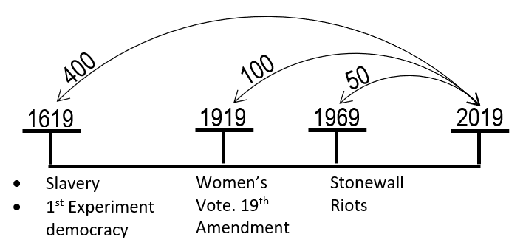
In 1619 at the same place at the same time in American history slavery began same place at the same time as the first experiment with a representative of democracy so you have the principles of Republicanism and freedom begin at the same time as slavery and this is why the subject of slavery is all through the news being brought to the world this year it's been a major subject just for normal people particularly in the United States and also the world. It was in 1919, 100 years ago that women won the right to vote this was the 19th Amendment, so racism has become an issue this year principles have a Republican government women's right to vote so racism and sexism already a subject. There's another subject that we can take from 1969 the stonewall riots The Stonewall riots began the gay rights movement so you have a 400-year anniversary a 100-year anniversary and a 50-year anniversary the issue for all is equality. Even before a Nethinim without the subject of Prophecy you already have these subjects being researched and presented. But we are priests so we don't just have 100-year anniversary God is teaching us a prophetic message based on the principle of Parable teaching we take the issue of racism that we saw that there was a new Earth equality we had one common family Noah and his family.

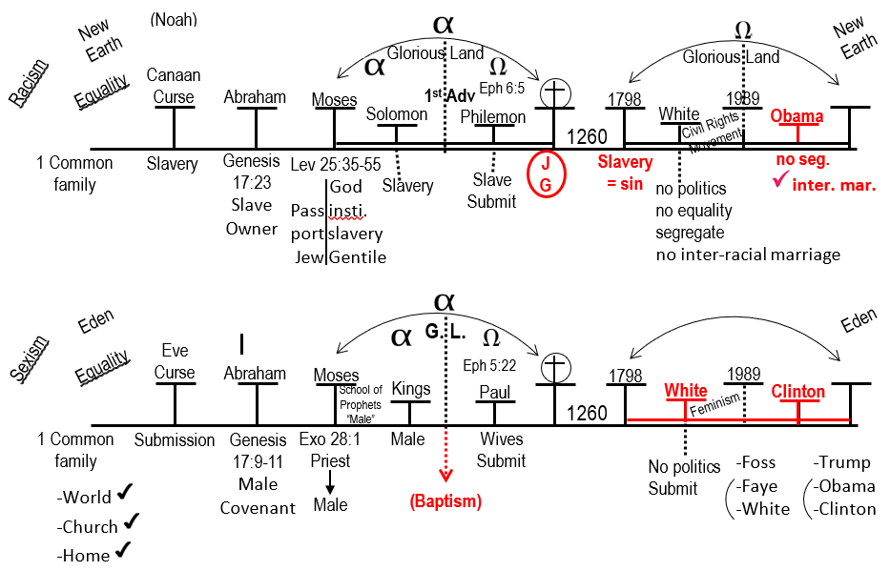Then there was a sin when equality was introduced a curse on Canaan, slavery, racism. Abraham was a slave owner you come to the beginning of ancient Israel and you find in Leviticus, God orders them to place their neighbors into slavery you have him Jew from Gentile he says Jews have rights that Gentiles don't have a Jew cannot be a slave. Solomon implements that then you come to the first Advent the A Mega of ancient Israel this revolutionary Rises up John the Baptist and he starts baptizing people and then comes Jesus and the Pharisees come and tempt him over and over again and what do they keep bringing with them all the writings of Moses they come to him with her quotes and they say Moses told us that a man can divorce his wife for every cause and Jesus said it wasn't like that in Endon what God has put together don't separate and they said but we have quotes Moses states that we can do that and Jesus says don't blame me it's your fault those quotes are there, with the condition of your heart that put those quotes there. Then Jesus says the truth will make you free and they say we are Israelites we have never been slaves to anyone how can you say you can make us free Jesus says I don't care you are in slavery and you thought that could never happen Pharisees say Abraham is our father Jesus says Where in the new dispensation Jesus says to a crippled man pick up your bed and walk and it's the Sabbath and the Jews say Moses told us how to keep the Sabbath you are breaking the writings of our Alpha history Jesus says I do not accuse you to the father there is another one who condemns you Moses condemns you. Moses the one you claim to trust because if you really believed Moses you would have believed me because he wrote of me. What you have is a difficult situation more difficult then you realize because what they are doing is that they're coming to the same quotes the same books and reading them in two different ways. The Pharisees could recite long passages they know well what Moses said their problem is there methodology, how they interpret. A lawyer comes to Jesus what do I do to inherit eternal life and Jesus says what is written in the law how do you read the lawyer says love the Lord your God with all your heart, soul strength and mind and thy neighbor as thyself and Jesus says you gave the right answer it's a simple question deceptively simple all that lawyer had to do is memorize the law and recite it and I'm suggesting if he did that he would have failed the test because that's the answer at the Pharisees would have given. Just take the quote as it's written resided but that is not what Jesus was looking for he identified that this lawyer is using the correct methodology is a whole division in the Omega history between two different methods of interpretation They have the same material and two sides read it in two different ways they are on the side of Christ but they could easily make the argument that it was breaking down the writings of Moses. Where did baptism ever come from because it wasn't an institution of Moses. Jew and Gentile now equal and all the Jews have to be convinced that thought that they are in a slavery to sin and other lives they're taught from quotes at their special that they can't be slaves. But if they could admit that, that they are themselves are slaves they could be worked with. I want to identify John the Baptist stand up, gives a message and what is he telling everyone there’s a messiah coming. That's going to free you from the Romans kill all your enemies restore Israel we're going to have this glorious Kingdom and these disciples rush to him they join John the Baptist Hoping to play a part in this glorious restoration and then comes Jesus he's slowly telling them the restoration does not look like what they thought it would look like and he says it and he says it but they are not listening and they get to the point of the cross. and the cross is Victory the blood of cross saved us restored the human race it's all restoration but for those who could not see it, it's complete devastation we have a widening chasm in this movement between those who could see the restoration and what this movement is going to look like and those who are devastated because they thought that John the Baptist taught them. It would look different one set of information two ways to read it. 1260 years Alpha of modern Israel what is the argument of the South we went thru that, they have thus saithe Noah thus saithe Abraham and thus saithe Moses and finally thus saithe Paul they have all the New Testament and then these Adventist they're saying slavery was a creation of Satan the south that says where is your quote. Quoting the South, ‘the North must give up the Bible and religion or adopt our views of slavery they both have the Old and New Testaments” but two ways to read it, Ellen White says the minds of the black people as well as the body has been abused, slavery originated with Satan she has no quote for that. She does say don't make any political speeches urge for equality between black and white segregate your churches do not intermarry just to remind us this congregation is not segregated going against thus saithe the Lord. There was an interesting article in the Washington Post a few days ago please read it, this article is titled conservatives say we have abandoned reason and civility the Old South said that also. A farmer conservative I don't know what condition he is in at this time, grew up conservative, home, friends, where conservative he grew up in Virginia obsessed with the Civil War reading all the Diaries of the soldiers studied almost nothing but Abraham Lincoln's speeches wrote his thesis on the Lincoln address. Studying not just the writings of the North but also of the South as well and he's trouble because what he can see are all the same argument of then by the south, he is hearing again today he finally understood that he had this feeling of Déjà vu. It's a long article I want to highlight two people he is targeting but in reality, there are six people I`m high lighting these two because it is these two that I know people in this movement listen to and respect Ben Shapiro and Jordan Peterson. what is saying the arguments and the rhetoric being used by them today the so-called reasonable right is identical to that of the South, what the problem is we don't know how well the South argued .Most Americans are unfamiliar with the actual language of the South they rarely declared slavery was good or said black people weren't equal they rarely talk of slavery itself. They claim themselves where the Defenders of reason free speech and civil discourse friendly debate. Arguments of the South said that the southerners where the keepers of the faith and martyrs of their dedication, facts, reason and civil conversation. they said they are the Guardians of Freedom's minority rights. Be aware the South is saying they are the persecuted minority they are “David against Goliath it's that bully North that won't listen to reason and is persecuting free speech” it's the same argument these conservatives are saying today the idea that the left won't let you express a different opinion this writer makes the point that Fox News is the most watched cable news Network on television. Ben Shapiro's book the New York Times number one bestseller, Jordan Peterson`s shows are sold out. their YouTube Channel have millions of subscribers conservative control the presidency, Senate and the Supreme Court. They are not David against a liberal Goliath, going back to the South stressing the importance of logic, facts, truth, logic they accuse the North of being romantic idleist that the North ignores the experience of centuries they say the issue of slavery should be open to fair honest investigation, and should stand or fall on facts and they say they have the best interest of the blacks people at heart. Quoting John Wilkes Booth just before he shot Abraham Lincoln “no one cares more about the black people then I do he says at to free black people into a cold cruel world, would destroy them, he says it is science if white people were built to work in a hot field they would but their constitution is built differently, the claim he makes before he shoots Lincoln was not aimed that slavery was ended instead he laments that he no longer feels comfortable expressing his thoughts and feelings about slavery in Good Company. They never saw themselves as the oppressors, but as the oppressed made to feel isolated and shamed just because they have the rights to think freely. and the Northerners humiliate and Bully them for their free beliefs. Abraham Lincoln Fought hardest not against those who openly supported slavery but against some politician that wouldn't defend slavery that they were Bound by Duty to defend the rights of the South as it was an American principle to freely choose how you live the argument made by the south is identical to that made by the likes Ben Shapiro and Jordan Peterson and others today and are more dangerous than Steve Bannon, the rest of this article takes a quote from Ben Shapiro and a quote from the south almost identical does that through six different conservatives writers, a straight compare and contrast because the arguments made today are not openly stated, that immigrants and black people are inferior, that women are inferior they're much more subtle just like the South. So, we come to this history the alpha of modern Israel. Despite all those good arguments and southern free speech and believe the movement stands firmly against them but to also says these things. and you have the Civil Rights Movement and the Omega of modern Israel. Now we come to sexism the same story Eden to Eden 1 common family, equality Eve is cursed but in subjection to her husband, then we find Abraham male Covenant, Moses male priests, Samuel male School of the prophets male Kings it's all a patriarchal system. Then the first Advent, Omega of ancient Israel there is a male Covenant until John the Baptist, there is a male priesthood. There is a male priesthood until Elder Jeff, Pipinger. Solomon this history the male Kings until Hillary Clinton, male School of the prophets until this movement. let us go to 1st Timothy is someone what's the office of an Elder he does a good work should be the husband of one wife a good priest father in the family and all we're saying how can we read that and it says male, male because all of you have already accepted that these no longer are, we can bring other evidence it support that the first argument is methodology and consistency.

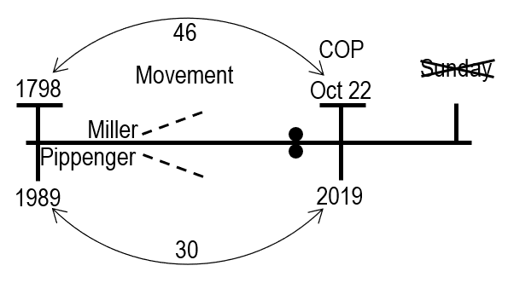
If you can see what we have already done, this is not a new or radical option, the problem people have with what they're saying how far is this going to go, what is next. They are worried about what is coming they don't know where this movement is going and they are worried it's going to make them uncomfortable, let me remind you the time of the end 1798, 1989, Miller, Pipinger increase of knowledge, October 22, primal application 2019 October 22 comes and goes, but for 46 years, go through the quotes, the camp meetings, the baptism, the message you are giving of the second Advent the story of the movement, the 46 years under the pioneers. They get to this history go back to those quotes all those baptism all those camp meetings, the preaching of the second Advent, Sunday after Sunday for 46 years they have past there close of probation and someone comes to them and tell them about the ten commandments and that Sunday is not the Sabbath so if you are worried that after 30 years that we are making changes here under the Midnight Cry message beware we have not gotten here yet. you can worry all you like it will not help because they should have worried too what commandment are we breaking what are we not keeping where is our Sunday worship no one knows but you can be sure that there is more information still coming that every increase of knowledge, and formalization will make you uncomfortable that is what it is design to do but if you can see that as a positive it makes it easier .
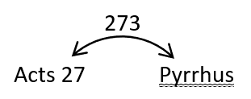
I said earlier in the presentation the bases of the whole Midnight Cry message is embedded in the King of the South. We go to acts 27 take the 273 to the history of Pyrus. Pyrus is the King of the South you understand the history of Pyrus in the Alpha and the Omega we know a lot I'm the king of the North Antigonis and Demetrius Salukis Rome but the underlying theme is the King of the South I want to suggest that is unique to any messages Gods people have ever had if you were to go to the writings of Daniel 2 this is the story of the statue . Babylon, Medo-Persia, Greece and Rome all the King of the North, Da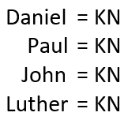niel 7 all the King of the North do you have introduction to the King of the South but the theme is all the perspective of the King of the North. Daniel 8 King of the North, Daniel 11 the son of the King of the South but the theme is the King of the North. if you were to go the writings of Paul in 2nd Thessalonians there is a warning of the King of the South no he is warning you of the King of the North. If you were to go in the Book of Revelation there is some stories of the King of the South as they relate to the King of the North but the underlined thyme is the king of the North. If you were to go past Bible History, to the reformation and Martin Luther King who was Martin Luther fighting the King of the North. The King of the North has always been the focus of our studies. if you were to ask someone teach you the structure of the King of the North they could take you too many passages they could talk about the woman riding the beast and the statue and the cup all those different symbols relating to it, and if you ask people what are the characteristics of the King of the South what do they say they start to get confused they would Ramble something about atheism and if you push the point no one knows no one would tell you about the King of the South. Because all they identified is based on the King of the North and the King of the South causes no end of confusion but we Overlook it’s not a coincidence that these studies are from the perspective of the South, so I want this to consider the King of the South a favorite quote is the great controversy 269 paragraph.2 she is talking about the great City spiritual Egypt she is going to line up atheistic France with Egypt you have any model I'm the king of the South and the King of the South she says of Egypt no nation was ever so bold and denying the existence of the Living God and resisting his Commandments no King was more open a rebellious against the authority of Heaven than pharaoh she said this is atheism the nation represented by Egypt would have a similar voice would make similar denials against the authority of God and would have the same spirit of unbelieve and defiance that city is also spiritually Sodom. So we have a few different countries highlighted we know the subject is the French Revolution chapter 15 so she is discussing Egypt its characteristics connected to the characteristics of Sodom all in the Endeavor to explain atheistic France saying these have the same characteristics unbelief and defiant against GOD she says also what characterizes Sodom was manifested in licentiousness this is the main characteristic of the Nation that will fulfill the specification Egypt, Sodom, French Revolution France she talks about licentiousness we are building a model of the King of the South we will not go into great detail but this is where we get our characteristics of the King of the South.
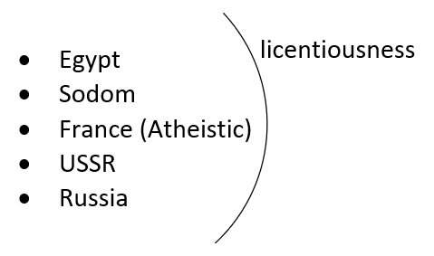
You can go back to the alpha history and talk about the Soviet Union our history talks about Russia when we use the words King of the North and King of the South, we are using a particular model that model is the model of geography.

Daniel 11:4 well give you the model of geography Alexa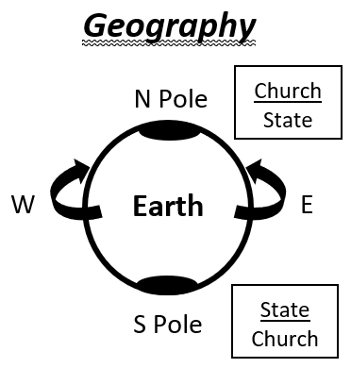nder the Great is going to die and when he dies his kingdom is going to be divided and to the Four Winds of Heaven it is divided into the four direction of the compass this is all the model of geography you have north east west and south if you were to imagine this is the Earth it has four directions to the compass north south east west now if I was to ask you take me to the point of absolute East where would you take me if we were to Head East you would be confused when we talk about the East wind what country are we talking about we don't have one we just have an ideology there is no East there is no country you can pinpoint when you talk about geography now if I was to ask you to take me West what country do you take me to there is no country that is West you have the Western world there is no absolute point that is West our model of geography is to explain the directions of the compass that they have different characteristics now if I was to ask you take me to Absolute North where would you take me you would take me, to the North Pole it's a point that's why when we talk about the North you can identify a kingdom one country you take me to the North Pole if I was to ask you take me to Absolute South where would you take me, an absolute location of the East Wind in the west wind can mean different countries that the North and the South are extremely specific they are poles, you can call them Polar Opposites absolutely extremes on the earth sphere they are absolutely opposed to each other, so when we think about the King of the North and its characteristics it's polar opposite of what the King of the South and its characteristics this model enables us to compare and contrast what is the model of the King of the North King of the North has a particular relationship between church and state and what does that look like in the language of Revelation the woman riding the beast is church overstate that is the model of the King of the North. But when we talk about the King of the South, we don’t know how to define it we say it has no church does the King of the South have a church yes but it's a polar opposite model of the King of the North. So what is the model of the King of the South it must be state over Church I want to quote Vladimir Putin these are all interviews on YouTube and I have typed them directly from his mouth but the translation I will paraphrase he sees that America takes in more and more immigrants as far as he understands it's white Christian population is outnumbered of course this has only changed recently but white Christians are now a minority I am still quoting him the world is going to a dramatic World change not saying it's good or it's bad but there is global changes and white Christians are a minority Russia is a large place you look at its culture and history and it is undoubtedly European we need to preserve this European culture everything he is sewing the what the ideology of the white supremacist and he's been doing this for years it's gotten to the point people are recognizing by working over a. Of years 20 years he is the international leader contact Conservative Christian far right quoting a pro-Russian Society in Italy I may be speaking heresy but Putin looks more like a pope to me than Francis by the way he lives and demonstrates Christianity the greatest the proudest and strongest advocate of Christian values is Vladimir Putin. Quoting Vladimir Putin again he says Russia is there an orthodox Christian Nation there has always been problems between Orthodox Christianity and the Catholic world I want to say a few words about Catholics so listen closely the King of the South is going to talk about Catholics he says are there any problems there yes he's talking about the sexual abuse problem. But they cannot be over exaggerated that it may destroy the Catholic Church because of these scandals sometimes I have the feeling that those liberals are using certain problems with the Catholic Church as a tool to destroy the church itself this is incorrect and dangerous remember quoting the King of the South have we forgotten that all of us live in the world based biblical values even atheist live in the world with Biblical values we don't have to think about this every day but deep inside we have those fundamental rules and moral values in this sense Traditional Values are more stable and more important to millions of people then this liberal idea which in my opinion is dying or dead the journalist said so Putin the King of the South it's religion not the Opium of the masses Vladimir Putin says no it is not our world is biblical values defending those white Christian conservatives he forged close relationship with the Orthodox Church the official spokesman for that church he said the very idea the separation of church and state is a peculiarity of the West. because the King of the North is in a church-state relationship, the King of the South says the idea to separate us is foreign to us, because the King of the South is a church and state relationship the journalist asked isn't Putin controlling the church to expand his power the spokesman of the orthodox church says that's one explanation that's a simple one we always here from the West because he doesn't deny it because you know this true Vladimir Putin for 20 years has been building an image of himself as this spokesman, the hero that there are persecuted minorities white evangelicals that's why when I say Donald Trump and he is friendly with Vladimir Putin they don't care there`re happy Vladimir Putin is what you want because that liberal Obama allowed gay marriage how are you treated as a homosexual in Russia the problem is we take quotes that talks about licentiousness in Sodom and we describe Sodom as destroyed because of homosexuals not getting into any arguments but you know now, when misusing those quotes because if this is the King of the South model Russia is licentious but not because of gay people they are the Evangelical far-right the King of the North it's a church state combination with the church on top we take that model and we use it over and over again and we've done that for thousands of years to build the argument of what an ugly picture it is if you have a woman over a man but for thousands years we have never understood the Polar Opposites we switch it and we look at Egypt's Sodom France Soviet Union or Russia and what characterizes all of them is not atheism that's too simple it's the state over the church, if you want to say woman over man a man over woman is this is satanic this is satanic Ellen White describes it as atheism but if you look at the King of the South I would suggest it's more of a scale you have the model of the King of the South State over Church it can start like Russia Today it looks friendly it looks peaceful many people like this model the Evangelical like this model because Russia is this patriarchal strongman country holding moral beliefs as a wall against the liberal West holding back to the tide of homosexual immorality but it starts off as control you can say that's Russia Today this is the model but it's on the sliding scale as to how far that abuse goes it starts as Control then the church is told to be quiet then you can turn into abuse find me when you get to atheistic France it's death that's the story of atheism we concentrate on that this is what happens to the church this is all the model of the King of the South depending on the age and the wishes of the state it exists at different levels so during history Soviet Union under Stalin it was here and then Germany invaded he needed the church on his side went back to about here just enough so they would support him against Hitler.
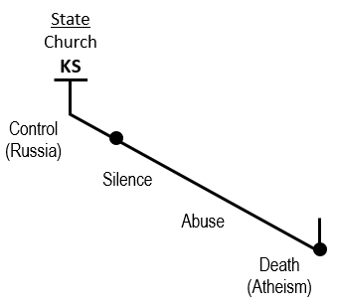 So if the north has a church and are in a relationship polar opposite must be .This is why the Midnight Cry message had to be based on the king of the South because the King of the South is that teaches us about equality for thousands of years God's people have opposed this and I would suggest they live like this it's been a model of ancient Israel the model of modern Israel and this is what our boards look like in this movement God's people have behaved as they were the King of the South in their homes and in their organization that is what we are learning to correct today which is why we are on time to understand the working and structure of the King of the South we cannot keep saying it is atheism and licentiousness one final point and we will close.
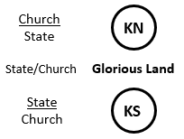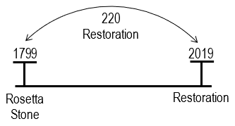
Elder Taboo spoke this morning about prophetic time span I want to give us one 1799 to 2019 this is 220 years what is the number 220 years mean it means restoration this is a story of restoration in 1799 it was an important discovery is the Rosetta Stone the Rosetta Stone was unearthed fought over between the British and the French it's written in three different languages and for the first time it opened up an understanding of the language of Egypt inscribed in that stone in hieroglyphics is the pharaoh the time describing how he related to his church describing is church and state relationship we have two faulty glorious lands we know there's a third glorious land it's not Canaan or America there is two faulty glorious lands do not properly demonstrate what it means to be a member of the Glorious land. The Glorious land is where, its wedged between the King of the North and the King of the South it's not church over state or state over Church it's church and state side by side a relationship that was not properly implemented either in ancient Israel or the United States 220 years ago the Rosetta Stone was unearthed it opened up the ancient language of Egypt by describing the relationship between a pharaoh and his church 220 years later right on time for a restoration we're understanding the relationship of the King of the South regarding their state and their Church in 2019 things are opening up to the King of the South we're able to experience a proper restoration a correct understanding of what it means to be a citizen of the Glorious land. Our subject comes from the King of the South when we understand the king of this out today overly simplistic to talk about licentiousness and Atheism we need to reconsider what we're taking from Sodom into Russia what side of the argument Vladimir Putin is on as we find them defending the Catholic Church against the immoral liberals you understand that he does this because he needs to church in his control and under his power we have exhibited today two different models of a church and state relationship both are satanic are option is a third side by side equality.

